ADBMS PROJECT

UID: 180130

**NAME: RAHUL MUKESH SINGH**

**WAREHOUSE MANAGEMENT SYSTEM**

**FEATURES ADDED IN THE PROJECT**

* NESTED TABLE
* VARRAY
* MULTIMEDIA
* XML
* ACTIVE DATABASE -TRIGGERS
* TEMPORAL DATABASE
* SPATIAL DATABASE
* INHERITANCE
* POLYMORPHISM
* DISTRIBUTED DATABASE
* NOSQL

**CLASS DIAGRAM:**

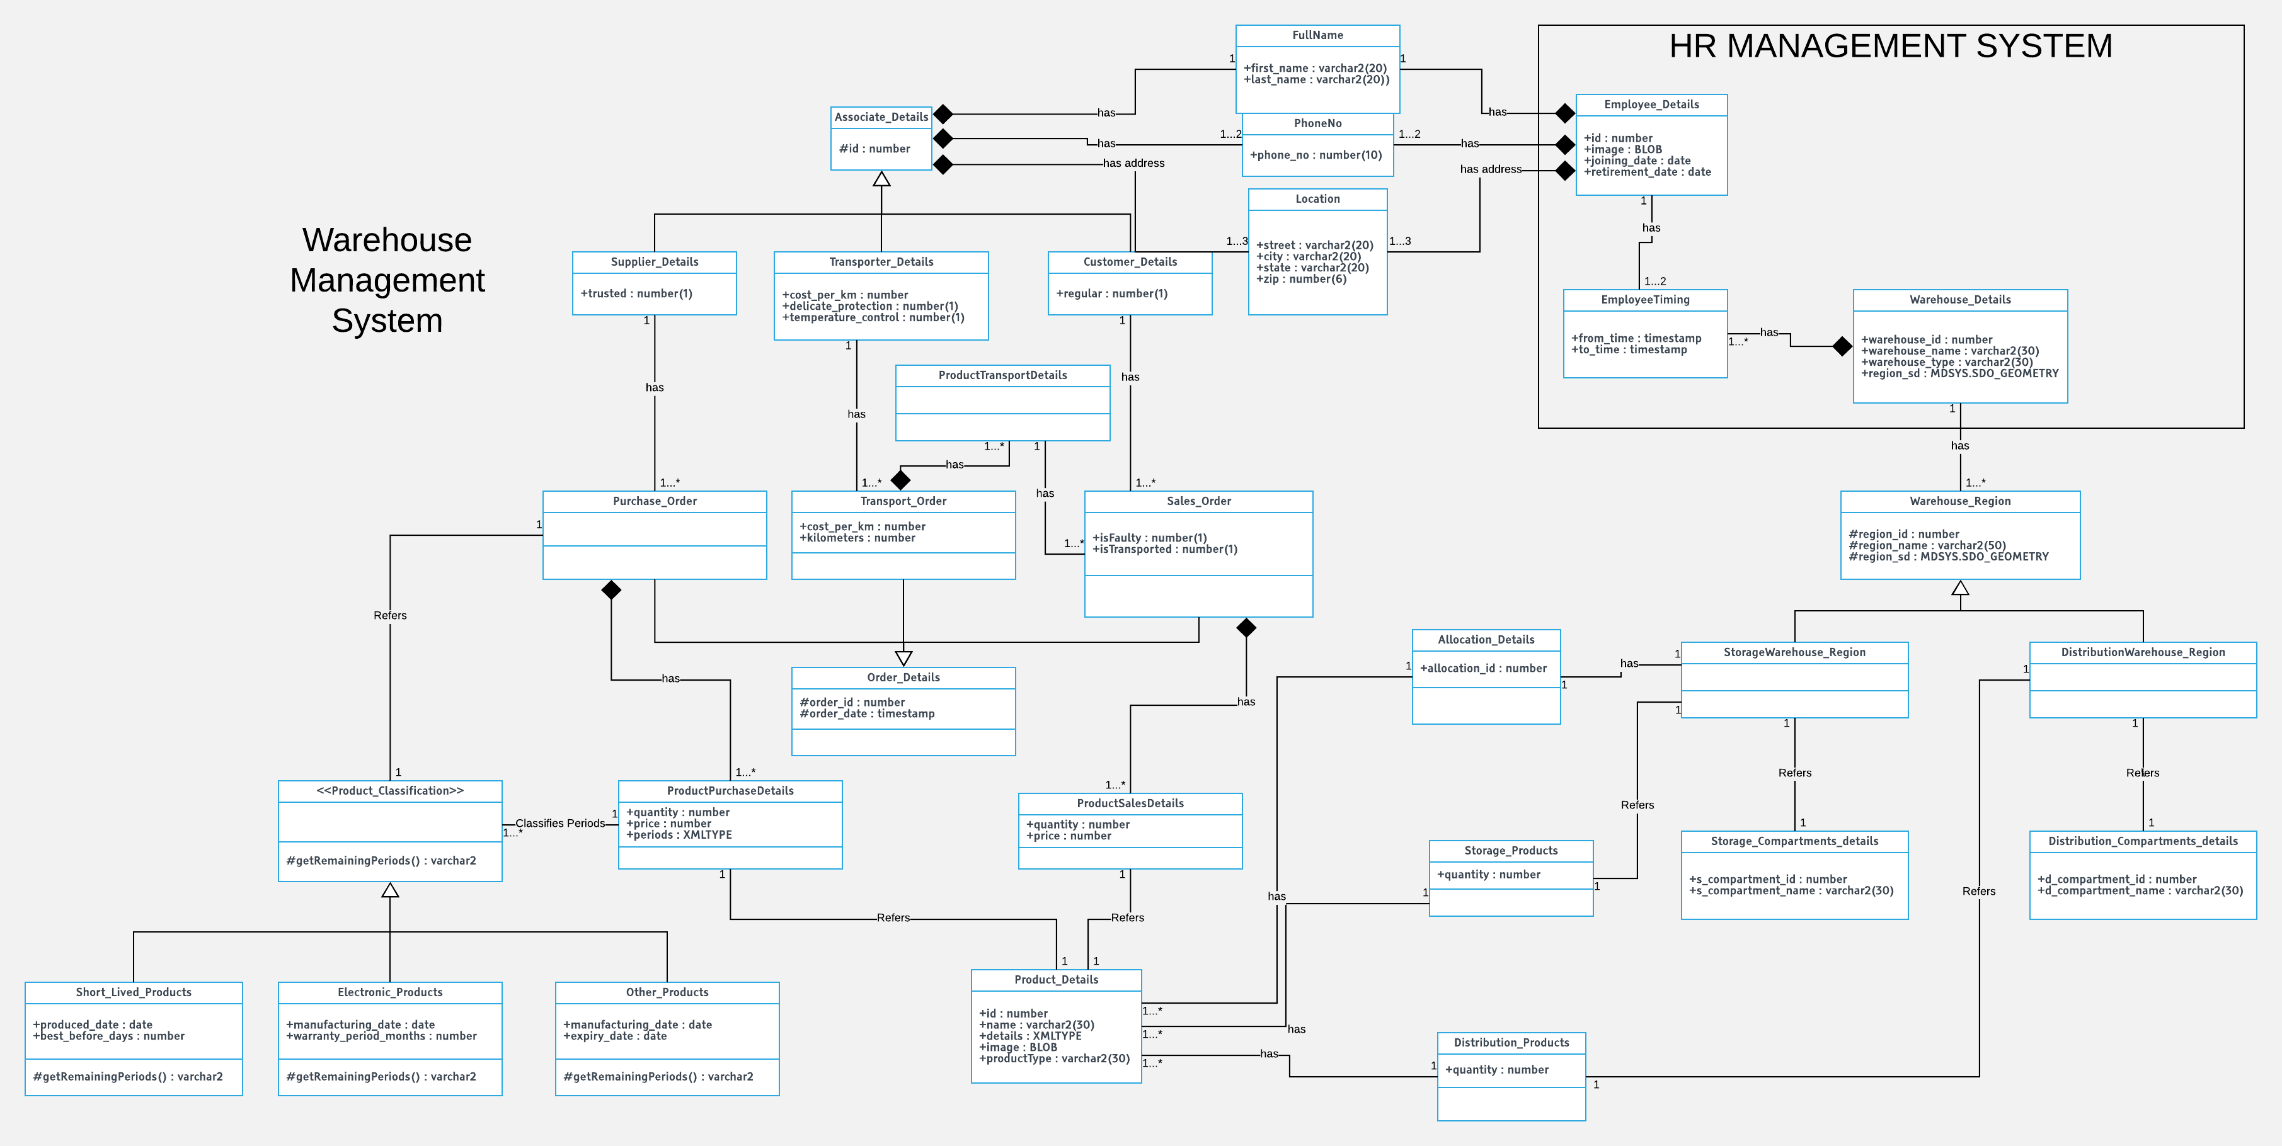

**SPATIAL DATABASE DESIGN:**

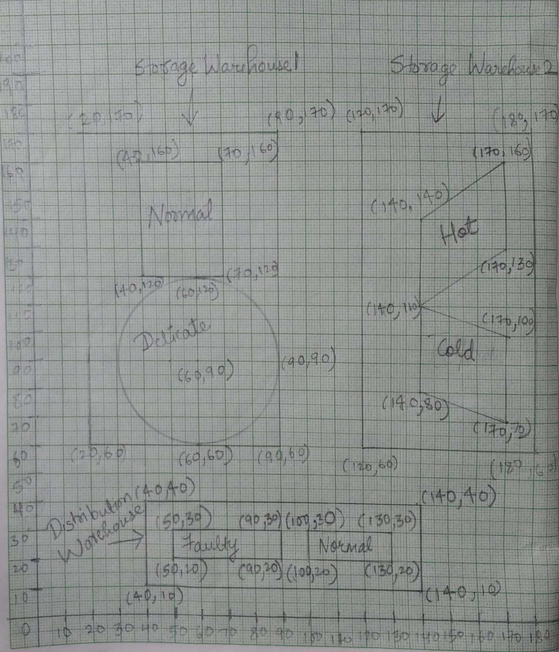

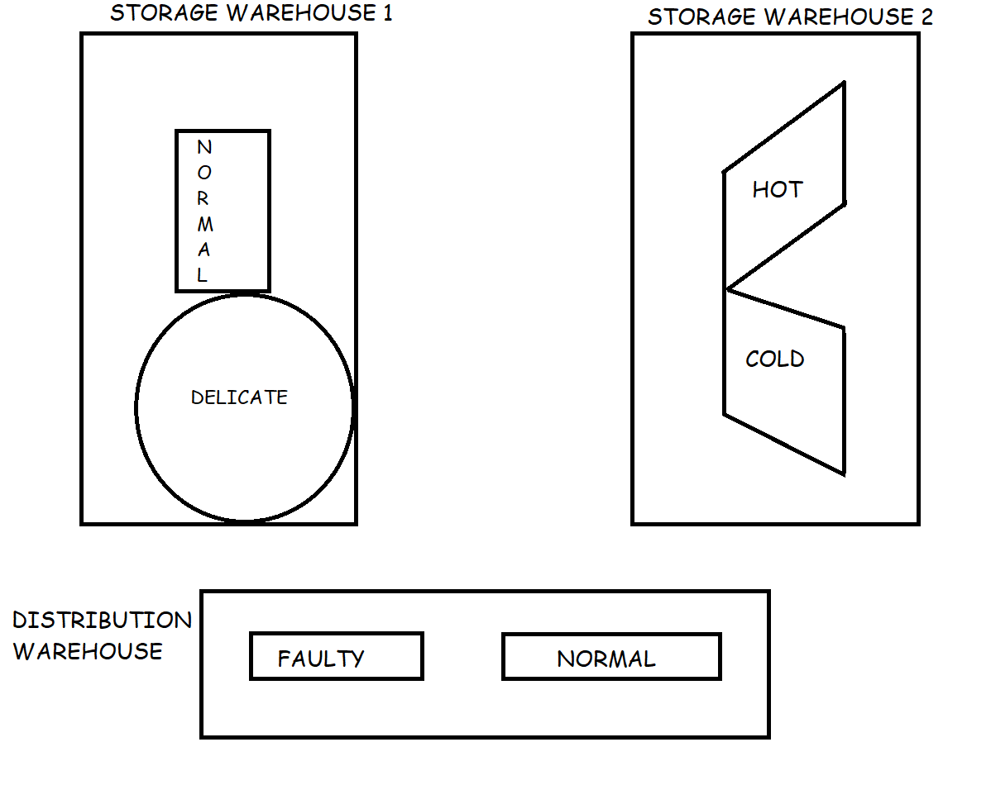

**HR MANAGEMENT SYSTEM**

**(FOR DISTRIBUTED DATABASE)**

**SEQUENCE:**

CREATE SEQUENCE Warehouse_Details_Seq MINVALUE 1 START WITH 1 INCREMENT BY 1;

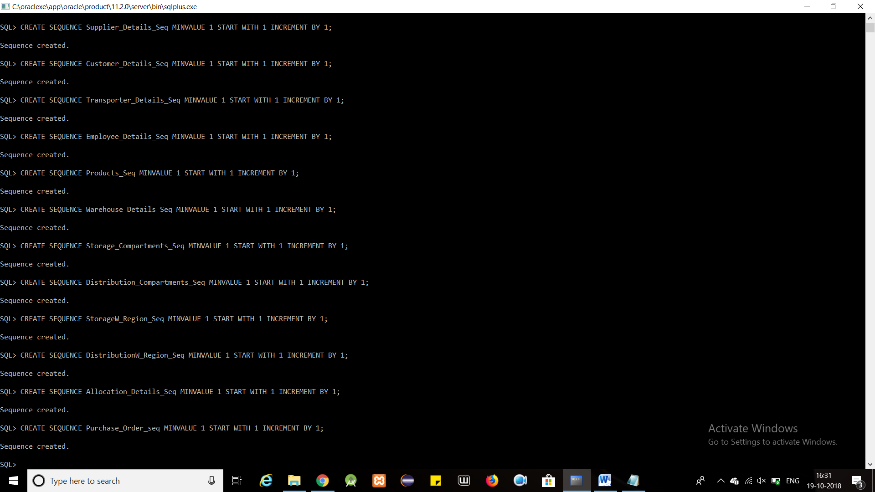

CREATE SEQUENCE Employee_Details_Seq MINVALUE 1 START WITH 1 INCREMENT BY 1;



=================================================================

**TABLES AND RELATED TYPES:**

create or replace type FullName1 as object(

first_name varchar2(20),

last_name varchar2(20)

)

/

create or replace type Location1 as object(

street varchar2(20),

city varchar2(20),

state varchar2(20),

zip number(6)

)

/

create or replace type PhoneNo1 as object(

phone_no number(10)

)

/

create or replace type loc1 as varray(3) of Location1

/

create or replace type pno1 as varray(2) of PhoneNo1

/

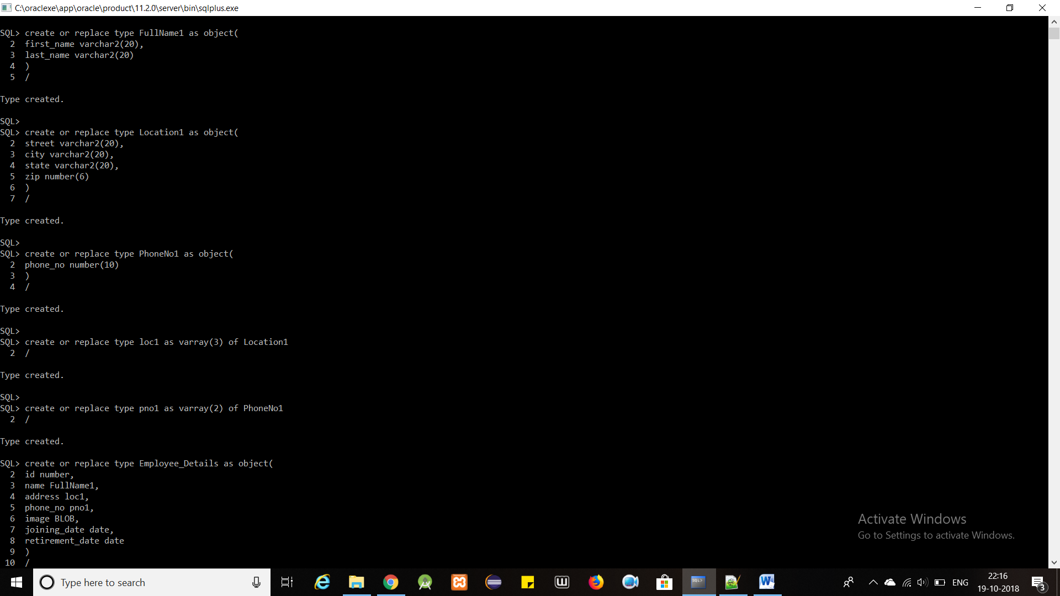

create or replace type Employee_Details as object(

id number,

name FullName1,

address loc1,

phone_no pno1,

image BLOB,

joining_date date,

retirement_date date

)

/

CREATE TABLE Employee_Details_T of Employee_Details;

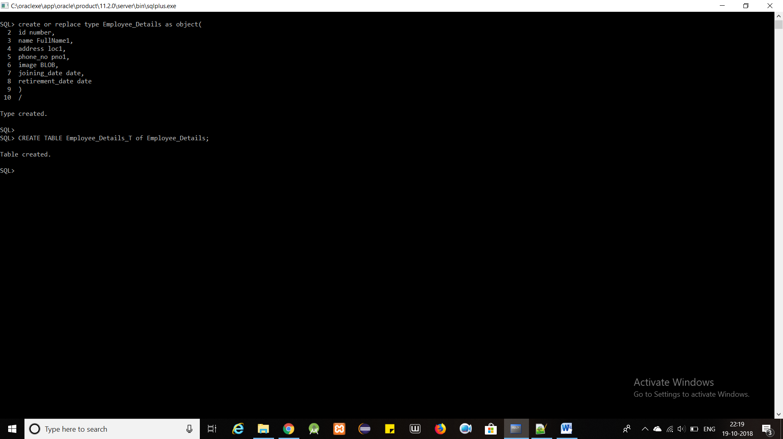

create or replace type EmployeeTimingDetails as object(

emp_id number,

from_time timestamp,

to_time timestamp

)

/

create or replace type EmployeeTiming as table of EmployeeTimingDetails

/

create or replace type Warehouse_Details as object(

warehouse_id number,

warehouse_name varchar2(30),

employee_incharge EmployeeTiming,

warehouse_type varchar2(30),

region_sd MDSYS.SDO_GEOMETRY

)

/

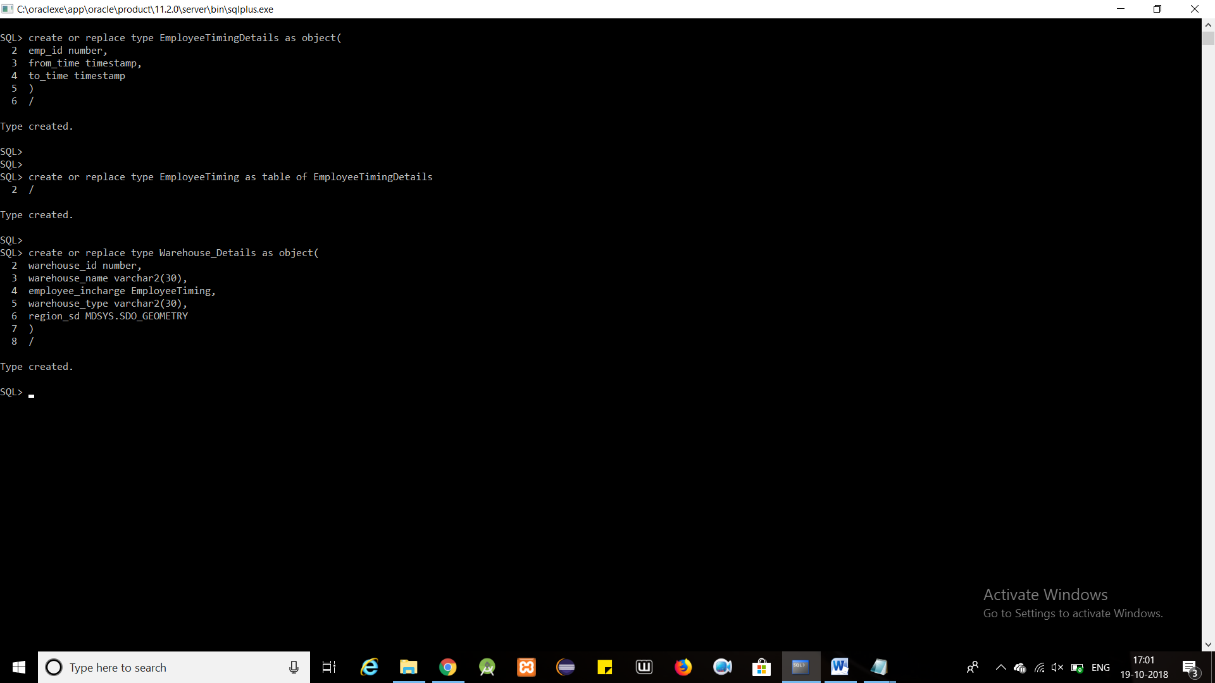

CREATE TABLE Warehouse_Details_T of Warehouse_Details nested table employee_incharge store as employee_incharge_NestedTable;

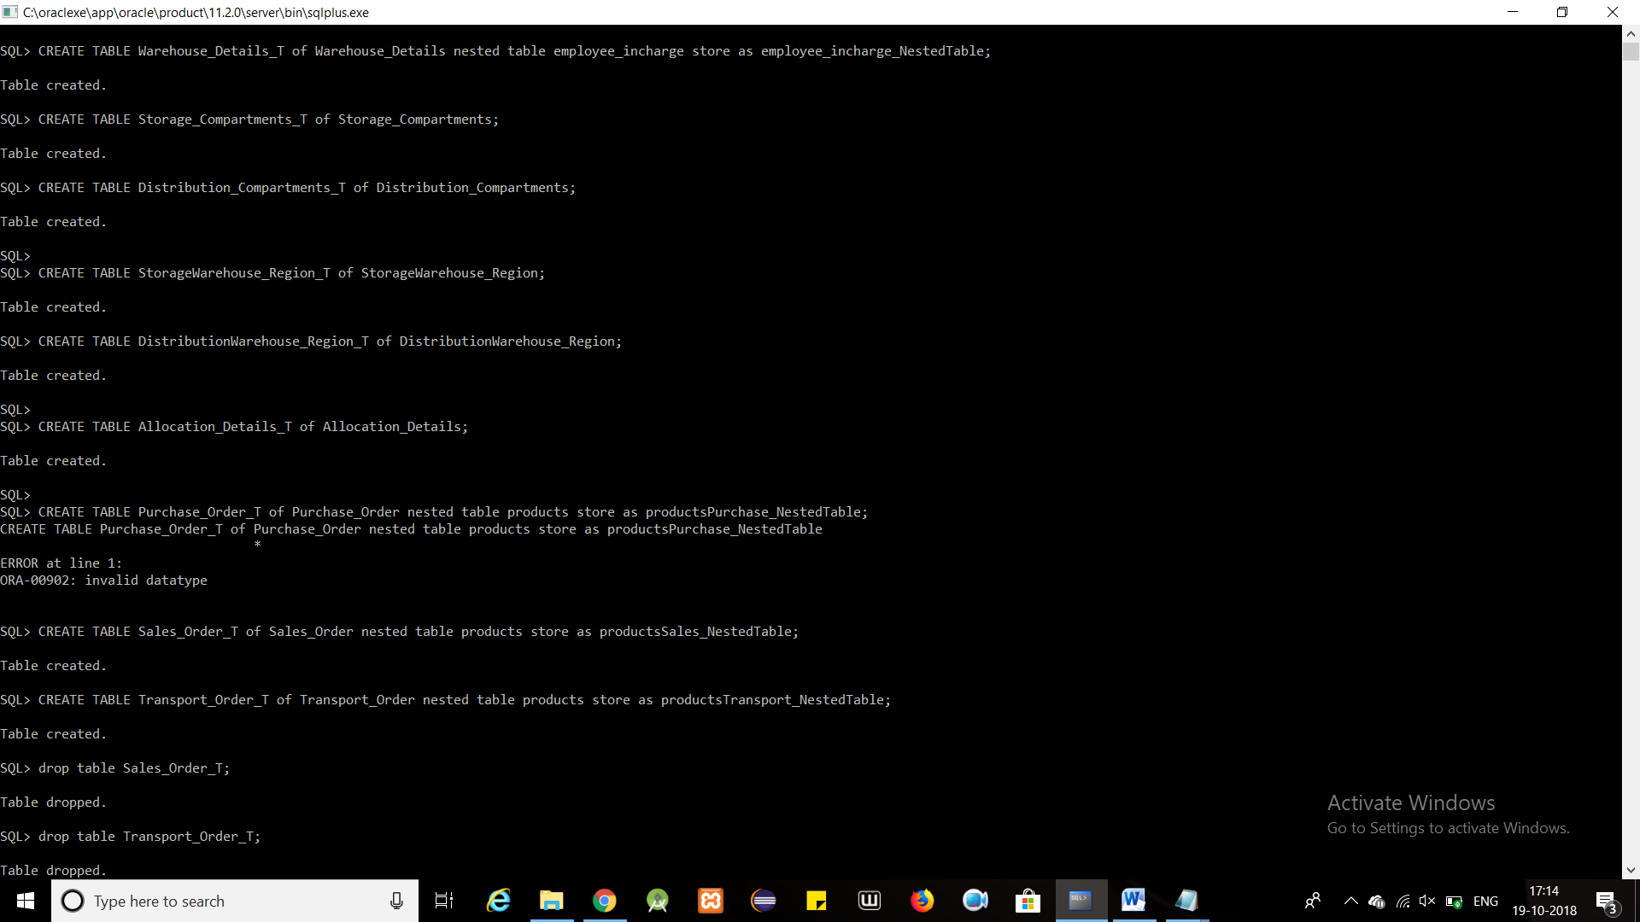

============================================

**INSERT**

INSERT INTO USER_SDO_GEOM_METADATA

VALUES (

'Warehouse_Details_T',

'region_sd',

MDSYS.SDO_DIM_ARRAY(

MDSYS.SDO_DIM_ELEMENT('X', 0, 200, 0.005),

MDSYS.SDO_DIM_ELEMENT('Y', 0, 200, 0.005)

),

NULL

);

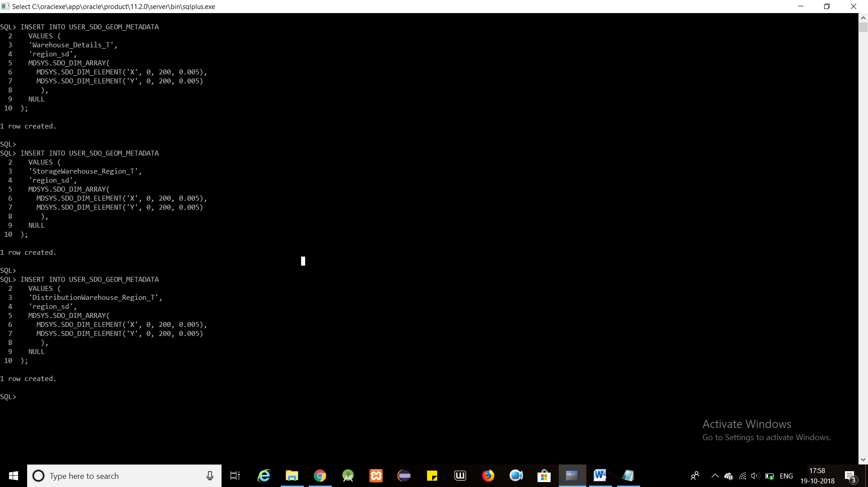

CREATE INDEX warehouse_SPID

ON Warehouse_Details_T(region_sd)

INDEXTYPE IS MDSYS.SPATIAL_INDEX;

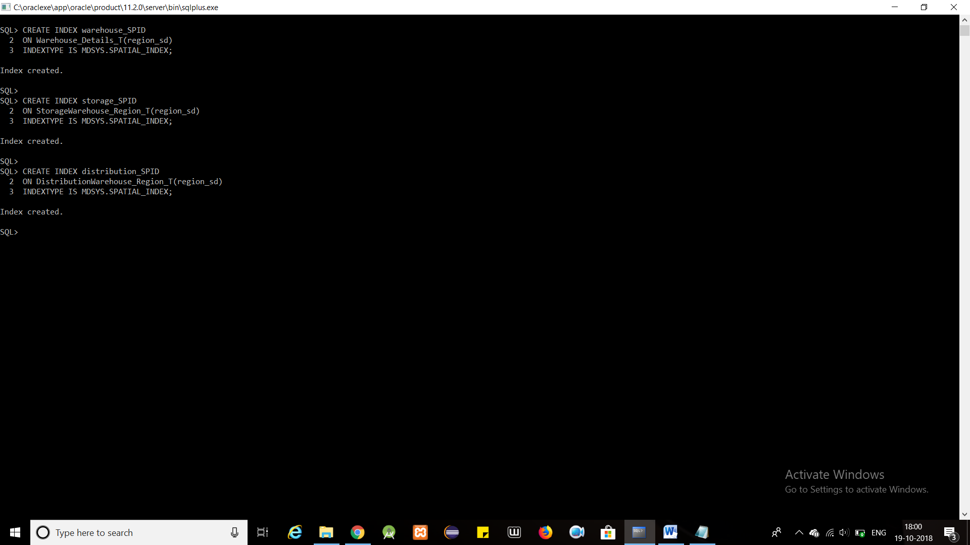

insert into Warehouse_Details_T values(Warehouse_Details(Warehouse_Details_Seq.nextval, 'Storage Warehouse1',

EmployeeTiming(EmployeeTimingDetails(1, to_timestamp('10:00:00', 'hh24:mi:ss'), to_timestamp('21:59:59', 'hh24:mi:ss')),EmployeeTimingDetails(3, to_timestamp('22:00:00', 'hh24:mi:ss'), to_timestamp('09:59:59', 'hh24:mi:ss'))),

'Storage',

MDSYS.SDO_GEOMETRY(

2003,

NULL,

NULL,

MDSYS.SDO_ELEM_INFO_ARRAY(1,1003,3),

MDSYS.SDO_ORDINATE_ARRAY(20,60,90,170)

)

));

insert into Warehouse_Details_T values(Warehouse_Details(Warehouse_Details_Seq.nextval, 'Storage Warehouse2',

EmployeeTiming(EmployeeTimingDetails(2,to_timestamp('10:00:00', 'hh24:mi:ss'), to_timestamp('21:59:59', 'hh24:mi:ss')),EmployeeTimingDetails(6,to_timestamp('22:00:00', 'hh24:mi:ss'), to_timestamp('09:59:59', 'hh24:mi:ss'))),

'Storage',

MDSYS.SDO_GEOMETRY(

2003,

NULL,

NULL,

MDSYS.SDO_ELEM_INFO_ARRAY(1,1003,3),

MDSYS.SDO_ORDINATE_ARRAY(120,60,180,170)

)

));

insert into Warehouse_Details_T values(Warehouse_Details(Warehouse_Details_Seq.nextval, 'Distribution Warehouse',

EmployeeTiming(EmployeeTimingDetails(4,to_timestamp('10:00:00', 'hh24:mi:ss'), to_timestamp('21:59:59', 'hh24:mi:ss')),EmployeeTimingDetails(5,to_timestamp('22:00:00', 'hh24:mi:ss'), to_timestamp('09:59:59', 'hh24:mi:ss'))),

'Distribution',

MDSYS.SDO_GEOMETRY(

2003,

NULL,

NULL,

MDSYS.SDO_ELEM_INFO_ARRAY(1,1003,3),

MDSYS.SDO_ORDINATE_ARRAY(40,10,140,40)

)

));

commit;

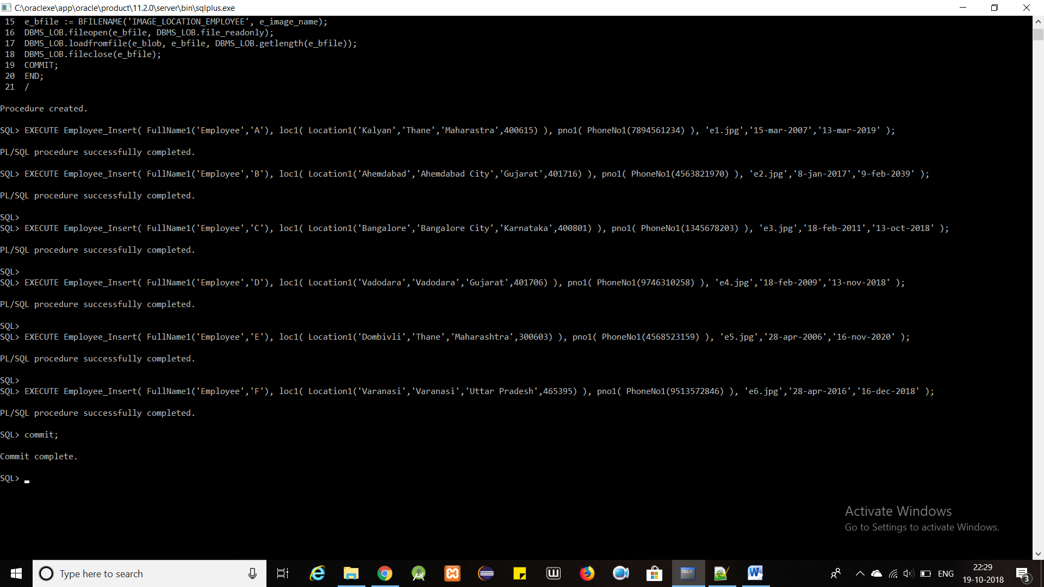

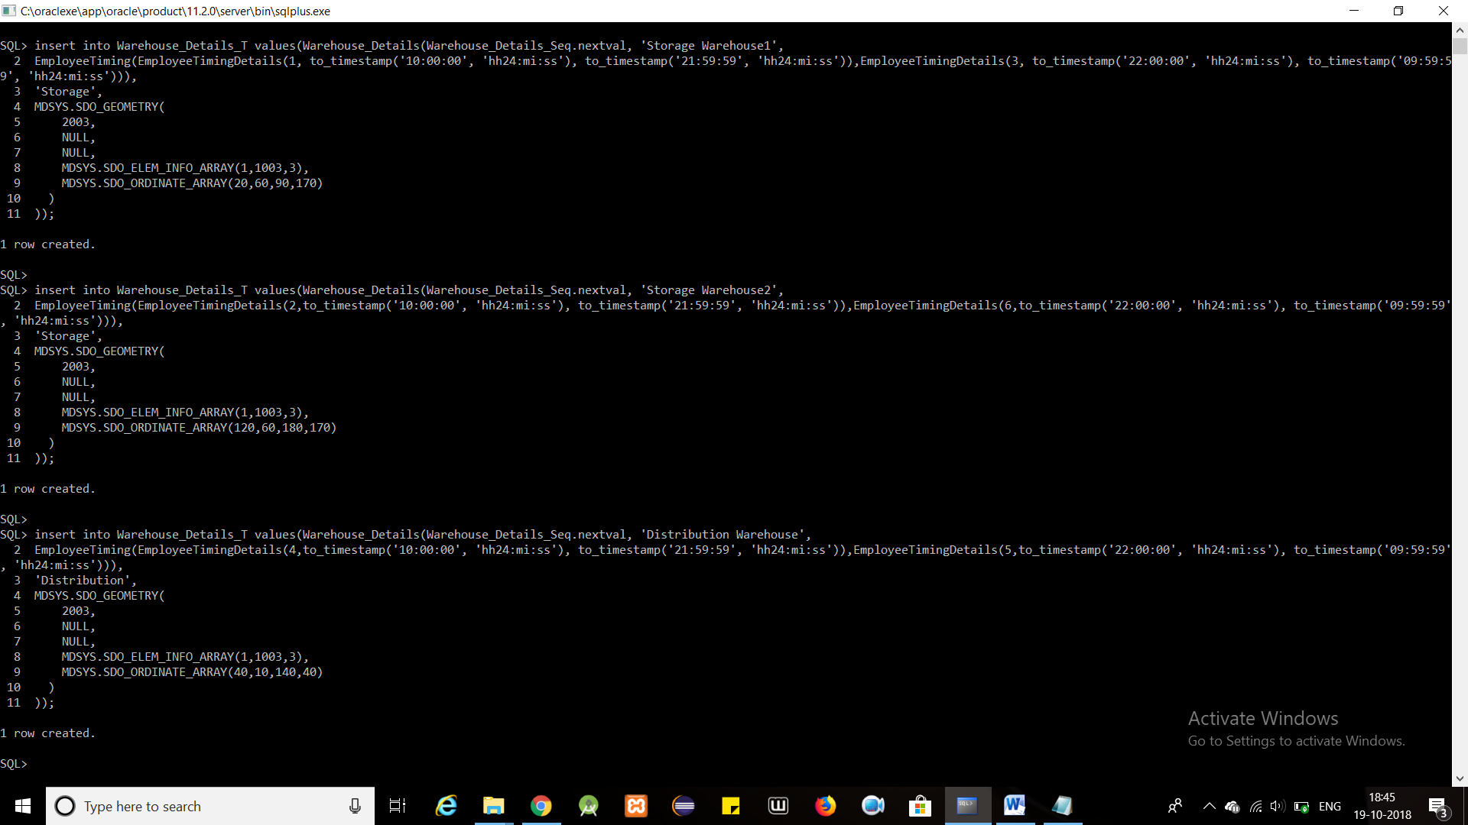

**PROCEDURE TO LOAD IMAGE**

CREATE OR REPLACE DIRECTORY IMAGE_LOCATION_EMPLOYEE AS 'E:\ADBMS Project\Employee_Image\\'

/

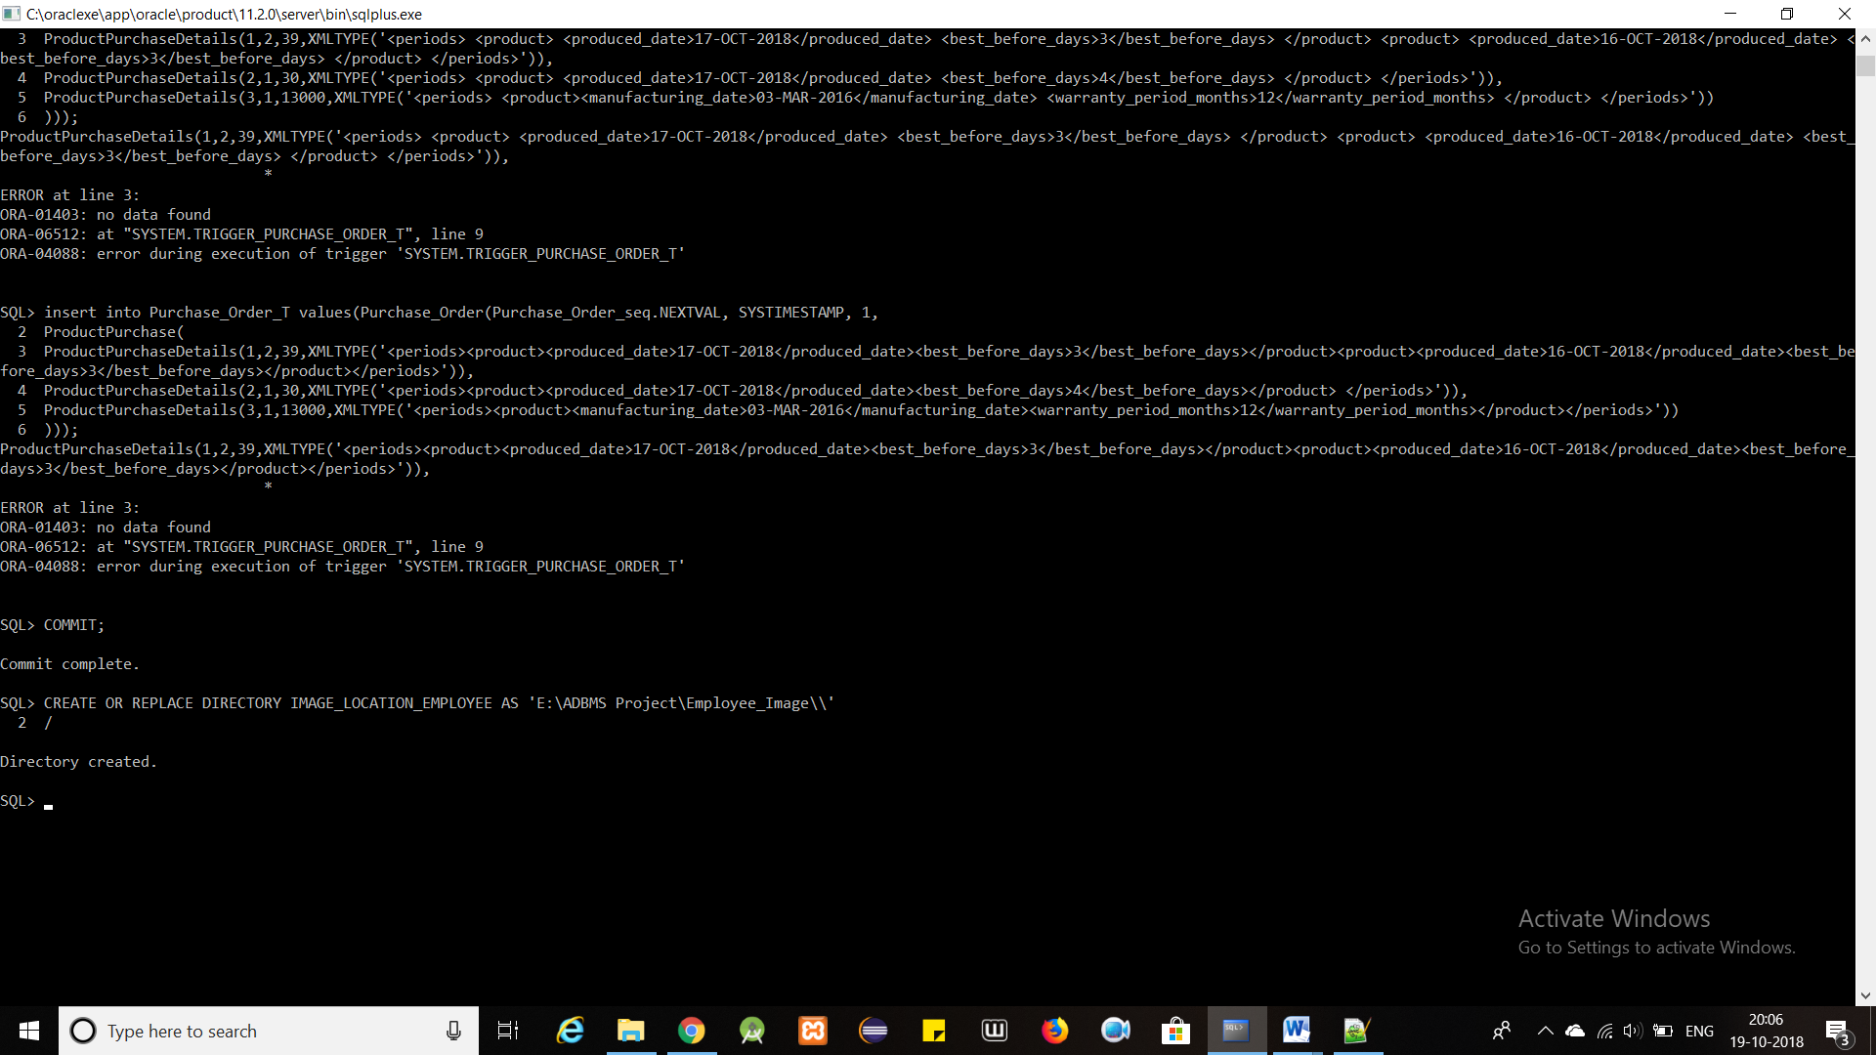

CREATE OR REPLACE PROCEDURE Employee_Insert

(

e_name IN Employee_Details_T.name%TYPE,

e_address IN Employee_Details_T.address%TYPE,

e_phone_no IN Employee_Details_T.phone_no%TYPE,

e_image_name varchar2,

e_joining_date IN Employee_Details_T.joining_date%TYPE,

e_retirement_date IN Employee_Details_T.retirement_date%TYPE

)

IS

e_bfile BFILE;

e_blob BLOB;

BEGIN

INSERT INTO Employee_Details_T VALUES(Employee_Details(Employee_Details_Seq.nextval,e_name,e_address,e_phone_no, EMPTY_BLOB(),e_joining_date,e_retirement_date)) RETURN image INTO e_blob;

e_bfile := BFILENAME('IMAGE_LOCATION_EMPLOYEE', e_image_name);

DBMS_LOB.fileopen(e_bfile, DBMS_LOB.file_readonly);

DBMS_LOB.loadfromfile(e_blob, e_bfile, DBMS_LOB.getlength(e_bfile));

DBMS_LOB.fileclose(e_bfile);

COMMIT;

END;

/

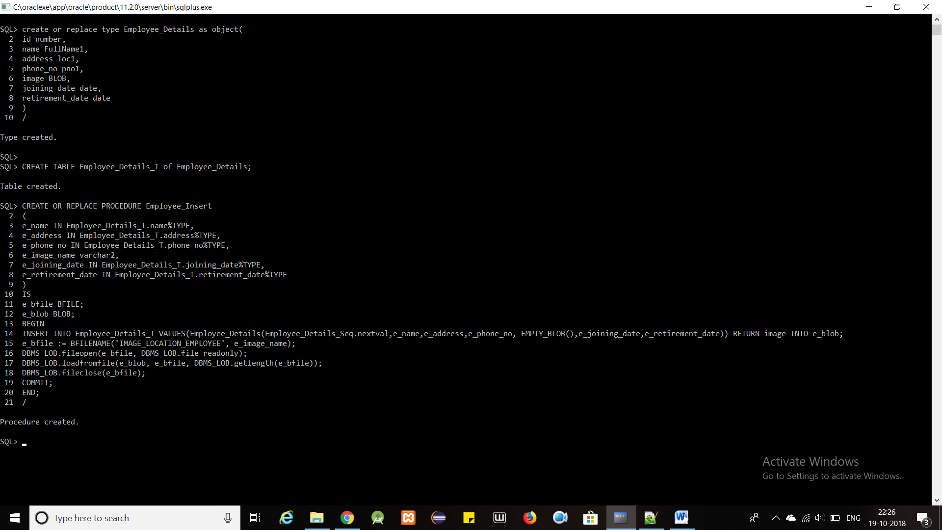

EXECUTE Employee_Insert( FullName1('Employee','A'), loc1( Location1('Kalyan','Thane','Maharastra',400615) ), pno1( PhoneNo1(7894561234) ), 'e1.jpg','15-mar-2007','13-mar-2019' );

EXECUTE Employee_Insert( FullName1('Employee','B'), loc1( Location1('Ahemdabad','Ahemdabad City','Gujarat',401716) ), pno1( PhoneNo1(4563821970) ), 'e2.jpg','8-jan-2017','9-feb-2039' );

EXECUTE Employee_Insert( FullName1('Employee','C'), loc1( Location1('Bangalore','Bangalore City','Karnataka',400801) ), pno1( PhoneNo1(1345678203) ), 'e3.jpg','18-feb-2011','13-oct-2018' );

EXECUTE Employee_Insert( FullName1('Employee','D'), loc1( Location1('Vadodara','Vadodara','Gujarat',401706) ), pno1( PhoneNo1(9746310258) ), 'e4.jpg','18-feb-2009','13-nov-2018' );

EXECUTE Employee_Insert( FullName1('Employee','E'), loc1( Location1('Dombivli','Thane','Maharashtra',300603) ), pno1( PhoneNo1(4568523159) ), 'e5.jpg','28-apr-2006','16-nov-2020' );

EXECUTE Employee_Insert( FullName1('Employee','F'), loc1( Location1('Varanasi','Varanasi','Uttar Pradesh',465395) ), pno1( PhoneNo1(9513572846) ), 'e6.jpg','28-apr-2016','16-dec-2018' );

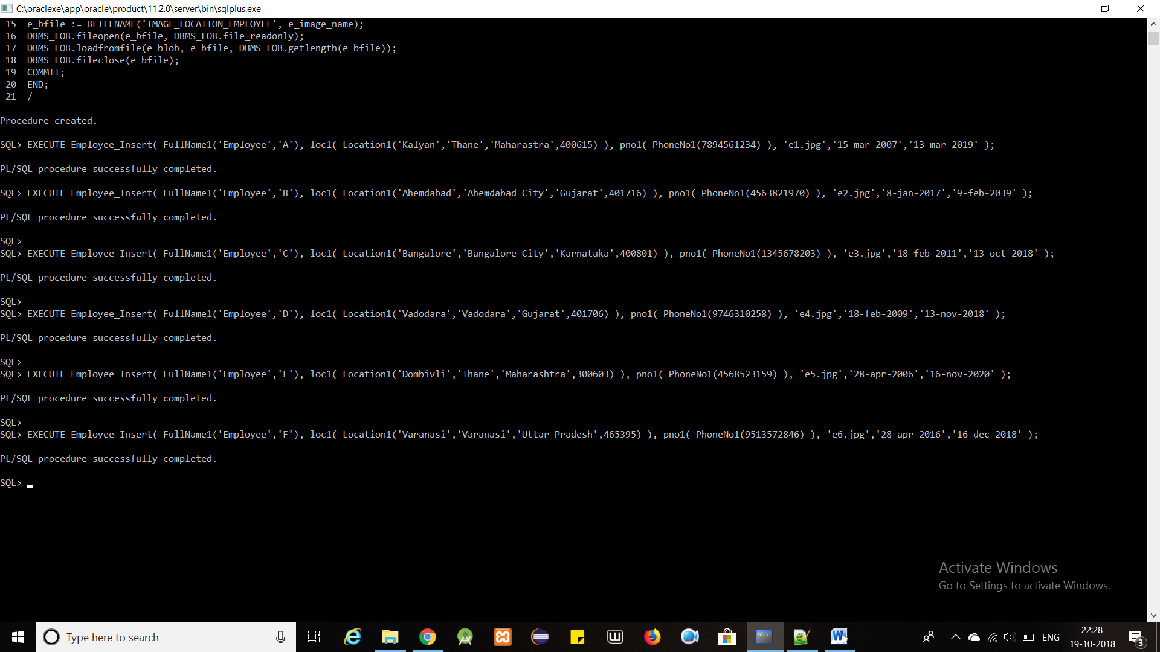

commit;



**select type_name, type_oid from dba_types where type_name = 'FULLNAME1' OR type_name='LOCATION1' or type_name='PHONENO1' or type_name='LOC1' or type_name='PNO1' OR type_name='EMPLOYEE_DETAILS' or type_name='EMPLOYEETIMINGDETAILS' or type_name='EMPLOYEETIMING' or type_name='WAREHOUSE_DETAILS';**

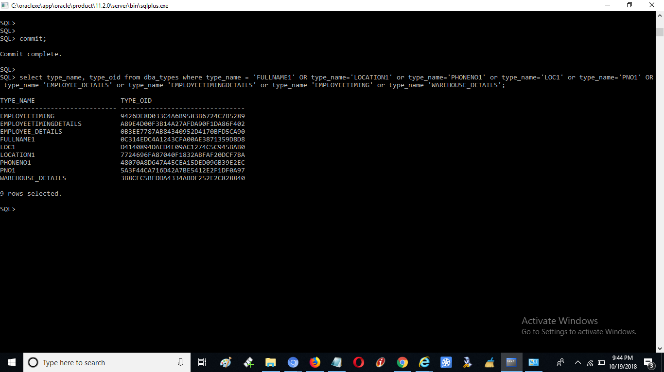

==================================================================

**WAREHOUSE MANAGEMENT SYSTEM**

**SEQUENCE:**

CREATE SEQUENCE Supplier_Details_Seq MINVALUE 1 START WITH 1 INCREMENT BY 1;

CREATE SEQUENCE Customer_Details_Seq MINVALUE 1 START WITH 1 INCREMENT BY 1;

CREATE SEQUENCE Transporter_Details_Seq MINVALUE 1 START WITH 1 INCREMENT BY 1;

CREATE SEQUENCE Products_Seq MINVALUE 1 START WITH 1 INCREMENT BY 1;

CREATE SEQUENCE Storage_Compartments_Seq MINVALUE 1 START WITH 1 INCREMENT BY 1;

CREATE SEQUENCE Distribution_Compartments_Seq MINVALUE 1 START WITH 1 INCREMENT BY 1;

CREATE SEQUENCE StorageW_Region_Seq MINVALUE 1 START WITH 1 INCREMENT BY 1;

CREATE SEQUENCE DistributionW_Region_Seq MINVALUE 1 START WITH 1 INCREMENT BY 1;

CREATE SEQUENCE Allocation_Details_Seq MINVALUE 1 START WITH 1 INCREMENT BY 1;

CREATE SEQUENCE Purchase_Order_seq MINVALUE 1 START WITH 1 INCREMENT BY 1;





CREATE SEQUENCE Sales_Order_seq MINVALUE 1 START WITH 1 INCREMENT BY 1;

CREATE SEQUENCE Transport_Order_seq MINVALUE 1 START WITH 1 INCREMENT BY 1;

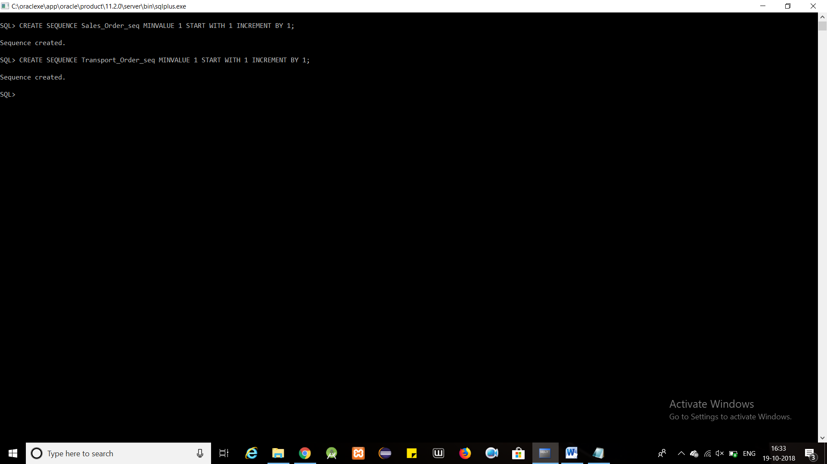

**TABLES AND RELATED TYPES**

create or replace type FullName as object(

first_name varchar2(20),

last_name varchar2(20)

)

/

create or replace type Location as object(

street varchar2(20),

city varchar2(20),

state varchar2(20),

zip number(6)

)

/

create or replace type PhoneNo as object(

phone_no number(10)

)

/

create or replace type loc as varray(3) of Location

/

create or replace type pno as varray(2) of PhoneNo

/

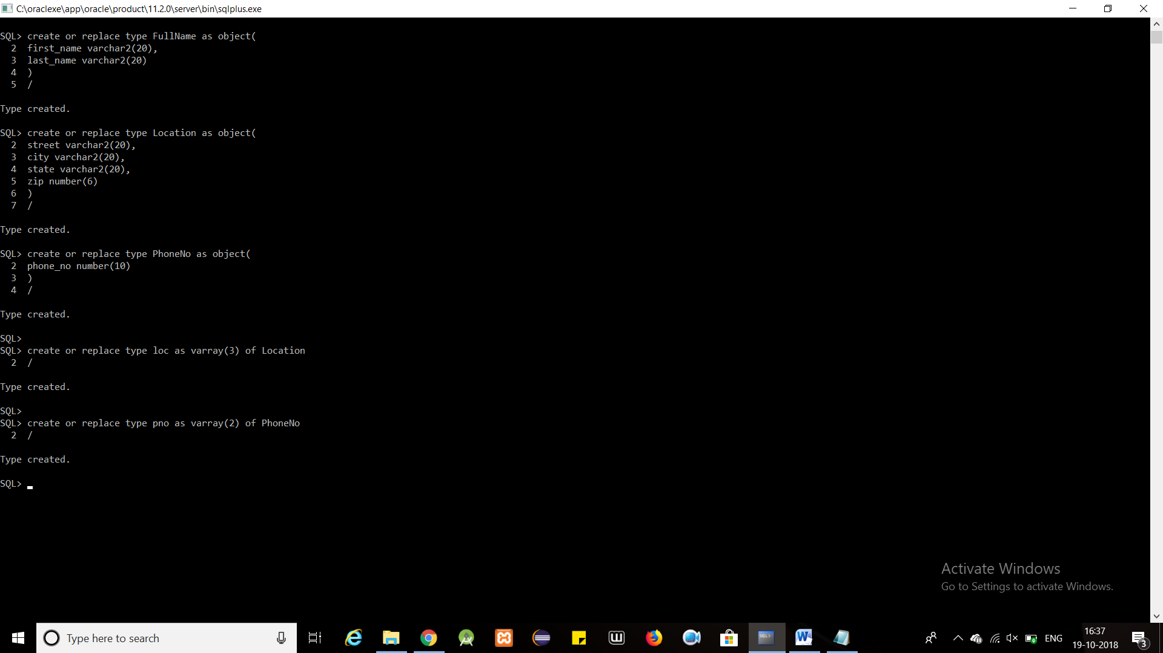

create or replace type Associate_Details as object(

id number,

name FullName,

address loc,

phone_no pno

)

NOT FINAL

/

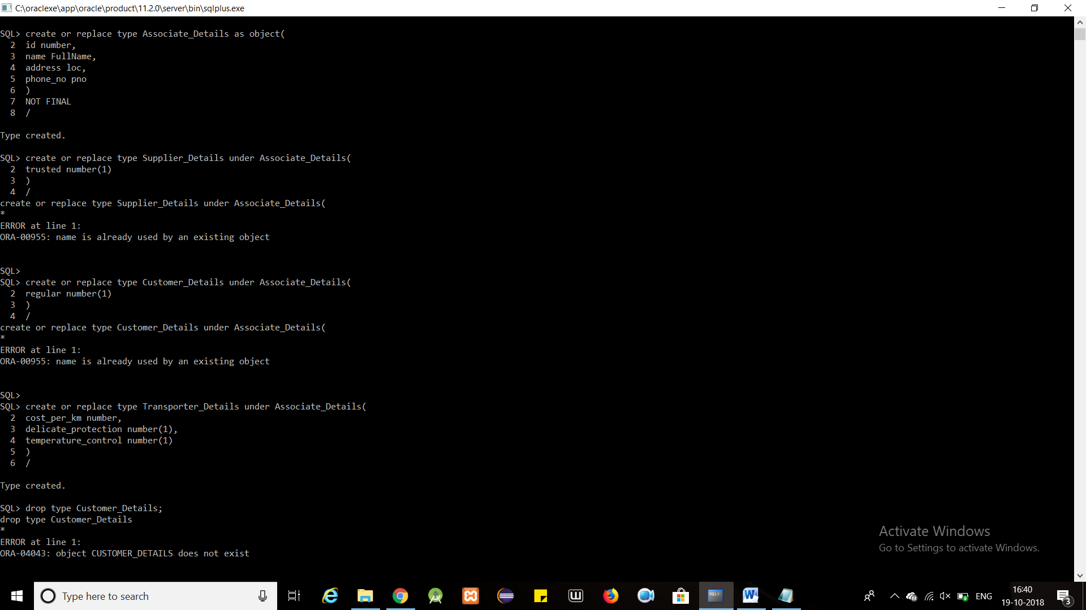

create or replace type Supplier_Details under Associate_Details(

trusted number(1)

)

/

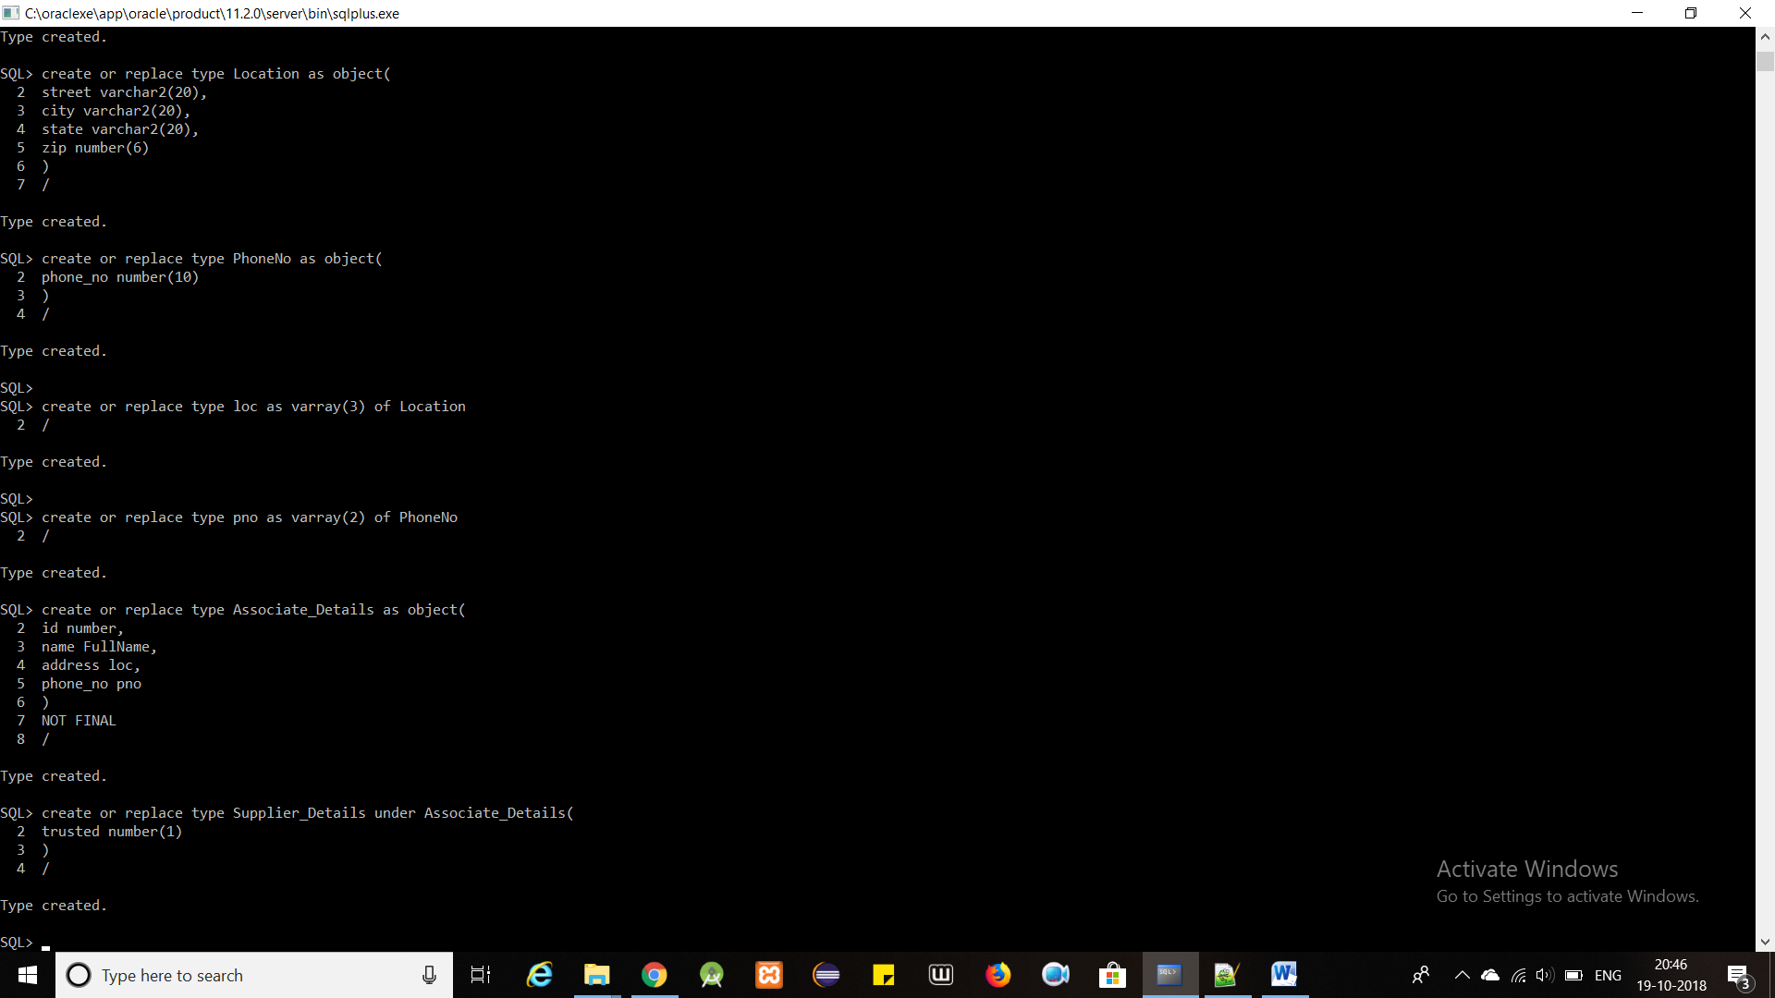

create or replace type Customer_Details under Associate_Details(

regular number(1)

)

/

create or replace type Transporter_Details under Associate_Details(

cost_per_km number,

delicate_protection number(1),

temperature_control number(1)

)

/

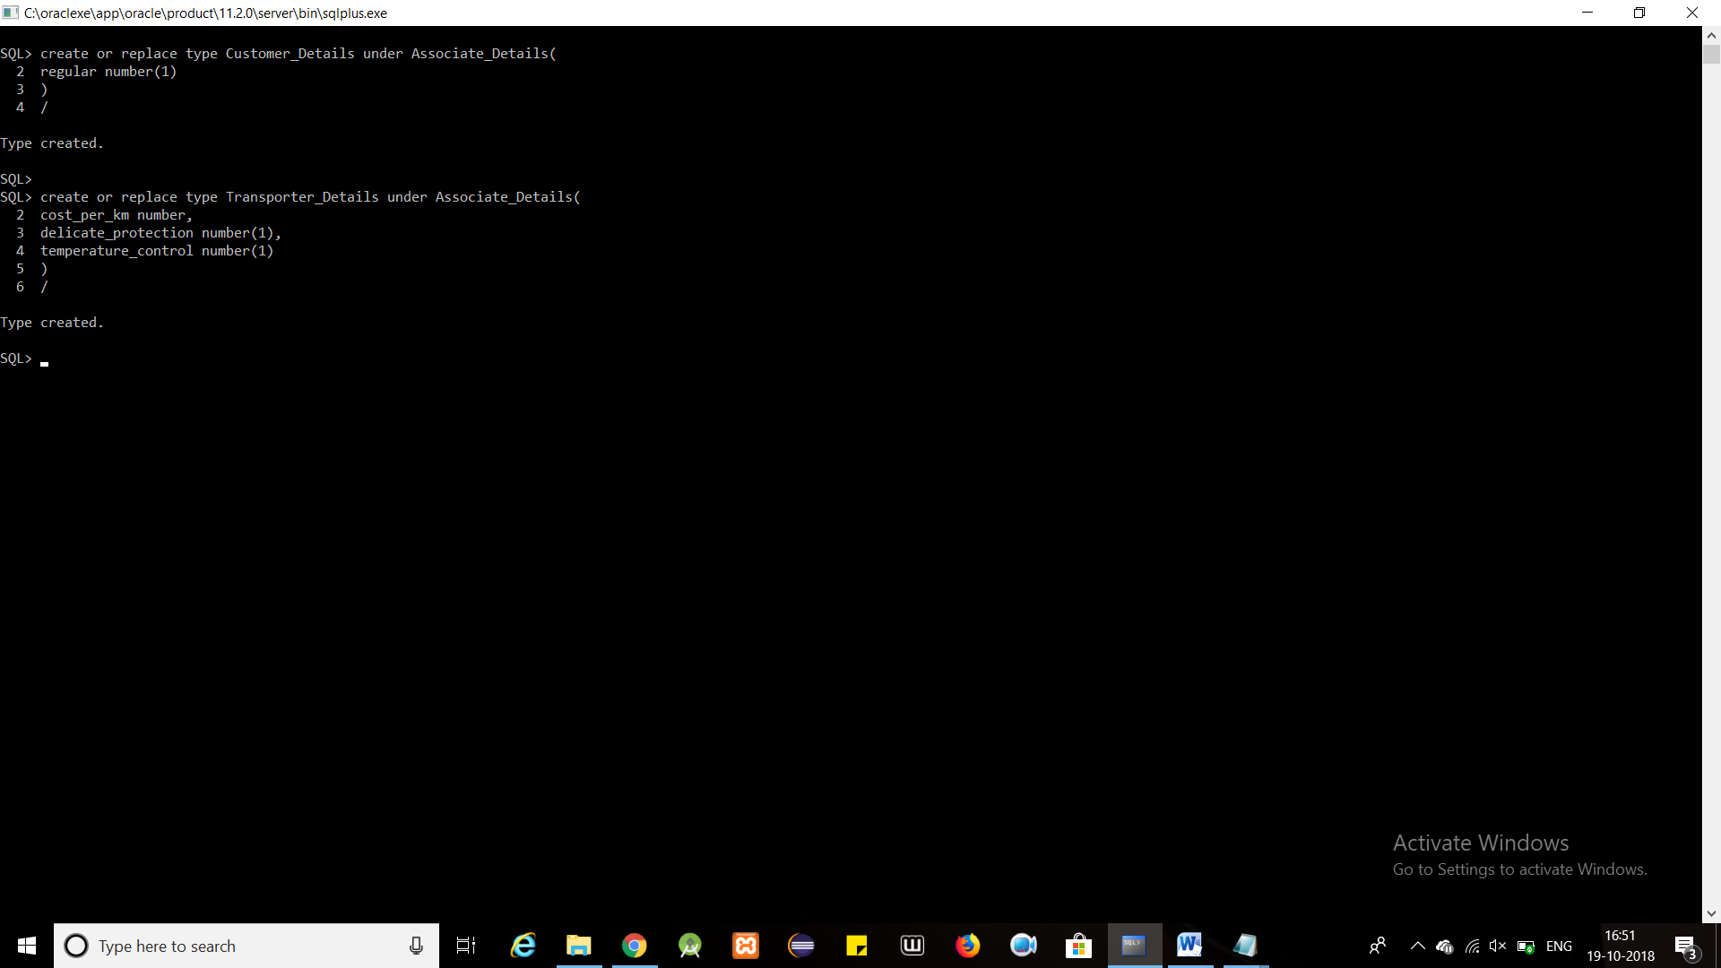

create or replace type Product_Details as object(

id number,

name varchar2(30),

details XMLTYPE, --area, price, is_delicate, needs_temperature_control

image BLOB,

productType varchar2(30)

)

/

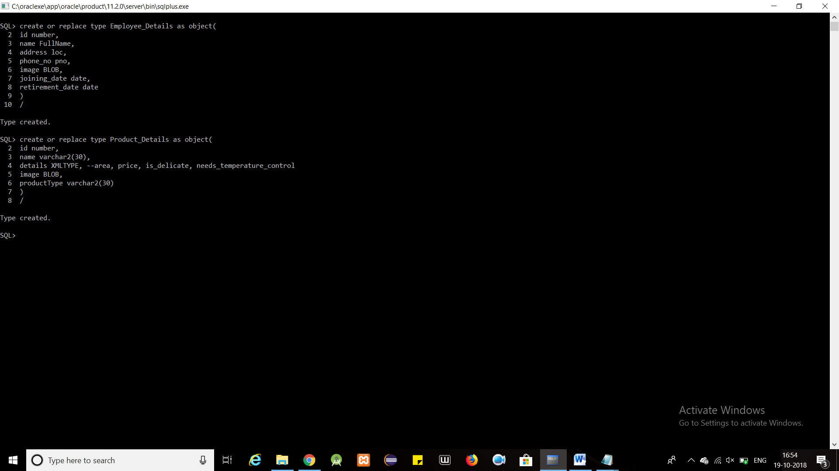

create or replace type Product_Classification as object(

product_id number,

order_id number,

NOT INSTANTIABLE MEMBER FUNCTION getRemainingPeriods RETURN VARCHAR2

)

NOT INSTANTIABLE NOT FINAL

/

create or replace type Short_Lived_Products under Product_Classification(

produced_date date,

best_before_days number,

OVERRIDING MEMBER FUNCTION getRemainingPeriods RETURN VARCHAR2

)

/

CREATE OR REPLACE TYPE BODY Short_Lived_Products

AS

OVERRIDING MEMBER FUNCTION getRemainingPeriods RETURN VARCHAR2

IS

differ number(5,2);

BEGIN

differ := (produced_date + best_before_days) - SYSDATE;

IF differ > 0 THEN

RETURN CONCAT(differ, ' Days Remaining');

ELSE

RETURN 'NO DAYS REMAINING';

END IF;

END;

END;

/

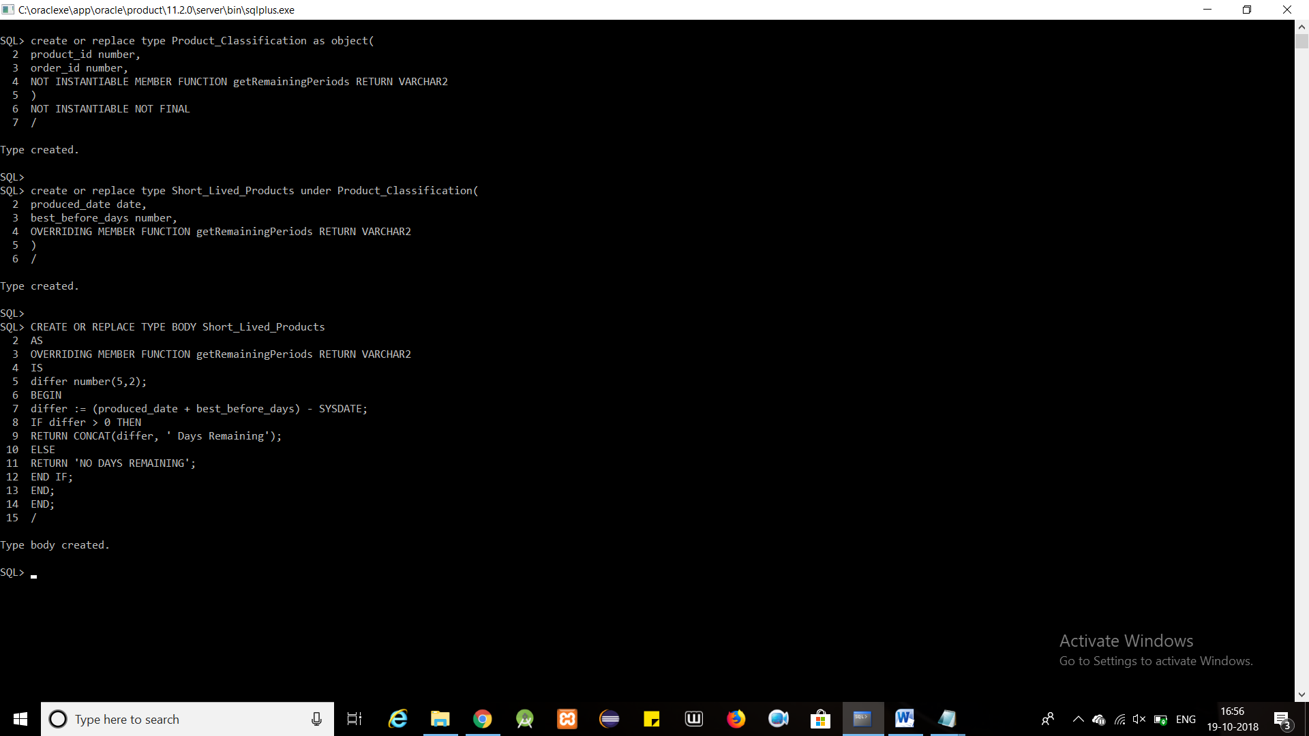

create or replace type Electronic_Products under Product_Classification(

manufacturing_date date,

warranty_period_months number,

OVERRIDING MEMBER FUNCTION getRemainingPeriods RETURN VARCHAR2

)

/

CREATE OR REPLACE TYPE BODY Electronic_Products

AS

OVERRIDING MEMBER FUNCTION getRemainingPeriods RETURN VARCHAR2

IS

BEGIN

RETURN CONCAT(warranty_period_months, ' Months Remaining');

END;

END;

/

create or replace type Other_Products under Product_Classification(

manufacturing_date date,

expiry_date date,

OVERRIDING MEMBER FUNCTION getRemainingPeriods RETURN VARCHAR2

)

/

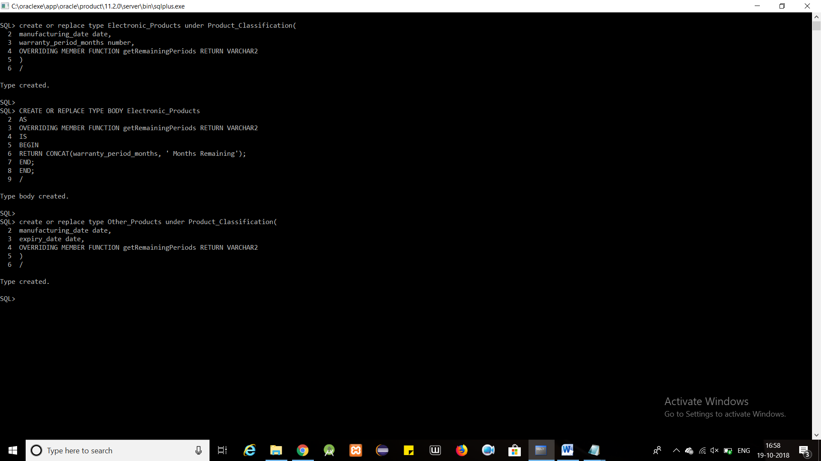

CREATE OR REPLACE TYPE BODY Other_Products

AS

OVERRIDING MEMBER FUNCTION getRemainingPeriods RETURN VARCHAR2

IS

differ number(5,2);

BEGIN

differ := MONTHS_BETWEEN(expiry_date, SYSDATE);

IF differ > 0 THEN

RETURN CONCAT(differ, ' Months Remaining');

ELSE

RETURN 'NO DAYS REMAINING';

END IF;

END;

END;

/

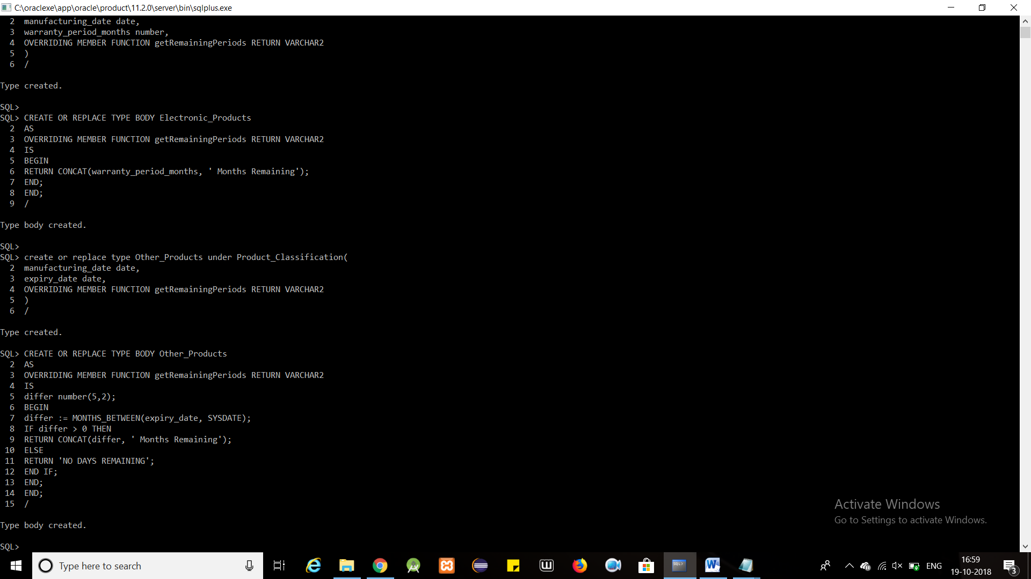

create or replace type Storage_Compartments as object(

s_compartment_id number,

s_compartment_name varchar2(30)

)

/

create or replace type Distribution_Compartments as object(

d_compartment_id number,

d_compartment_name varchar2(30)

)

/

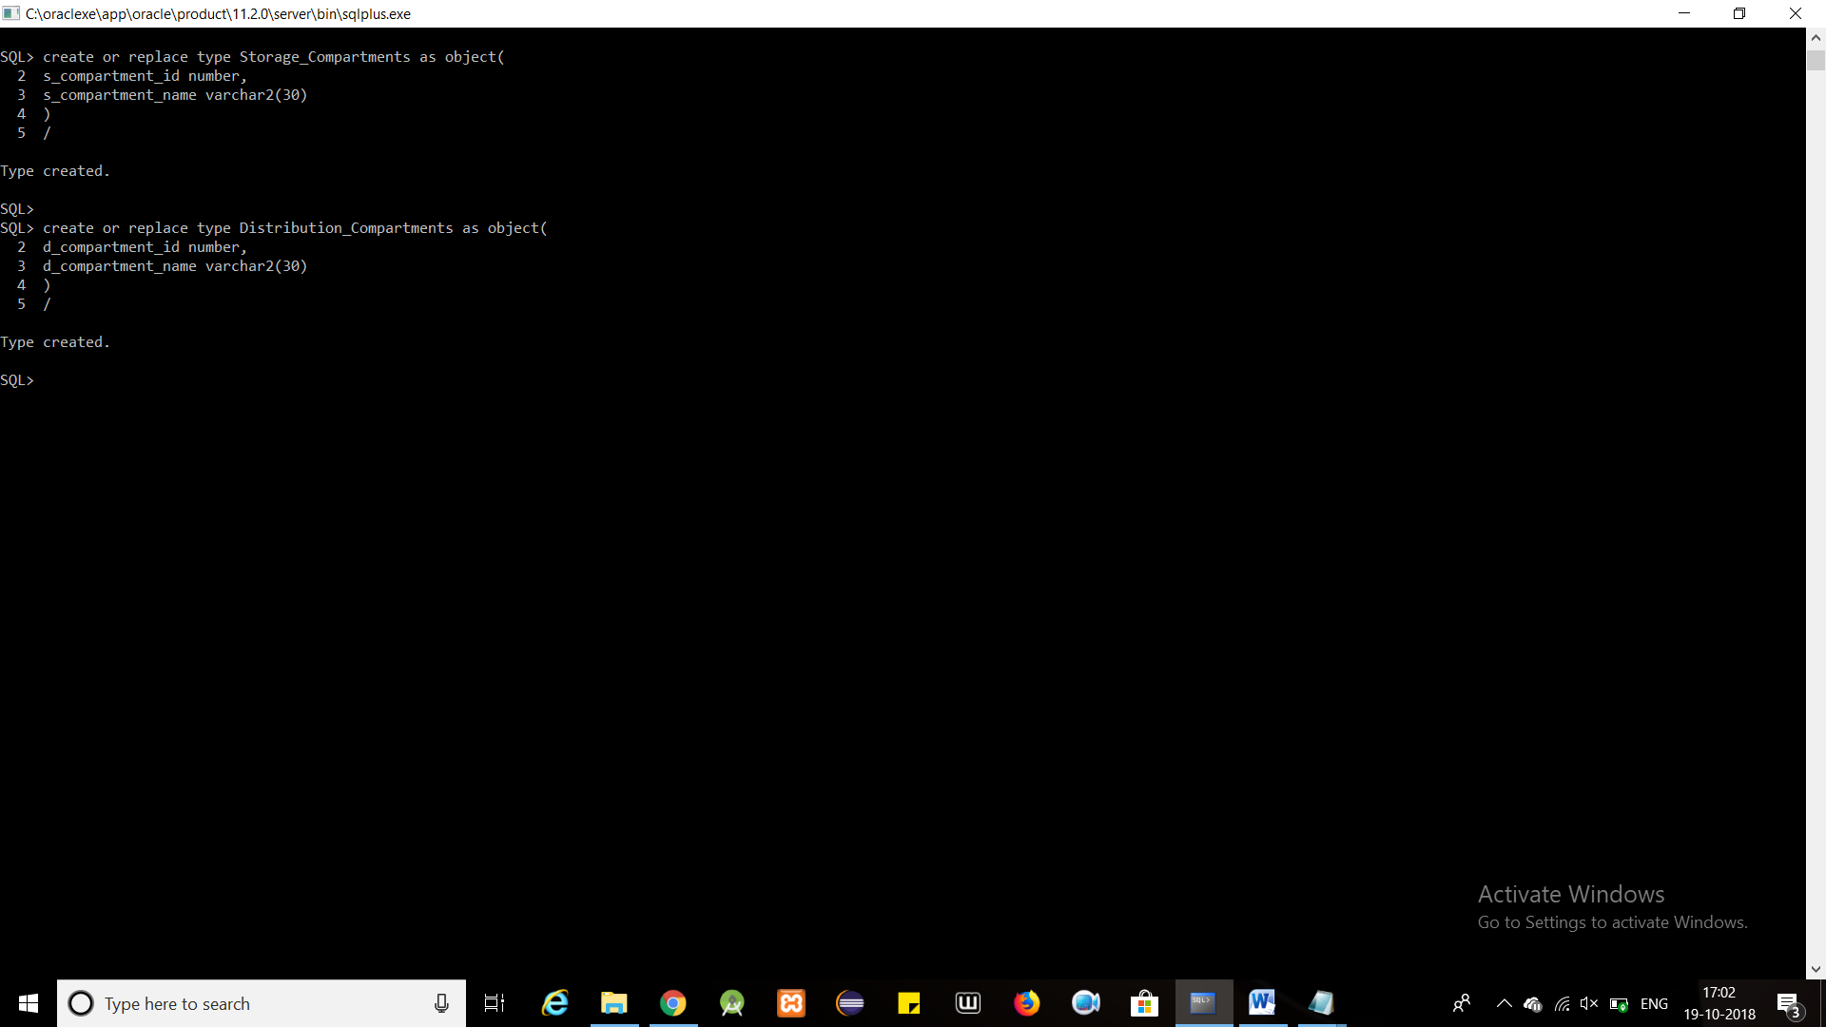

create or replace type Warehouse_Region as object(

region_id number ,

region_name varchar2(50) ,

warehouse_id number,

region_sd MDSYS.SDO_GEOMETRY

)

NOT FINAL

/

create or replace type StorageWarehouse_Region under Warehouse_Region(

storage_compartment_id number

)

/

create or replace type DistributionWarehouse_Region under Warehouse_Region(

distribution_compartment_id number

)

/

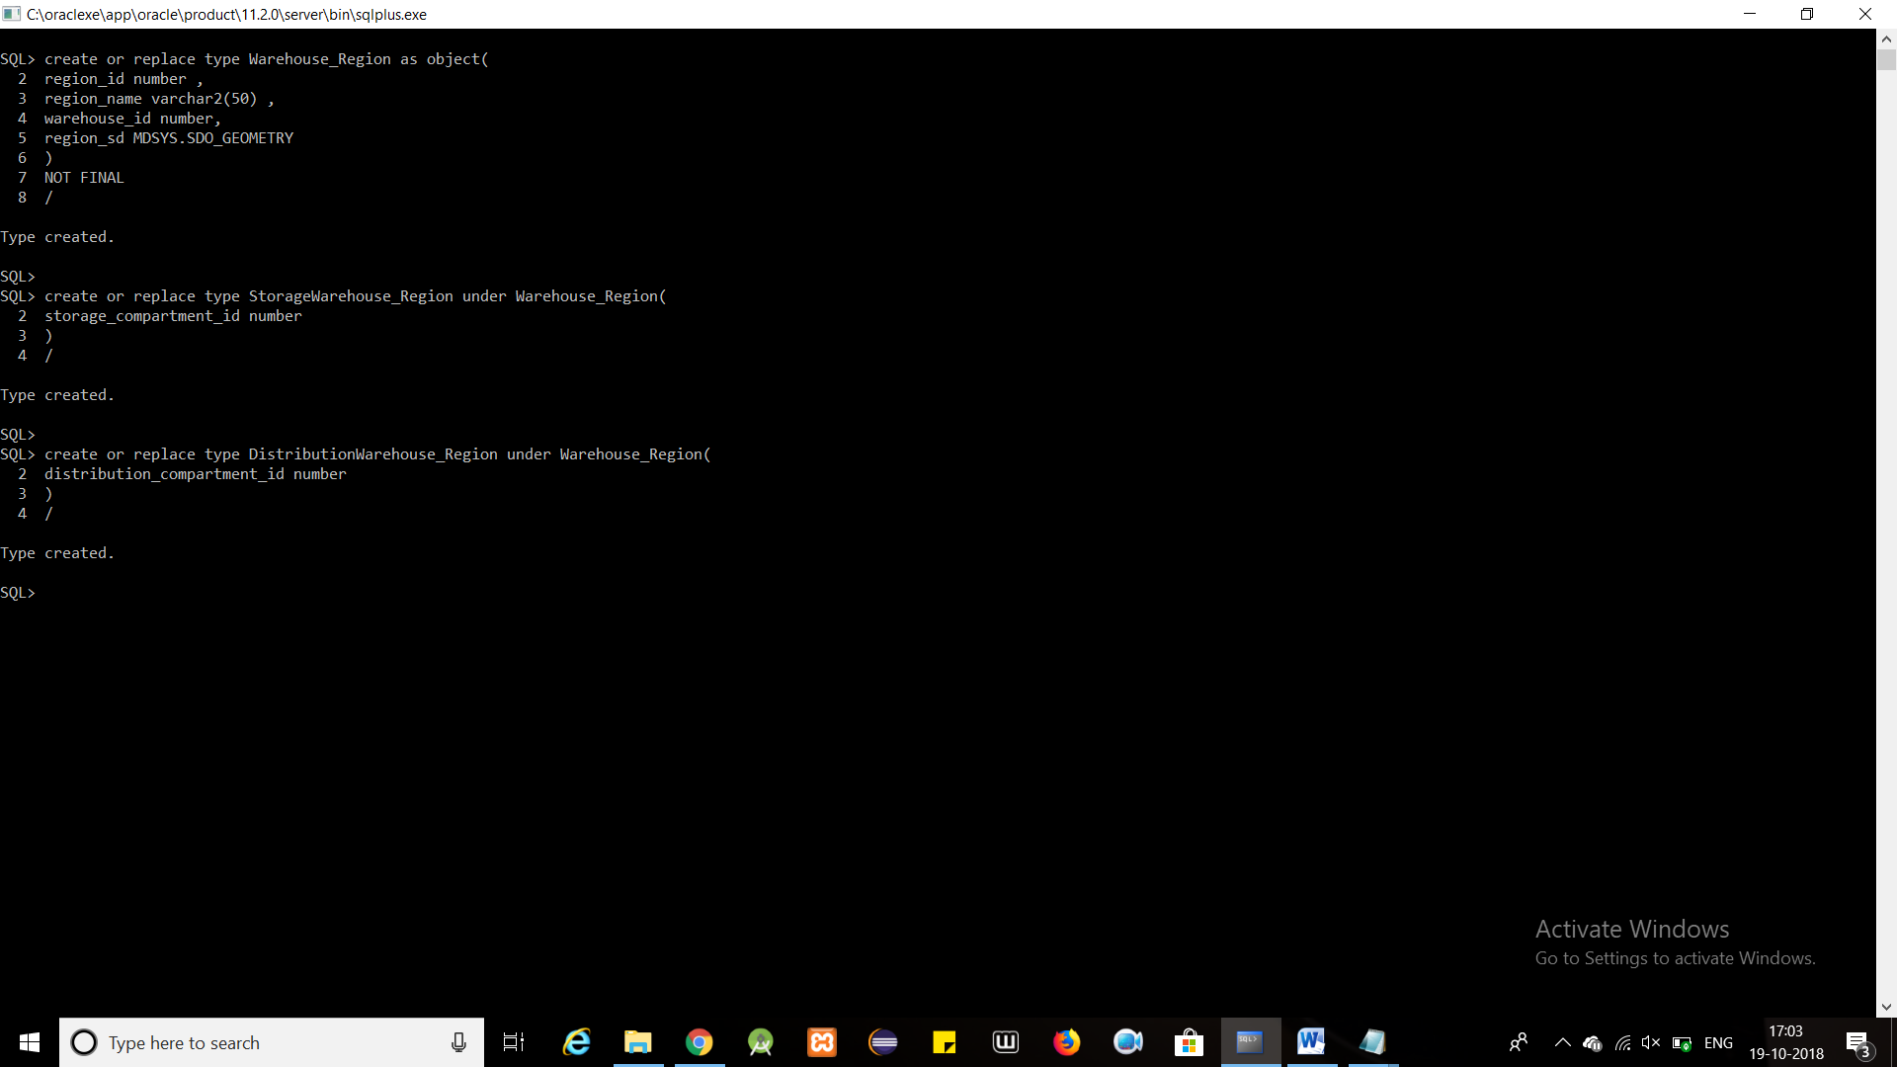

create or replace type ProductPurchaseDetails as object(

product_id number,

quantity number,

price number,

periods XMLTYPE

)

/

create or replace type ProductSalesDetails as object(

product_id number,

quantity number,

price number

)

/

create or replace type ProductTransportDetails as object(

sales_order_id number

)

/

create or replace type ProductPurchase as table of ProductPurchaseDetails

/

create or replace type ProductSales as table of ProductSalesDetails

/

create or replace type productTransport as table of ProductTransportDetails

/

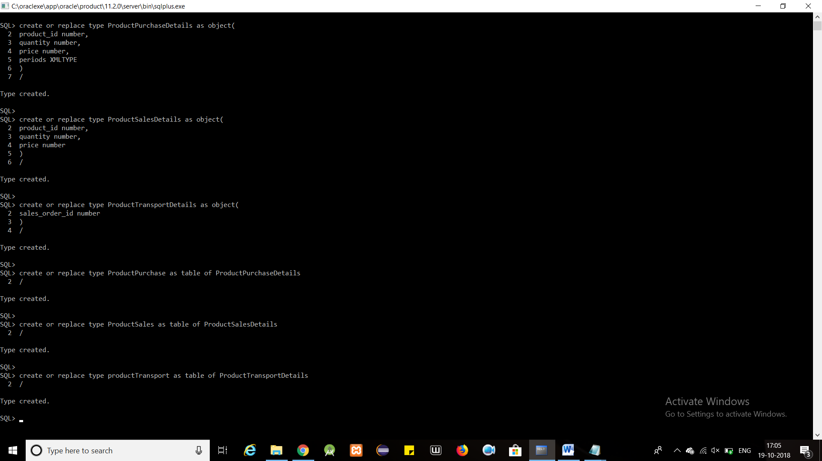

create or replace type Order_Details as object(

order_id number,

order_date timestamp

)

NOT FINAL

/

create or replace type Purchase_Order under Order_Details(

supplier_id number,

products ProductPurchase

)

/

create or replace type Sales_Order under Order_Details(

customer_id number,

products ProductSales,

isFaulty number(1),

isTransported number(1)

)

/

create or replace type Transport_Order under Order_Details(

transporter_id number,

products productTransport,

cost_per_km number,

kilometers number

)

/

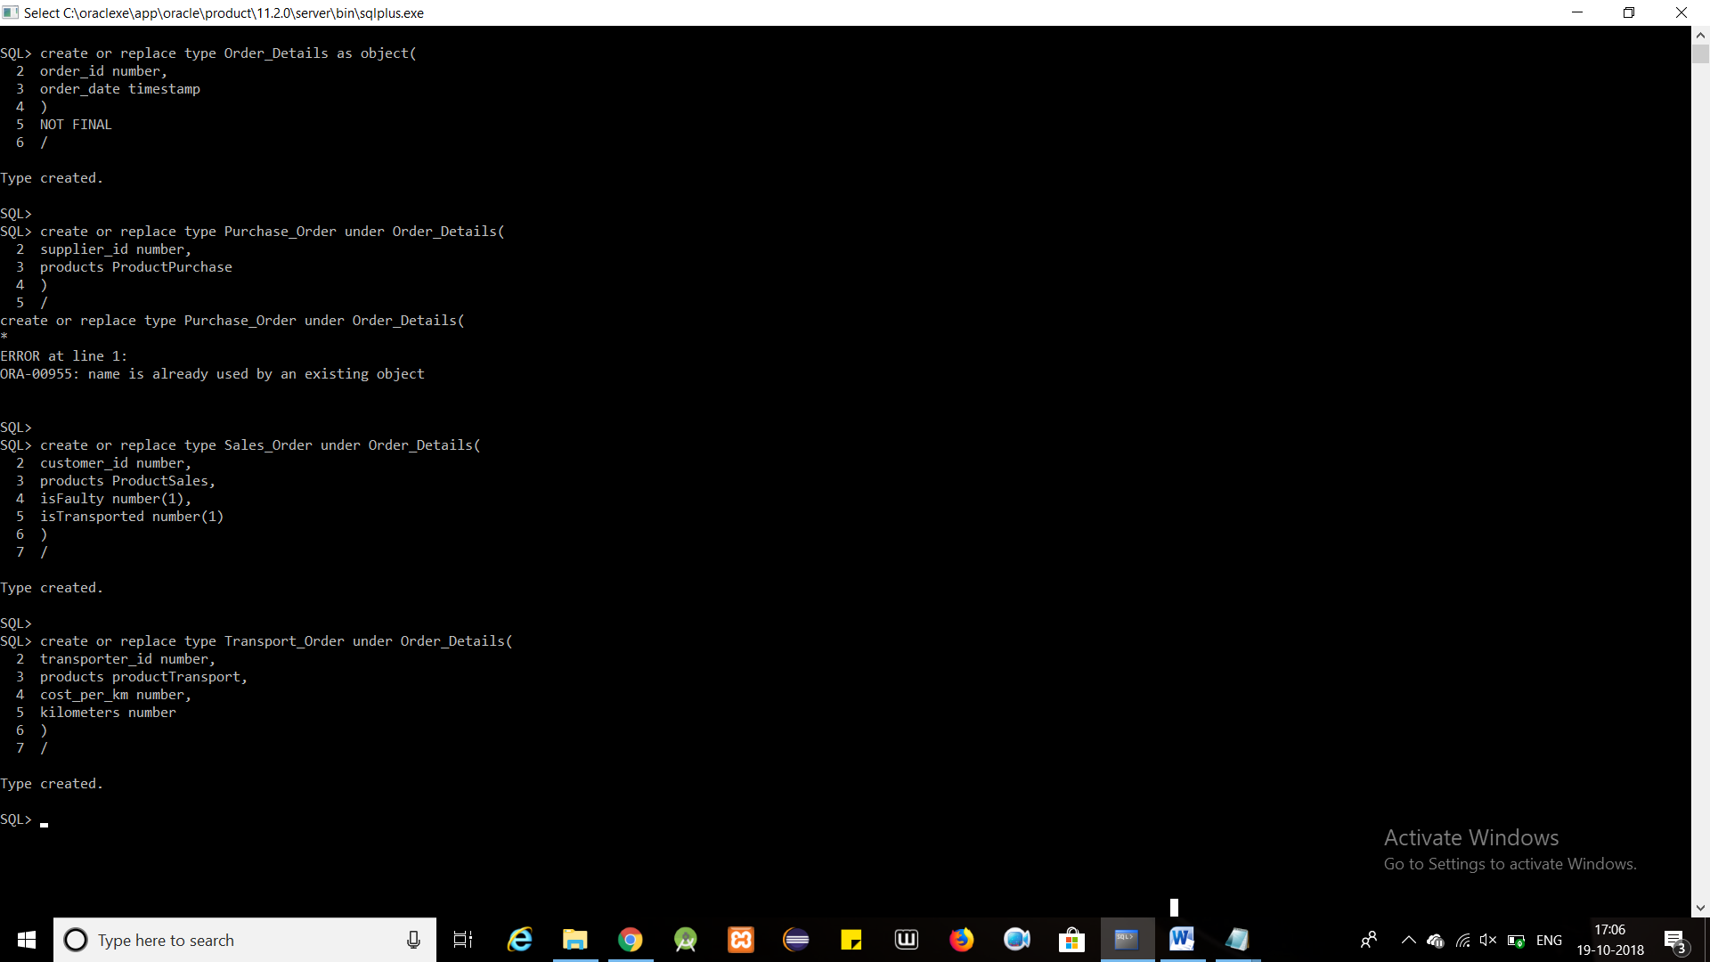

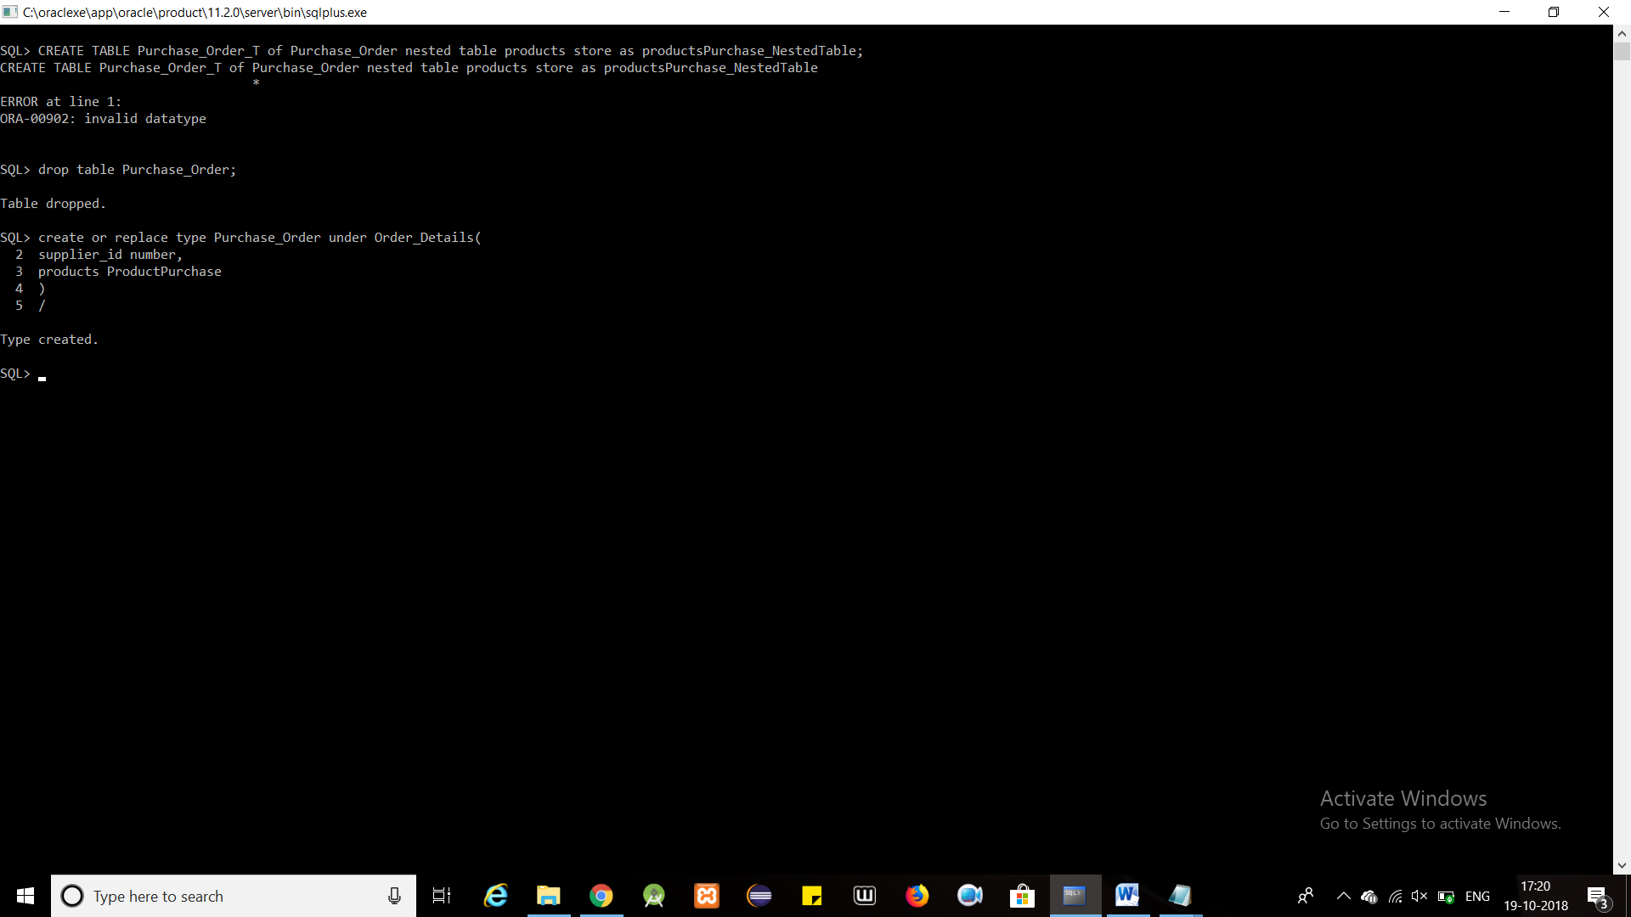



create or replace type Storage_Products as object(

region_id number,

product_id number,

quantity number

)

/

create or replace type Distribution_Products as object(

region_id number,

product_id number,

quantity number

)

/

create or replace type Allocation_Details as object(

allocation_id number,

region_id number,

product_id number

)

/

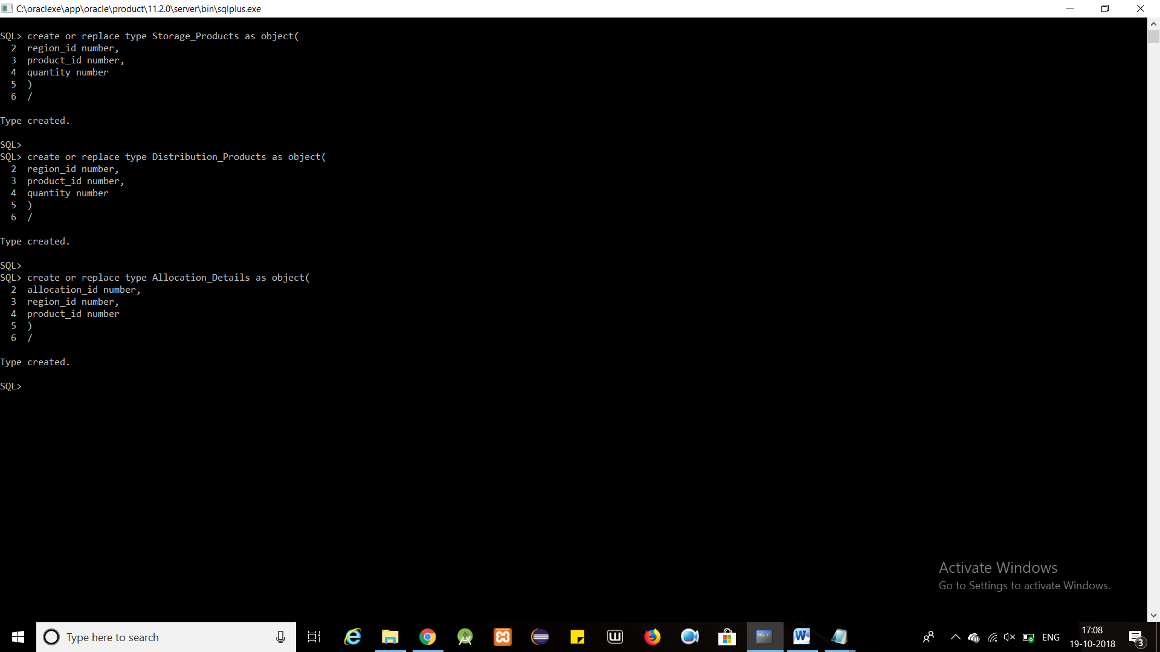

CREATE TABLE Supplier_Details_T of Supplier_Details;

CREATE TABLE Customer_Details_T of Customer_Details;

CREATE TABLE Transporter_Details_T of Transporter_Details;

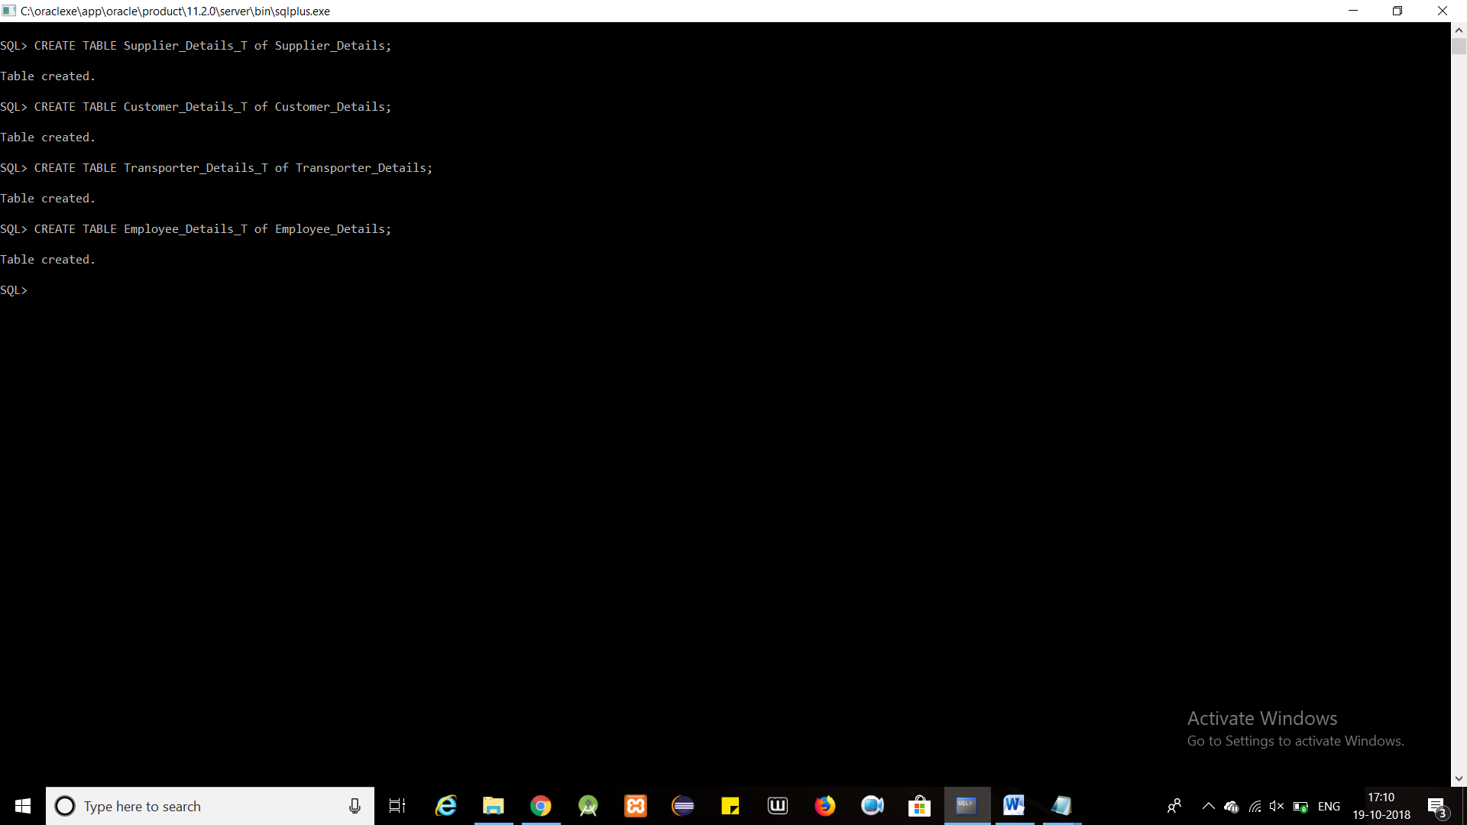

CREATE TABLE Product_Details_T of Product_Details;

CREATE TABLE Short_Lived_Products_T of Short_Lived_Products;

CREATE TABLE Electronic_Products_T of Electronic_Products;

CREATE TABLE Other_Products_T of Other_Products;

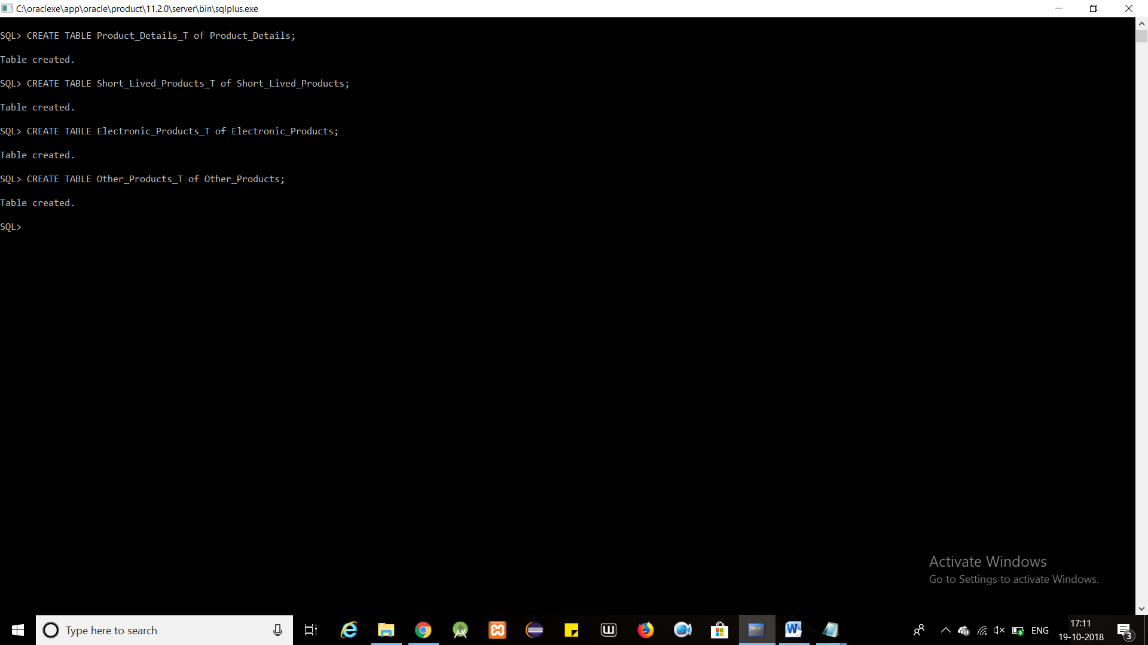

CREATE TABLE Storage_Compartments_T of Storage_Compartments;

CREATE TABLE Distribution_Compartments_T of Distribution_Compartments;

CREATE TABLE StorageWarehouse_Region_T of StorageWarehouse_Region;

CREATE TABLE DistributionWarehouse_Region_T of DistributionWarehouse_Region;

CREATE TABLE Allocation_Details_T of Allocation_Details;



CREATE TABLE Purchase_Order_T of Purchase_Order nested table products store as productsPurchase_NestedTable;

CREATE TABLE Sales_Order_T of Sales_Order nested table products store as productsSales_NestedTable;

CREATE TABLE Transport_Order_T of Transport_Order nested table products store as productsTransport_NestedTable;

CREATE TABLE Storage_Products_T of Storage_Products;

CREATE TABLE Distribution_Products_T of Distribution_Products;

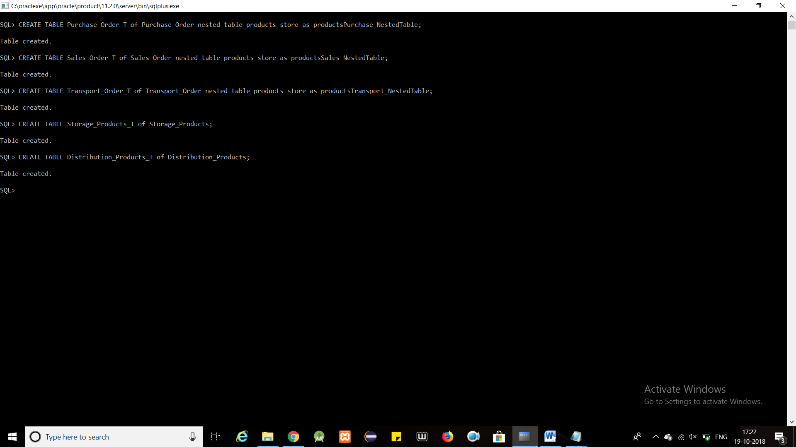

db.createCollection("Products");

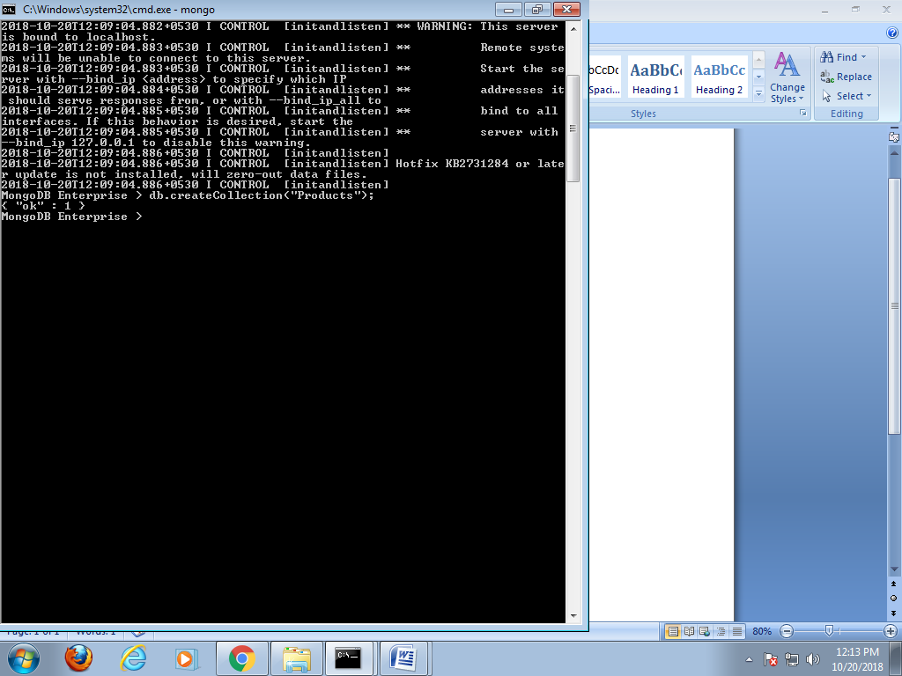

==================================================================

**INSERT**

INSERT INTO USER_SDO_GEOM_METADATA

VALUES (

'StorageWarehouse_Region_T',

'region_sd',

MDSYS.SDO_DIM_ARRAY(

MDSYS.SDO_DIM_ELEMENT('X', 0, 200, 0.005),

MDSYS.SDO_DIM_ELEMENT('Y', 0, 200, 0.005)

),

NULL

);

INSERT INTO USER_SDO_GEOM_METADATA

VALUES (

'DistributionWarehouse_Region_T',

'region_sd',

MDSYS.SDO_DIM_ARRAY(

MDSYS.SDO_DIM_ELEMENT('X', 0, 200, 0.005),

MDSYS.SDO_DIM_ELEMENT('Y', 0, 200, 0.005)

),

NULL

);



CREATE INDEX storage_SPID

ON StorageWarehouse_Region_T(region_sd)

INDEXTYPE IS MDSYS.SPATIAL_INDEX;

CREATE INDEX distribution_SPID

ON DistributionWarehouse_Region_T(region_sd)

INDEXTYPE IS MDSYS.SPATIAL_INDEX;



insert into Supplier_Details_T values( Supplier_Details(

Supplier_Details_Seq.nextval,

FullName('XYZ','LLC'),

loc(

Location('Thane','Thane','Maharastra',400605),

Location('Vadodara','Vadodara','Gujarat',401706)

),

pno(

PhoneNo(9167089770),

PhoneNo(9999999999)

),

0

));

insert into Supplier_Details_T values( Supplier_Details(

Supplier_Details_Seq.nextval,

FullName('ABC','Ltd.'),

loc(

Location('Mumbai','Mumbai','Maharastra',400601)

),

pno(

PhoneNo(9667889777),

PhoneNo(9898989898)

),

0

));

insert into Supplier_Details_T values( Supplier_Details(

Supplier_Details_Seq.nextval,

FullName('LMN','Co.'),

loc(

Location('Bangalore','Bangalore City','Karnataka',400801)

),

pno(

PhoneNo(8777787777)

),

0

));

insert into Supplier_Details_T values( Supplier_Details(

Supplier_Details_Seq.nextval,

FullName('PQR','Enterprise'),

loc(

Location('Bangalore','Bangalore City','Karnataka',400801)

),

pno(

PhoneNo(9693969366)

),

0

));

insert into Supplier_Details_T values( Supplier_Details(

Supplier_Details_Seq.nextval,

FullName('UVW','Corp.'),

loc(

Location('Vadodara','Vadodara','Gujarat',401706)

),

pno(

PhoneNo(9999966666)

),

0

));

insert into Supplier_Details_T values( Supplier_Details(

Supplier_Details_Seq.nextval,

FullName('XYZ','Company'),

loc(

Location('Varanasi','Varanasi','Uttar Pradesh',465395)

),

pno(

PhoneNo(9764310134)

),

0

));

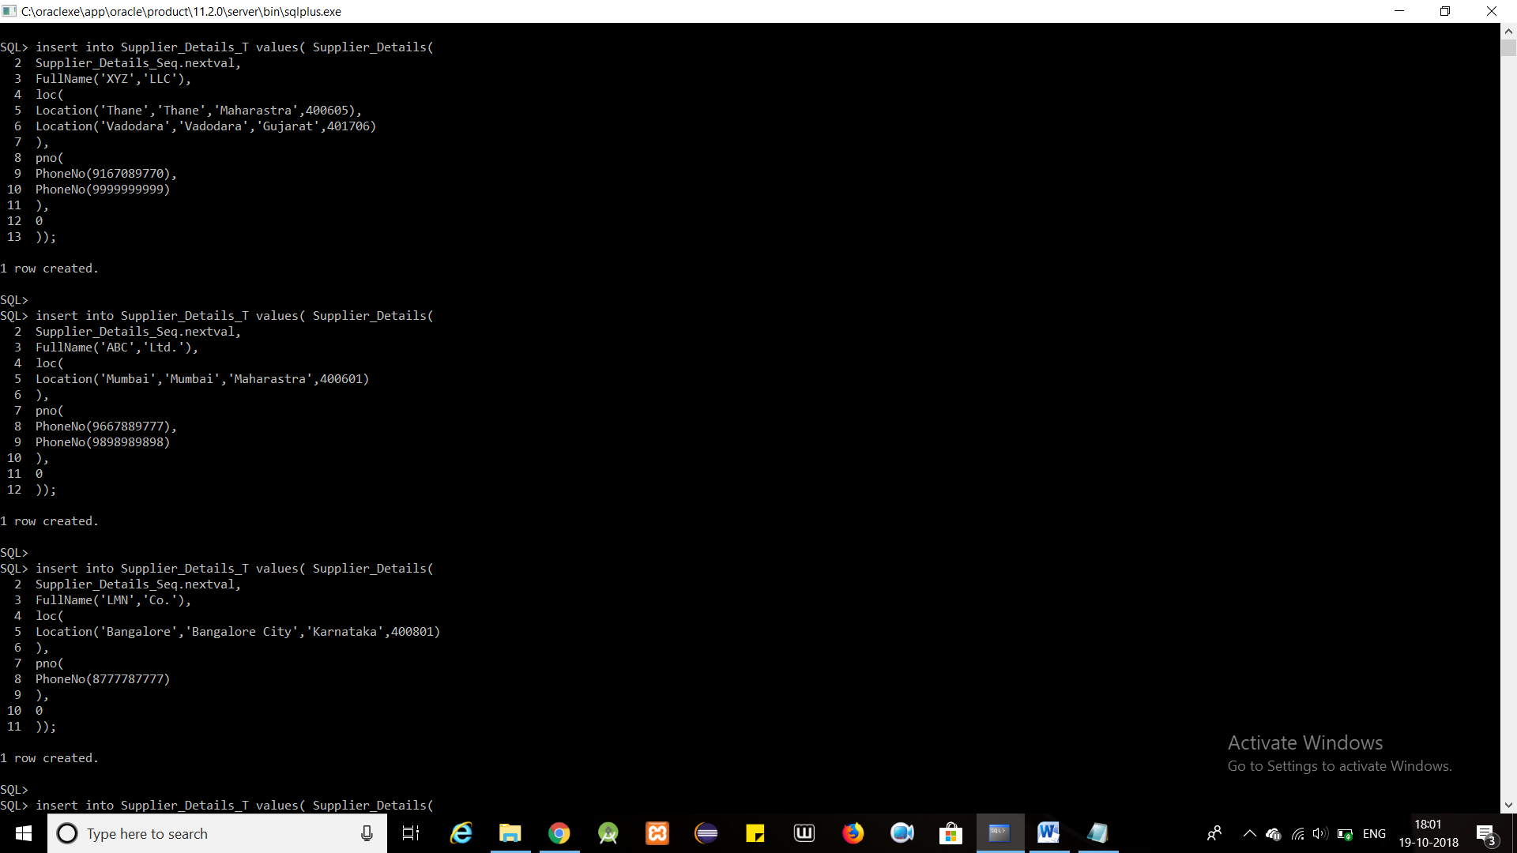

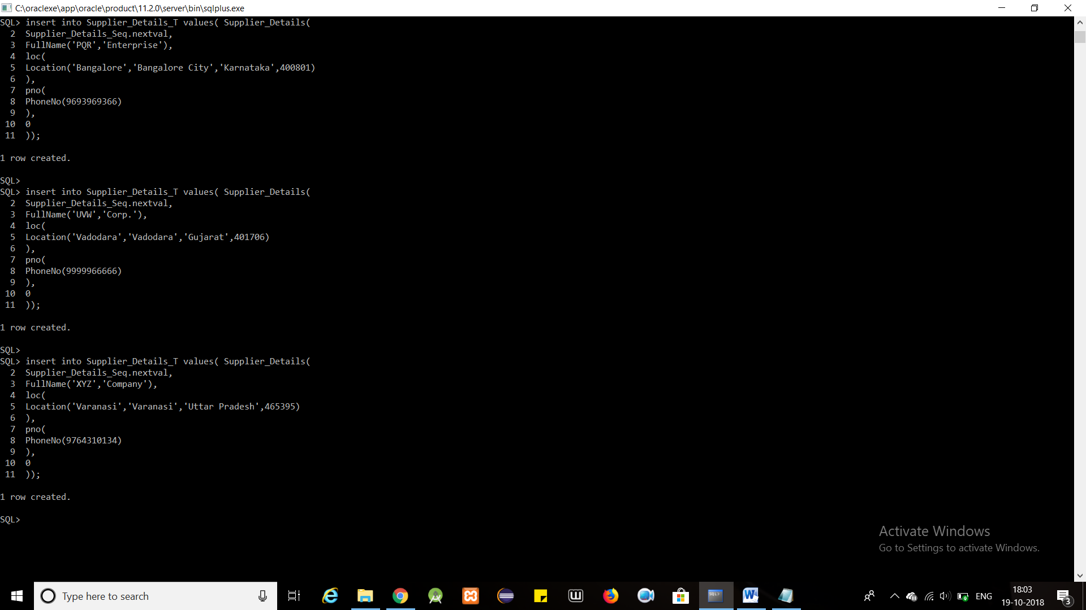

insert into Customer_Details_T values( Customer_Details(

Customer_Details_Seq.nextval,

FullName('Rahul','Singh'),

loc(

Location('Dadar','Mumbai','Maharashtra',400333),

Location('Thane','Thane City','Maharashtra',400666),

Location('CSMT','Mumbai','Maharashtra',400999)

),

pno(

PhoneNo(9797979797)

),

0

));

insert into Customer_Details_T values( Customer_Details(

Customer_Details_Seq.nextval,

FullName('Sanjana','GopalKrishna'),

loc(

Location('Vadodara','Vadodara','Gujarat',431679)

),

pno(

PhoneNo(9636363669)

),

0

));

insert into Customer_Details_T values( Customer_Details(

Customer_Details_Seq.nextval,

FullName('Rahana','Singh'),

loc(

Location('Dombivli','Thane','Maharashtra',300603)

),

pno(

PhoneNo(9639333999)

),

0

));

insert into Customer_Details_T values( Customer_Details(

Customer_Details_Seq.nextval,

FullName('Ashutosh','Singh'),

loc(

Location('Mumbai','Mumbai','Maharastra',400601)

),

pno(

PhoneNo(9794613258),

PhoneNo(1324654897)

),

0

));

insert into Customer_Details_T values( Customer_Details(

Customer_Details_Seq.nextval,

FullName('Unmesh','Kadam'),

loc(

Location('Bangalore','Bangalore City','Karnataka',400801)

),

pno(

PhoneNo(8795462130)

),

0

));

insert into Customer_Details_T values( Customer_Details(

Customer_Details_Seq.nextval,

FullName('Saurabh','Pawar'),

loc(

Location('Bangalore','Bangalore City','Karnataka',400801)

),

pno(

PhoneNo(9137546820)

),

0

));

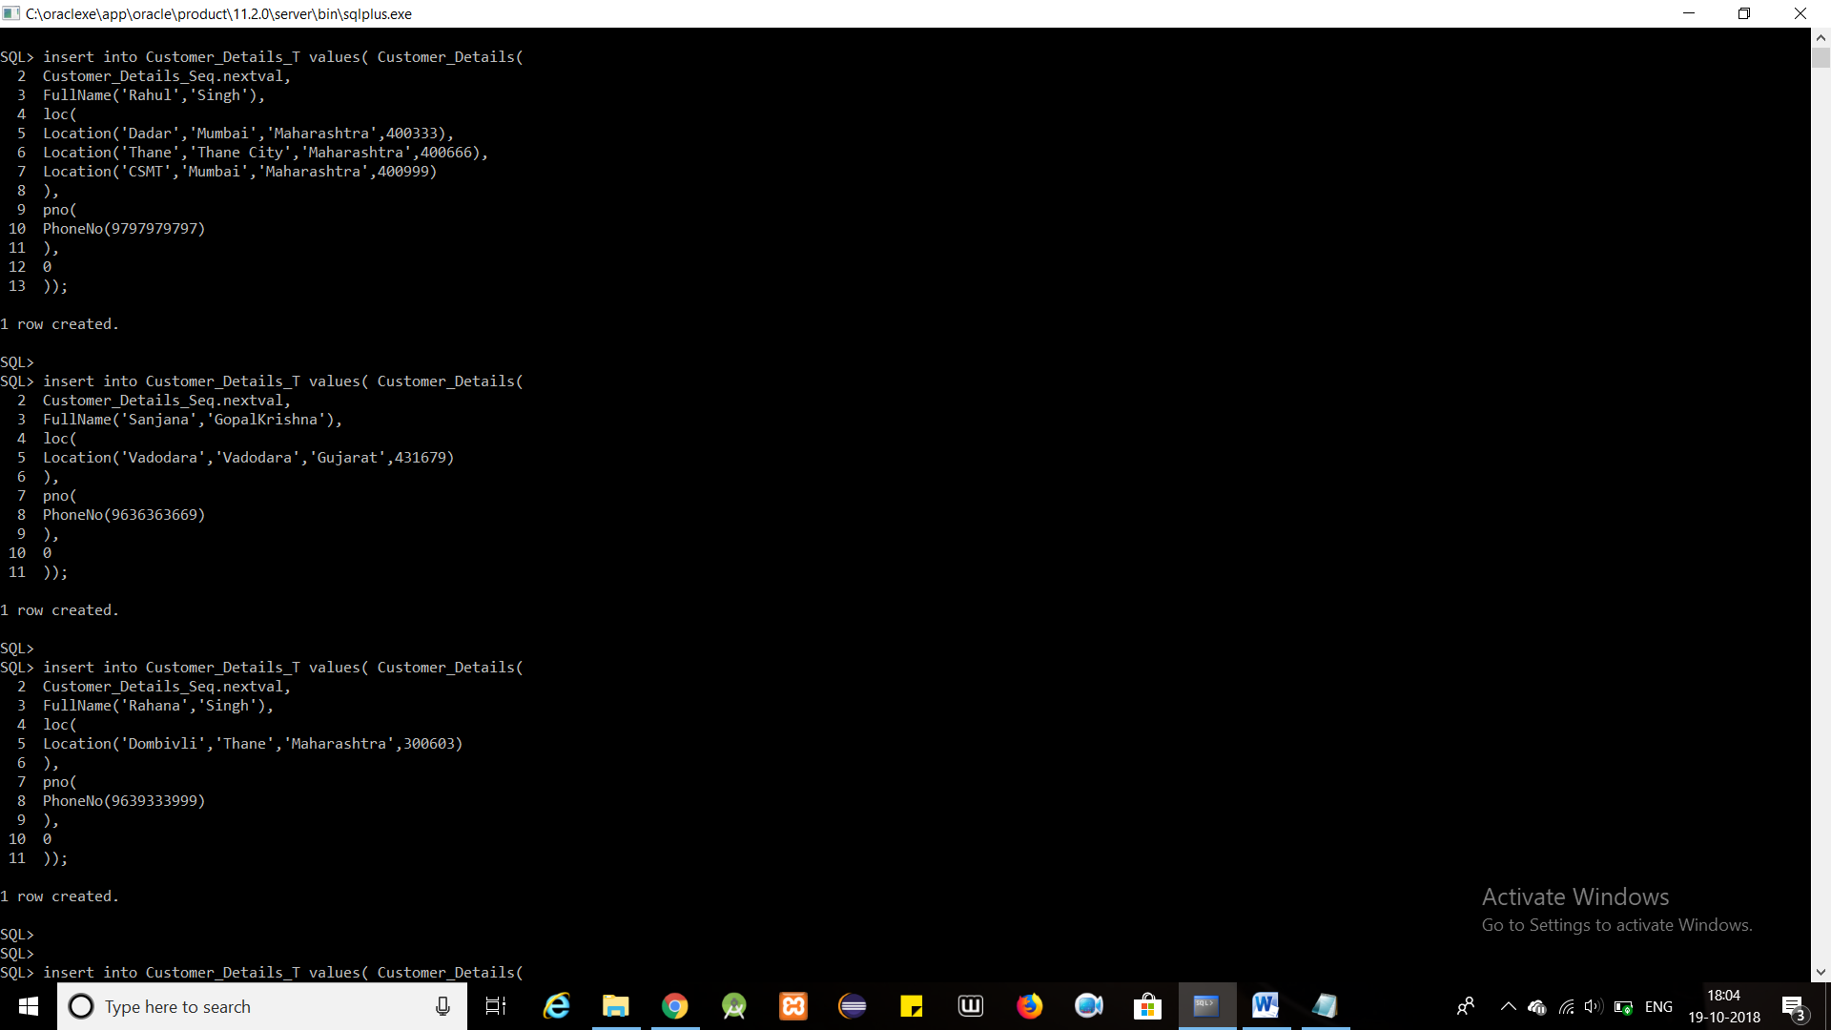

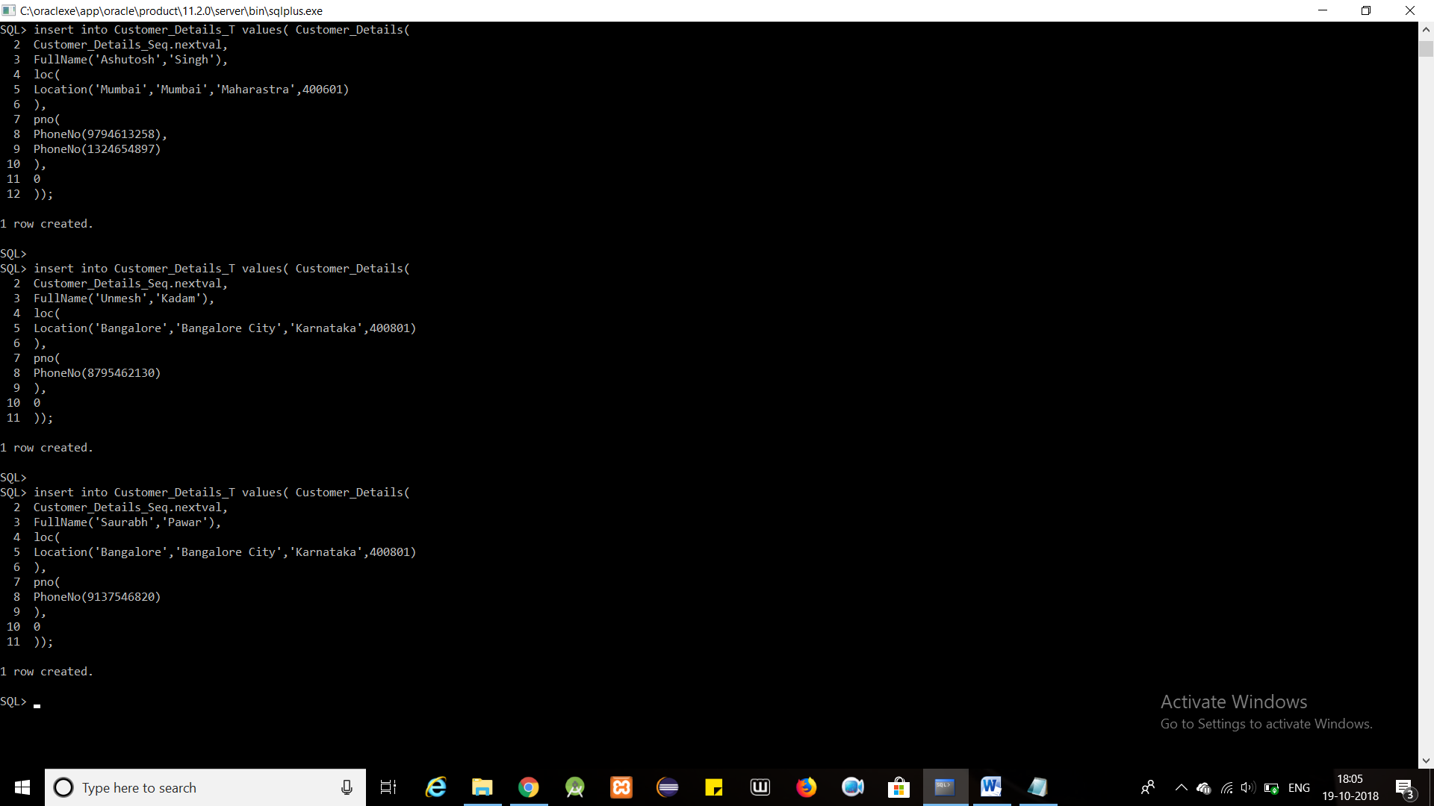

insert into Transporter_Details_T values( Transporter_Details(

Transporter_Details_Seq.nextval,

FullName('A','Transporter'),

loc(

Location('Kalyan','Thane','Maharastra',400615)

),

pno(

PhoneNo(9111111111)

),

20,1,1

));

insert into Transporter_Details_T values( Transporter_Details(

Transporter_Details_Seq.nextval,

FullName('B','Transporter'),

loc(

Location('Kalyan','Thane','Maharastra',400615)

),

pno(

PhoneNo(933993396)

),

15,0,1

));

insert into Transporter_Details_T values( Transporter_Details(

Transporter_Details_Seq.nextval,

FullName('C','Transporter'),

loc(

Location('Ahemdabad','Ahemdabad City','Gujarat',401716)

),

pno(

PhoneNo(8888888888)

),

16,1,0

));

insert into Transporter_Details_T values( Transporter_Details(

Transporter_Details_Seq.nextval,

FullName('D','Transporter'),

loc(

Location('Kalyan','Thane','Maharastra',400615)

),

pno(

PhoneNo(9456789421)

),

10,0,0

));

insert into Transporter_Details_T values( Transporter_Details(

Transporter_Details_Seq.nextval,

FullName('E','Transporter'),

loc(

Location('Kalyan','Thane','Maharastra',400615)

),

pno(

PhoneNo(9894561230)

),

18,1,1

));

insert into Transporter_Details_T values( Transporter_Details(

Transporter_Details_Seq.nextval,

FullName('F','Transporter'),

loc(

Location('Ahemdabad','Ahemdabad City','Gujarat',401716)

),

pno(

PhoneNo(6666666666)

),

21,1,0

));

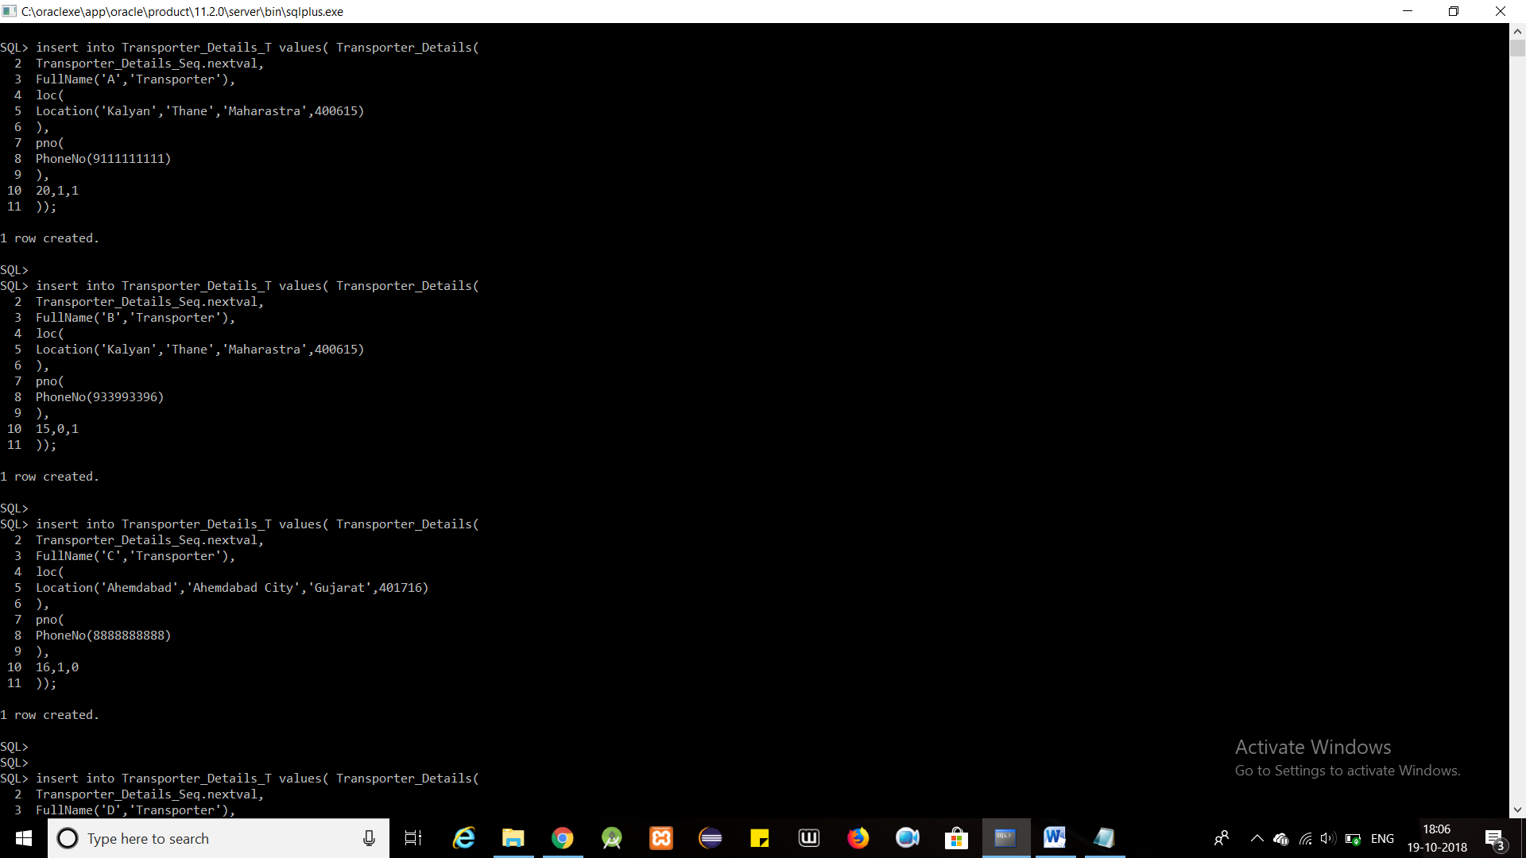

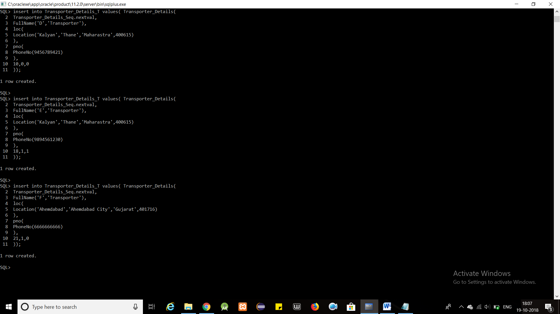

**PROCEDURE FOR INSERTING IMAGE**

CREATE OR REPLACE DIRECTORY IMAGE_LOCATION_PRODUCT AS 'C:\Users\Rahul\Desktop\ADBMS Project\Product_Image\\'

/

CREATE OR REPLACE PROCEDURE Product_Insert

(

p_name IN Product_Details_T.name%TYPE,

p_details IN Product_Details_T.details%TYPE,

p_image_name varchar2,

p_type IN Product_Details_T.productType%TYPE

)

IS

p_bfile BFILE;

p_blob BLOB;

BEGIN

INSERT INTO Product_Details_T VALUES(Product_Details(Products_Seq.nextval, p_name, p_details, EMPTY_BLOB(), p_type)) RETURN image INTO p_blob;

p_bfile := BFILENAME('IMAGE_LOCATION_PRODUCT', p_image_name);

DBMS_LOB.fileopen(p_bfile, DBMS_LOB.file_readonly);

DBMS_LOB.loadfromfile(p_blob, p_bfile, DBMS_LOB.getlength(p_bfile));

DBMS_LOB.fileclose(p_bfile);

COMMIT;

END;

/

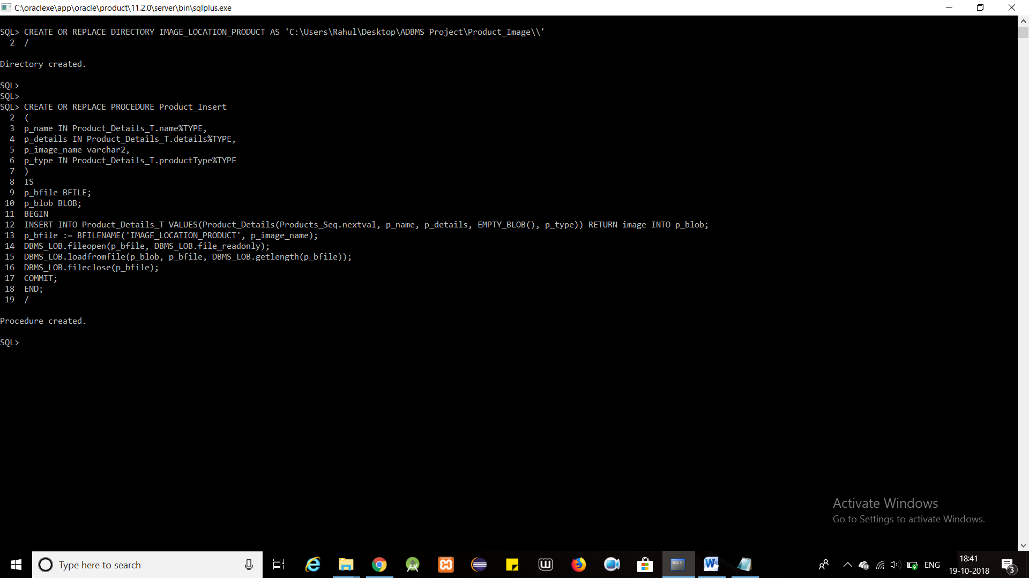

EXECUTE Product_Insert('Bread', XMLTYPE('<description> <area>5</area> <price>40</price> <is_delicate>0</is_delicate> <needs_temperature_control>1</needs_temperature_control> </description>'), 'p1.jpg','ShortLived' );

EXECUTE Product_Insert('Milk', XMLTYPE('<description> <area>4</area> <price>30</price> <is_delicate>1</is_delicate> <needs_temperature_control>1</needs_temperature_control> </description>'), 'p2.jpeg','ShortLived' );

EXECUTE Product_Insert('Moto G4 Plus', XMLTYPE('<description> <area>5</area> <price>14000</price> <is_delicate>0</is_delicate> <needs_temperature_control>0</needs_temperature_control> <features> <camera>15mp</camera> <ram>2gb</ram> </features> </description>'), 'p3.jpeg','Electronic');

EXECUTE Product_Insert('Dell Inspiron', XMLTYPE('<description> <area>8</area> <price>40000</price> <is_delicate>0</is_delicate> <needs_temperature_control>1</needs_temperature_control> <features> <camera>2mp</camera> <ram>4gb</ram> <processor>Intel i3</processor> </features> </description>'), 'p4.jpg','Electronic' );

EXECUTE Product_Insert('Denim', XMLTYPE('<description> <area>8</area> <price>1000</price> <is_delicate>0</is_delicate> <needs_temperature_control>0</needs_temperature_control> </description>'), 'p5.jpg','Other' );

EXECUTE Product_Insert('Biscuits', XMLTYPE('<description> <area>3</area> <price>50</price> <is_delicate>1</is_delicate> <needs_temperature_control>0</needs_temperature_control> </description>'), 'p6.jpg','Other' );

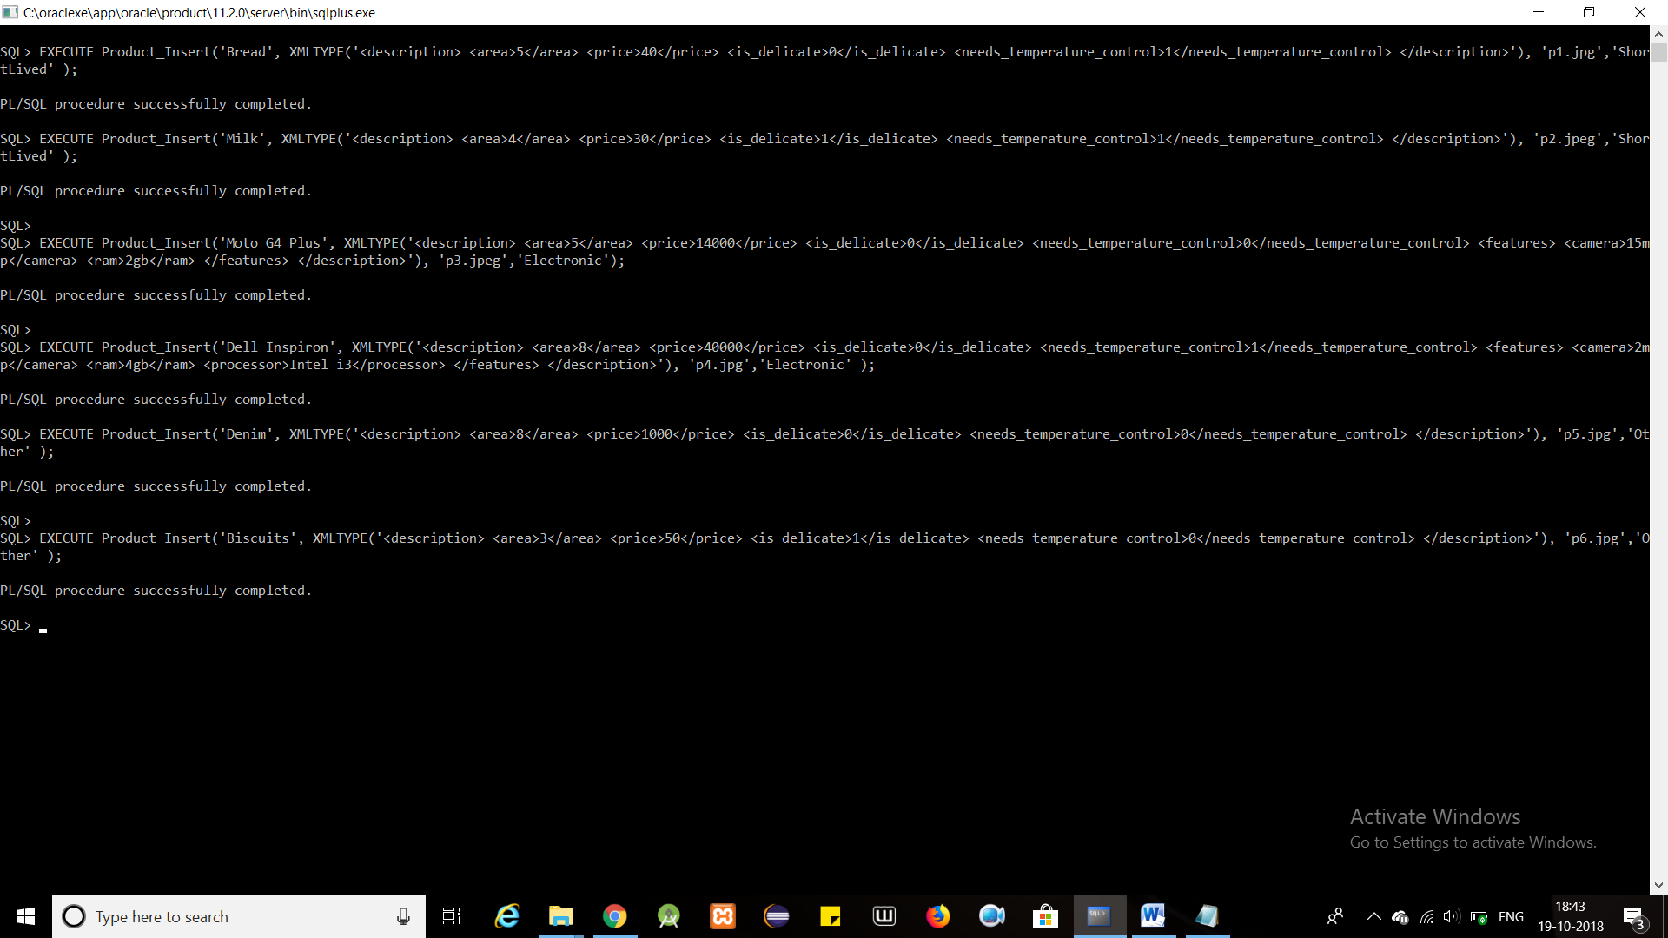

insert into Storage_Compartments_T values(Storage_Compartments_Seq.nextval, 'Normal');

insert into Storage_Compartments_T values(Storage_Compartments_Seq.nextval, 'Delicate');

insert into Storage_Compartments_T values(Storage_Compartments_Seq.nextval, 'Hot');

insert into Storage_Compartments_T values(Storage_Compartments_Seq.nextval, 'Cold');

insert into Distribution_Compartments_T values(Distribution_Compartments_Seq.nextval, 'Faulty');

insert into Distribution_Compartments_T values(Distribution_Compartments_Seq.nextval, 'Normal');

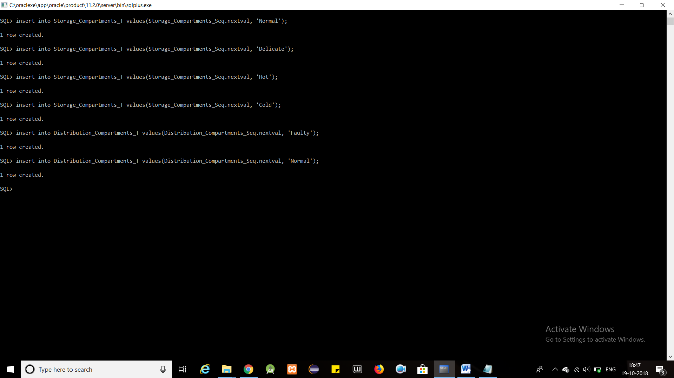

insert into StorageWarehouse_Region_T values(StorageWarehouse_Region(

StorageW_Region_Seq.nextval,'Normal Storage Warehouse1',1,

MDSYS.SDO_GEOMETRY(

2003,

NULL,

NULL,

MDSYS.SDO_ELEM_INFO_ARRAY(1,1003,3),

MDSYS.SDO_ORDINATE_ARRAY(40,120,170,160)

),

1

));

insert into StorageWarehouse_Region_T values(StorageWarehouse_Region(

StorageW_Region_Seq.nextval,'Delicate Storage Warehouse1', 1,

MDSYS.SDO_GEOMETRY(

2003,

NULL,

NULL,

MDSYS.SDO_ELEM_INFO_ARRAY(1,1003,4),

MDSYS.SDO_ORDINATE_ARRAY(60,120,90,90,60,60)

),

2

));

insert into StorageWarehouse_Region_T values(StorageWarehouse_Region(

StorageW_Region_Seq.nextval,'Hot Storage Warehouse2',2,

MDSYS.SDO_GEOMETRY(

2003,

NULL,

NULL,

MDSYS.SDO_ELEM_INFO_ARRAY(1,1003,1),

MDSYS.SDO_ORDINATE_ARRAY(140,110,140,140,170,160,170,130,140,110)

),

3

));

insert into StorageWarehouse_Region_T values(StorageWarehouse_Region(

StorageW_Region_Seq.nextval,'Cold Storage Warehouse2', 2,

MDSYS.SDO_GEOMETRY(

2003,

NULL,

NULL,

MDSYS.SDO_ELEM_INFO_ARRAY(1,1003,1),

MDSYS.SDO_ORDINATE_ARRAY(140,110,170,100,170,70,140,80,140,110)

),

4

));

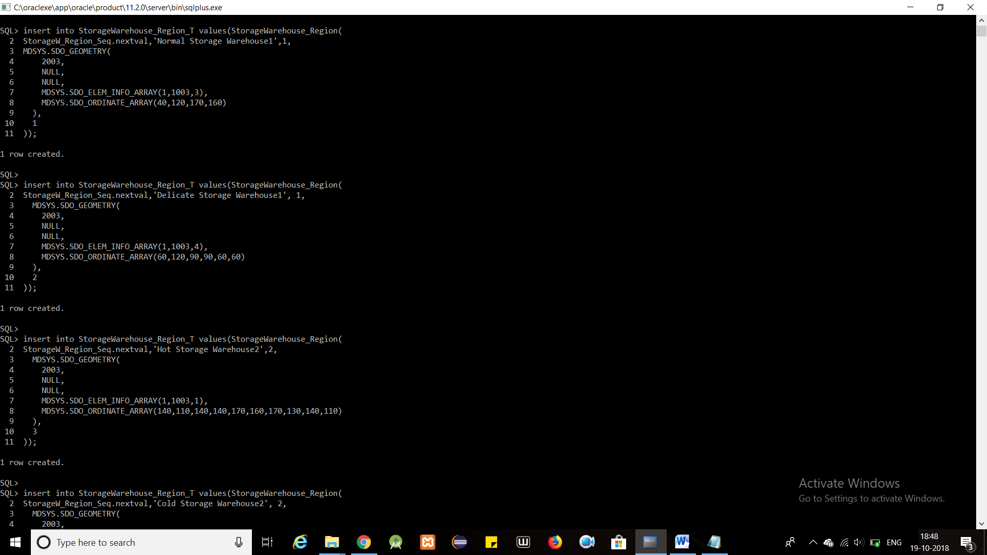

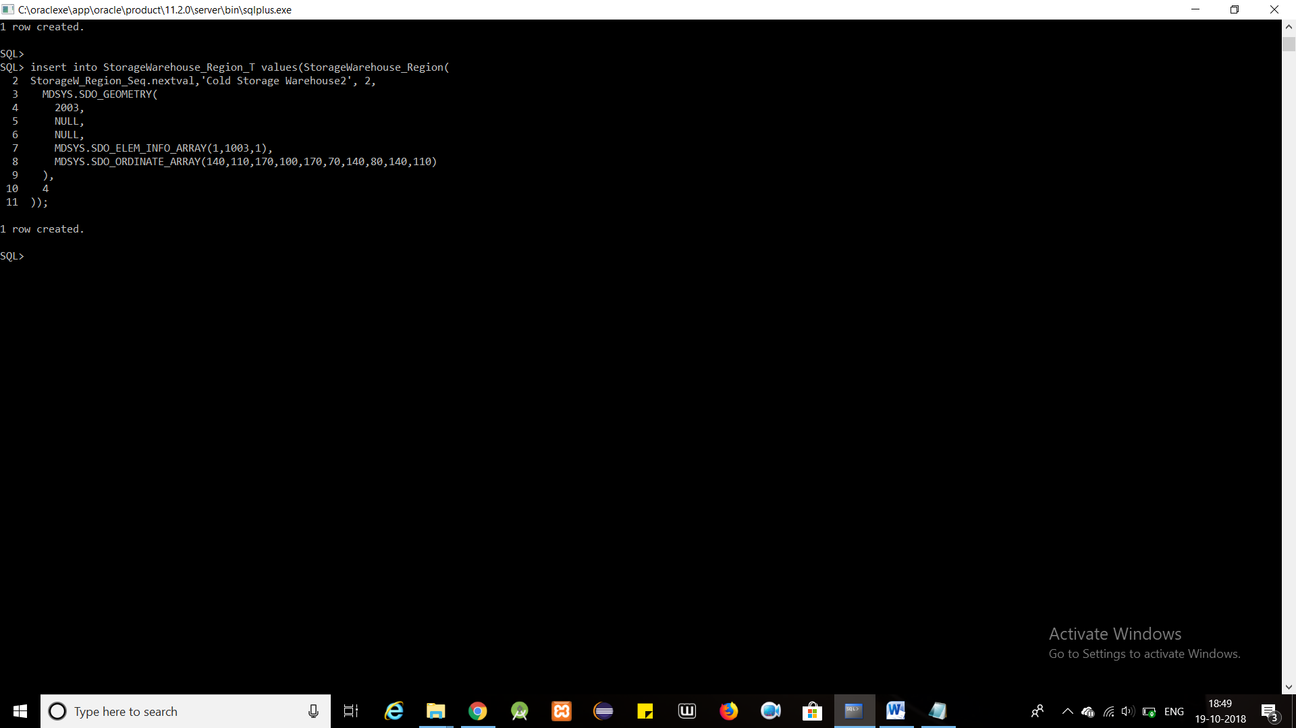

insert into DistributionWarehouse_Region_T values(DistributionWarehouse_Region(

DistributionW_Region_Seq.nextval,'Faulty Distribution Warehouse',3,

MDSYS.SDO_GEOMETRY(

2003,

NULL,

NULL,

MDSYS.SDO_ELEM_INFO_ARRAY(1,1003,3),

MDSYS.SDO_ORDINATE_ARRAY(50,20,90,30)

),

1

));

insert into DistributionWarehouse_Region_T values(DistributionWarehouse_Region(

DistributionW_Region_Seq.nextval,'Normal Distribution Warehouse',3,

MDSYS.SDO_GEOMETRY(

2003,

NULL,

NULL,

MDSYS.SDO_ELEM_INFO_ARRAY(1,1003,3),

MDSYS.SDO_ORDINATE_ARRAY(100,20,130,30)

),

2

));

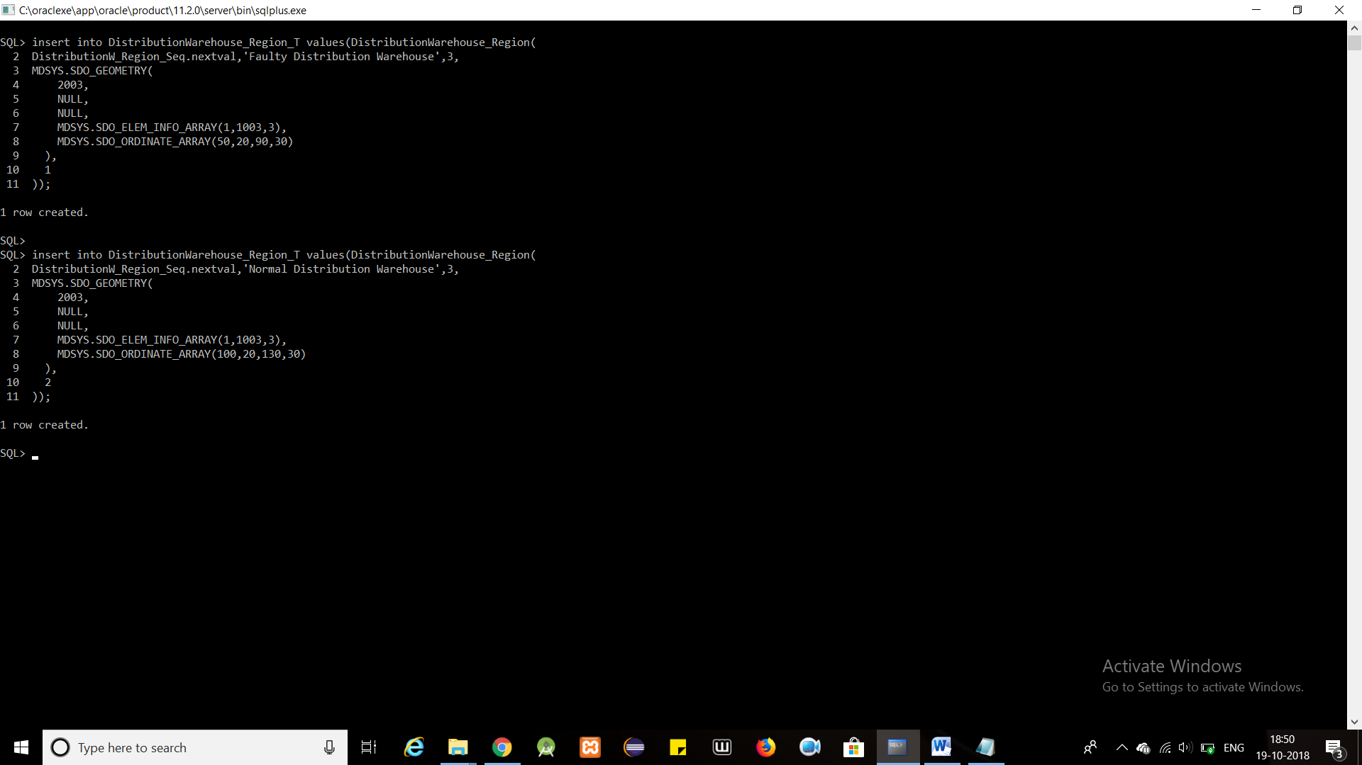

insert into Allocation_Details_T values(Allocation_Details_Seq.nextval,4,1);

insert into Allocation_Details_T values(Allocation_Details_Seq.nextval,4,2);

insert into Allocation_Details_T values(Allocation_Details_Seq.nextval,1,3);

insert into Allocation_Details_T values(Allocation_Details_Seq.nextval,4,4);

insert into Allocation_Details_T values(Allocation_Details_Seq.nextval,1,5);

insert into Allocation_Details_T values(Allocation_Details_Seq.nextval,2,6);

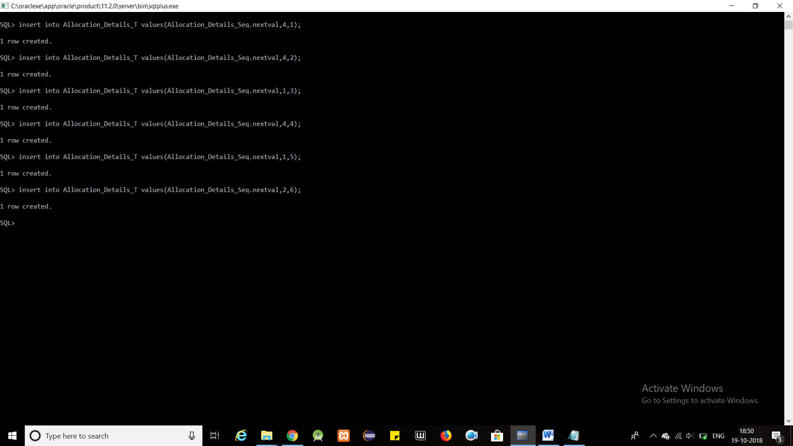

db.Products.insert([{_id : 1,Name : 'Eggs', Qty : 2000 },{_id : 2,Name : 'Bread', Qty : 1500 },{_id : 3,Name : 'Denim', Qty : 2500 },{_id : 4,Name : 'Dell Inspiron', Qty : 7500 },{_id : 5,Name : 'Moto G4 Plus', Qty : 500 },{_id : 6,Name : 'Milk', Qty : 9000 }]);

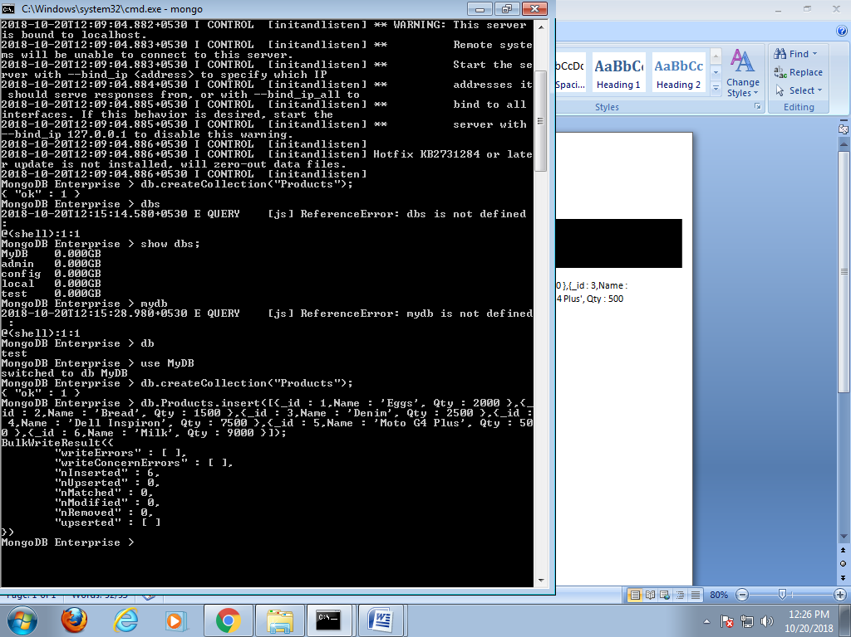

=============================================================

**TRIGGERS**

SET SERVEROUTPUT ON;

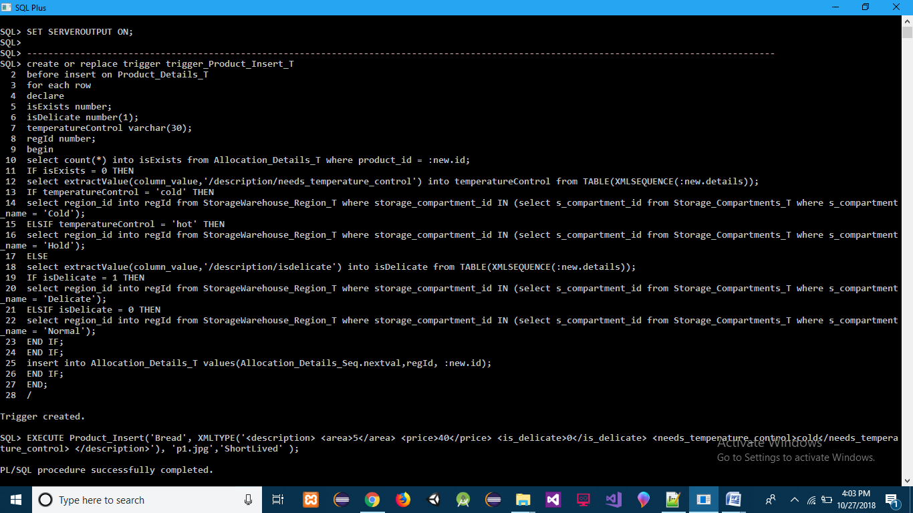

**TRIGGER 1(Products Allocation According to Product Details, if Product Allocation Details was not already present in Allocation_Details Table) :-**

create or replace trigger trigger_Product_Insert_T

before insert on Product_Details_T

for each row

declare

isExists number;

isDelicate number(1);

temperatureControl varchar(30);

regId number;

begin

select count(*) into isExists from Allocation_Details_T where product_id = :new.id;

IF isExists = 0 THEN

select extractValue(column_value,'/description/needs_temperature_control') into temperatureControl from TABLE(XMLSEQUENCE(:new.details));

IF temperatureControl = 'cold' THEN

select region_id into regId from StorageWarehouse_Region_T where storage_compartment_id IN (select s_compartment_id from Storage_Compartments_T where s_compartment_name = 'Cold');

ELSIF temperatureControl = 'hot' THEN

select region_id into regId from StorageWarehouse_Region_T where storage_compartment_id IN (select s_compartment_id from Storage_Compartments_T where s_compartment_name = 'Hold');

ELSE

select extractValue(column_value,'/description/is_delicate') into isDelicate from TABLE(XMLSEQUENCE(:new.details));

IF isDelicate = 1 THEN

select region_id into regId from StorageWarehouse_Region_T where storage_compartment_id IN (select s_compartment_id from Storage_Compartments_T where s_compartment_name = 'Delicate');

ELSIF isDelicate = 0 THEN

select region_id into regId from StorageWarehouse_Region_T where storage_compartment_id IN (select s_compartment_id from Storage_Compartments_T where s_compartment_name = 'Normal');

END IF;

END IF;

insert into Allocation_Details_T values(Allocation_Details_Seq.nextval,regId, :new.id);

END IF;

END;

/

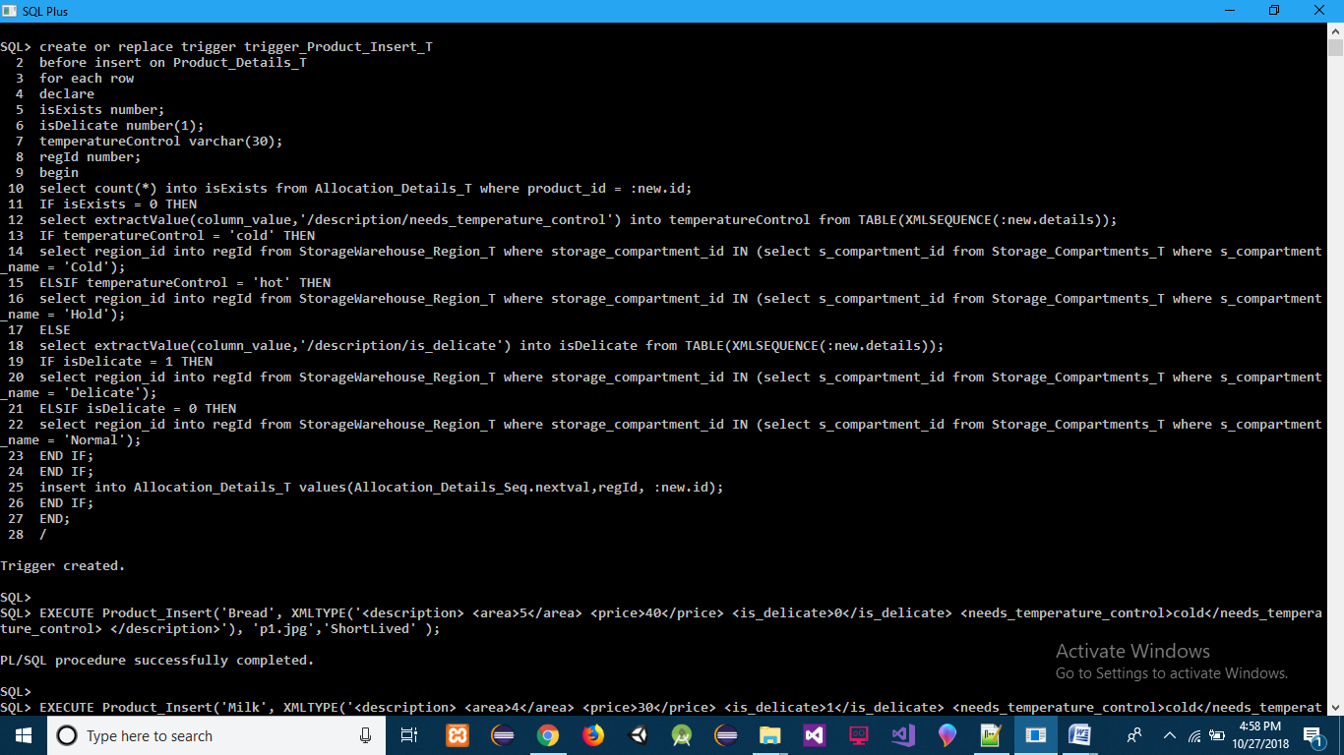

**INSERT :-**

EXECUTE Product_Insert('Bread', XMLTYPE('<description> <area>5</area> <price>40</price> <is_delicate>0</is_delicate> <needs_temperature_control>cold</needs_temperature_control> </description>'), 'p1.jpg','ShortLived' );

EXECUTE Product_Insert('Milk', XMLTYPE('<description> <area>4</area> <price>30</price> <is_delicate>1</is_delicate> <needs_temperature_control>cold</needs_temperature_control> </description>'), 'p2.jpeg','ShortLived' );

EXECUTE Product_Insert('Moto G4 Plus', XMLTYPE('<description> <area>5</area> <price>14000</price> <is_delicate>0</is_delicate> <needs_temperature_control>no</needs_temperature_control> <features> <camera>15mp</camera> <ram>2gb</ram> </features> </description>'), 'p3.jpeg','Electronic');

EXECUTE Product_Insert('Dell Inspiron', XMLTYPE('<description> <area>8</area> <price>40000</price> <is_delicate>0</is_delicate> <needs_temperature_control>cold</needs_temperature_control> <features> <camera>2mp</camera> <ram>4gb</ram> <processor>Intel i3</processor> </features> </description>'), 'p4.jpg','Electronic' );

EXECUTE Product_Insert('Denim', XMLTYPE('<description> <area>8</area> <price>1000</price> <is_delicate>0</is_delicate> <needs_temperature_control>no</needs_temperature_control> </description>'), 'p5.jpg','Other' );

EXECUTE Product_Insert('Biscuits', XMLTYPE('<description> <area>3</area> <price>50</price> <is_delicate>1</is_delicate> <needs_temperature_control>no</needs_temperature_control> </description>'), 'p6.jpg','Other' );

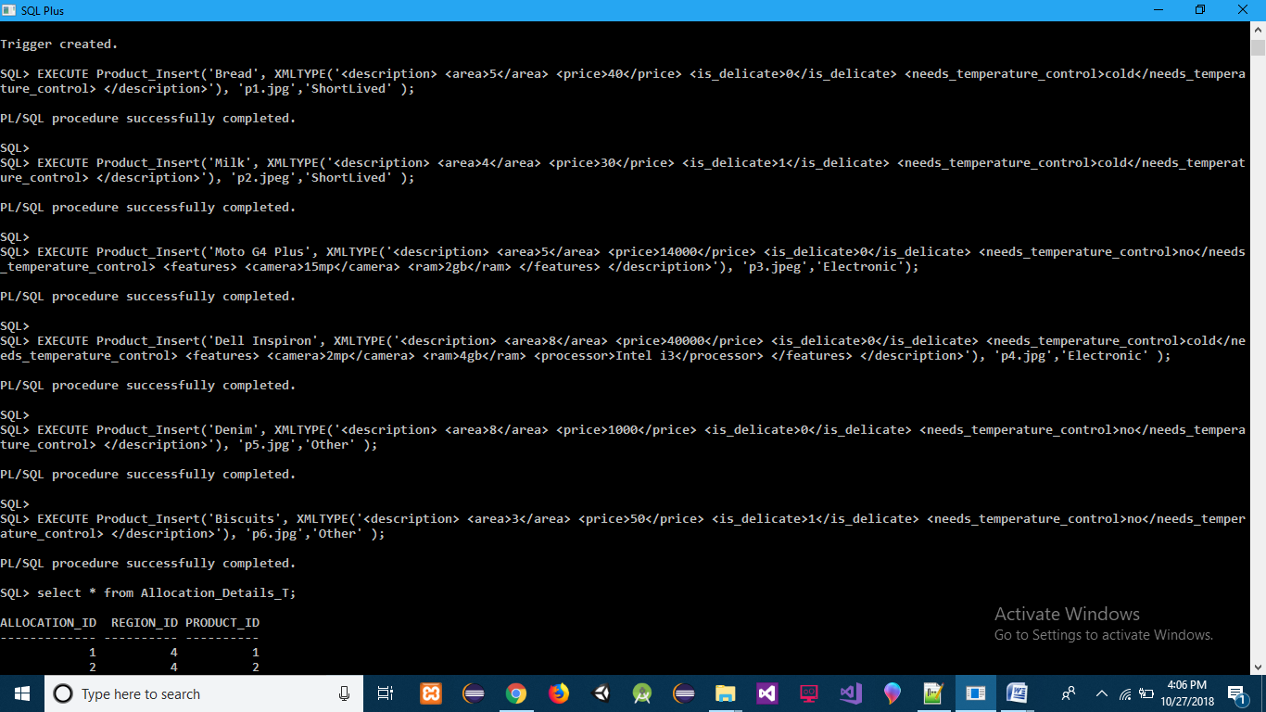

**ACTION :-**

select * from Allocation_Details_T;

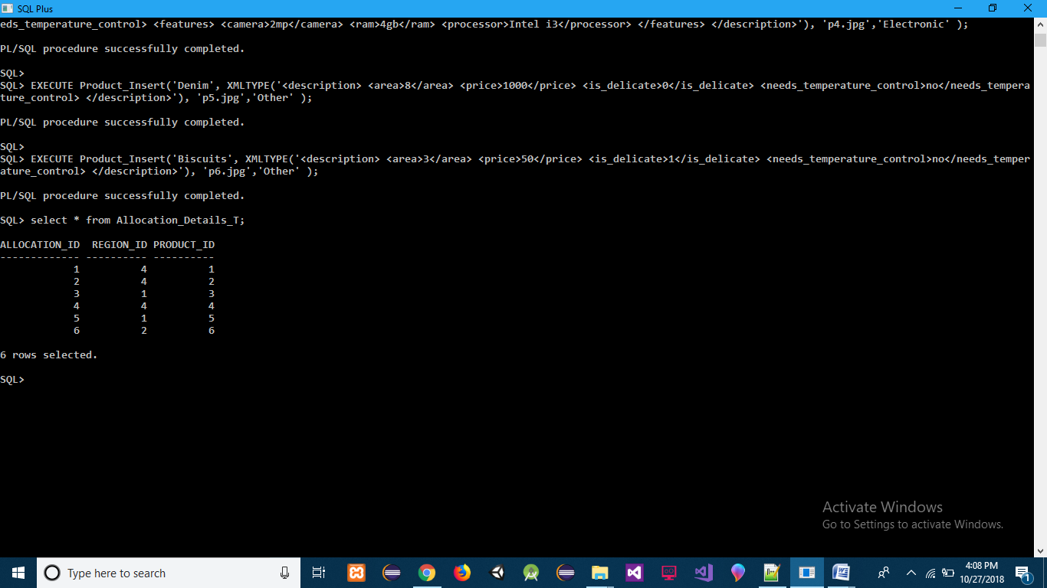

**TRIGGER 2(Area Of Storage Warehouse is Filled or Not)**

**AND**

**TRIGGER 3[Purchase Order Steps] (Insert into Storage_Products_T, if space is available and According to Products in Purchase Order Classify the Product and decide if Supplier is trusted according to it’s No of Orders till now) :-**

create or replace trigger Trigger_Storage_Product_T

before insert on Storage_Products_T

for each row

declare

totalWarehouseArea number;

productArea number;

totalProductArea number;

pArea number;

BEGIN

totalProductArea := 0;

select SDO_GEOM.SDO_AREA(s.region_sd,0.005) into totalWarehouseArea from StorageWarehouse_Region_T s where region_id = :new.region_id;

FOR pr IN(select s.product_id, s.quantity from Storage_Products_T s where region_id = :new.region_id) LOOP

select (extractvalue(column_value,'/description/area') * pr.quantity) into productArea from Product_Details_T p, TABLE(XMLSEQUENCE(p.DETAILS)) q where p.id = pr.product_id;

totalProductArea := totalProductArea + productArea;

END LOOP;

select extractvalue(column_value,'/description/area') into pArea from Product_Details_T p, TABLE(XMLSEQUENCE(p.DETAILS)) q where p.id = :new.product_id;

IF (totalWarehouseArea - totalProductArea) < pArea THEN

RAISE_APPLICATION_ERROR(-20001,'No Space Available');

END IF;

END;

/

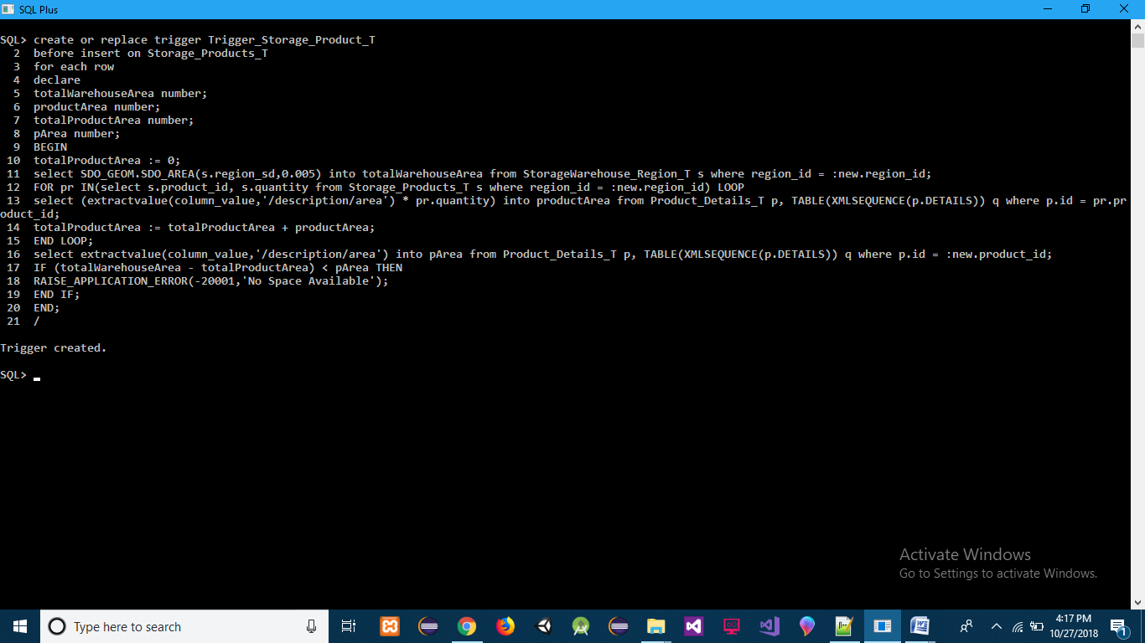

create or replace trigger trigger_Purchase_Order_T

before insert on Purchase_Order_T

for each row

declare

cursor prod is select * from TABLE(:new.products);

reg_id number;

isExists number;

pType varchar2(30);

supplierCount number;

begin

FOR p in prod LOOP

select count(*) into isExists from Storage_Products_T where product_id = p.product_id;

IF isExists > 0 THEN

update Storage_Products_T set quantity = quantity + p.quantity where product_id = p.product_id;

ELSE

select region_id into reg_id from Allocation_Details_T where product_id = p.product_id;

insert into Storage_Products_T values(Storage_Products(reg_id,p.product_id,p.quantity));

END IF;

select productType into pType from Product_Details_T where id = p.product_id;

IF pType = 'ShortLived' THEN

FOR period in (select extractvalue(column_value,'/product/produced_date') produced_date,

extractvalue(column_value,'/product/best_before_days') best_before_days from TABLE(XMLSEQUENCE(p.periods.extract('/periods/product')))) LOOP

insert into Short_Lived_Products_T values(Short_Lived_Products(p.product_id, :new.order_id,TO_DATE(period.produced_date), TO_NUMBER(period.best_before_days)));

END LOOP;

ELSIF pType = 'Electronic' THEN

FOR period in (select extractvalue(column_value,'/product/manufacturing_date') manufacturing_date,

extractvalue(column_value,'/product/warranty_period_months') warranty_period_months from TABLE(XMLSEQUENCE(p.periods.extract('/periods/product')))) LOOP

insert into Electronic_Products_T values(Electronic_Products(p.product_id, :new.order_id,TO_DATE(period.manufacturing_date), TO_NUMBER(period.warranty_period_months)));

END LOOP;

ELSIF pType = 'Other' THEN

FOR period in (select extractvalue(column_value,'/product/manufacturing_date') manufacturing_date,

extractvalue(column_value,'/product/expiry_date') expiry_date from TABLE(XMLSEQUENCE(p.periods.extract('/periods/product')))) LOOP

insert into Other_Products_T values(Other_Products(p.product_id, :new.order_id,TO_DATE(period.manufacturing_date),

TO_DATE(period.expiry_date)));

END LOOP;

END IF;

END LOOP;

select (count(*) + 1) into supplierCount from Purchase_Order_T where supplier_id = :new.supplier_id;

IF supplierCount = 3 THEN

update Supplier_Details_T set trusted = 1 where id = :new.supplier_id;

END IF;

END;

/

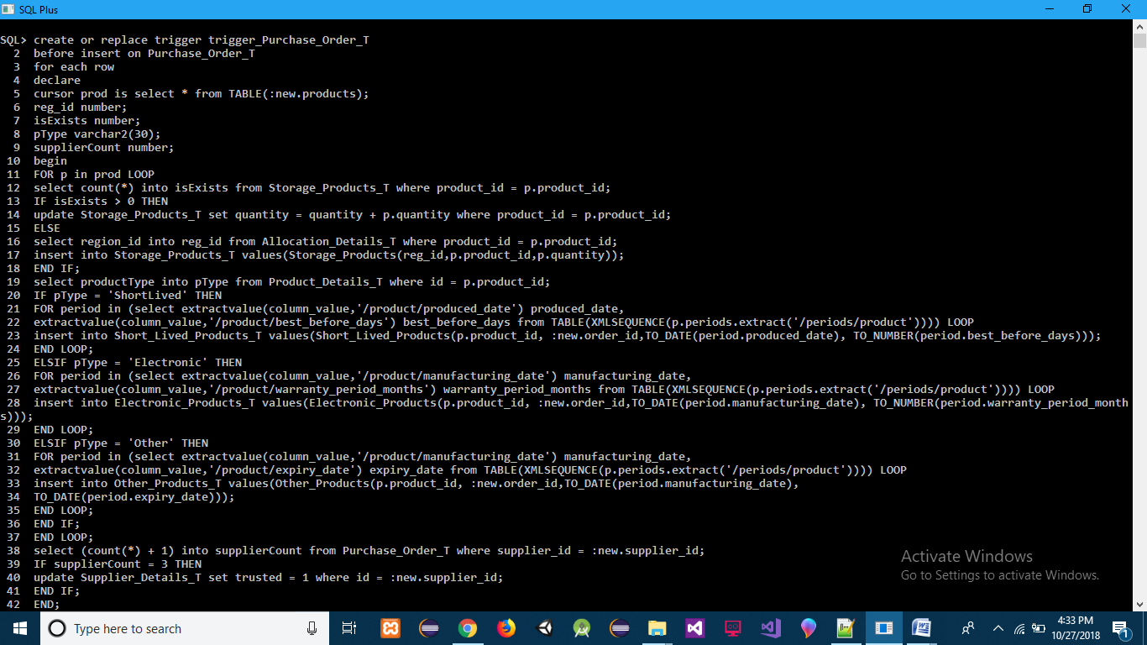

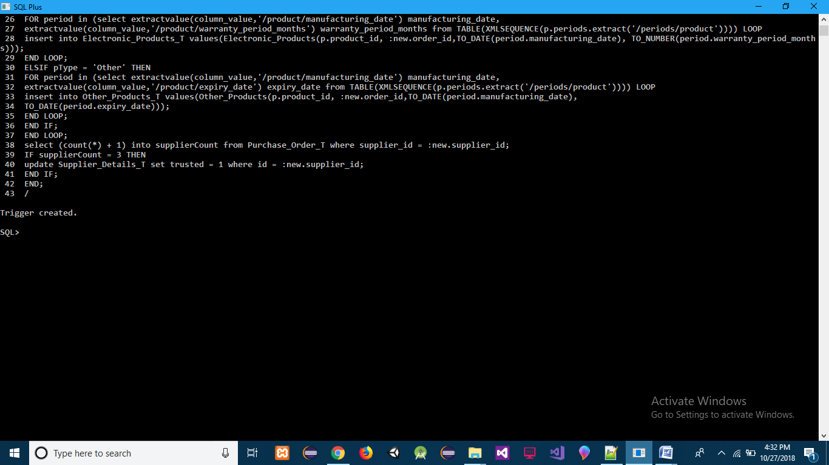

**INSERT :-**

insert into Purchase_Order_T values(Purchase_Order(Purchase_Order_seq.NEXTVAL, SYSTIMESTAMP, 1,

ProductPurchase(

ProductPurchaseDetails(1,2,39,XMLTYPE('<periods> <product> <produced_date>17-OCT-2018</produced_date> <best_before_days>3</best_before_days> </product> <product> <produced_date>16-OCT-2018</produced_date> <best_before_days>3</best_before_days> </product> </periods>')),

ProductPurchaseDetails(2,1,30,XMLTYPE('<periods> <product> <produced_date>17-OCT-2018</produced_date> <best_before_days>4</best_before_days> </product> </periods>')),

ProductPurchaseDetails(3,1,13000,XMLTYPE('<periods> <product> <manufacturing_date>03-MAR-2016</manufacturing_date> <warranty_period_months>12</warranty_period_months> </product> </periods>'))

)));

insert into Purchase_Order_T values(Purchase_Order(Purchase_Order_seq.NEXTVAL, SYSTIMESTAMP, 3,

ProductPurchase(

ProductPurchaseDetails(4,1,40000,XMLTYPE('<periods> <product> <manufacturing_date>03-OCT-2017</manufacturing_date> <warranty_period_months>12</warranty_period_months> </product> </periods>')),

ProductPurchaseDetails(6,2,50,XMLTYPE('<periods> <product> <manufacturing_date>17-OCT-2018</manufacturing_date> <expiry_date>17-APR-2019</expiry_date> </product> <product> <manufacturing_date>27-SEP-2018</manufacturing_date> <expiry_date>27-MAR-2019</expiry_date> </product> </periods>')),

ProductPurchaseDetails(3,2,14000,XMLTYPE('<periods> <product> <manufacturing_date>03-OCT-2017</manufacturing_date> <warranty_period_months>12</warranty_period_months> </product> <product> <manufacturing_date>09-SEP-2017</manufacturing_date> <warranty_period_months>12</warranty_period_months> </product> </periods>'))

)));

insert into Purchase_Order_T values(Purchase_Order(Purchase_Order_seq.NEXTVAL, SYSTIMESTAMP, 5,

ProductPurchase(

ProductPurchaseDetails(6,1,50,XMLTYPE('<periods> <product> <manufacturing_date>09-SEP-2018</manufacturing_date> <expiry_date>09-MAR-2019</expiry_date> </product> </periods>'))

)));

insert into Purchase_Order_T values(Purchase_Order(Purchase_Order_seq.NEXTVAL, SYSTIMESTAMP, 5,

ProductPurchase(

ProductPurchaseDetails(6,1,50,XMLTYPE('<periods> <product> <manufacturing_date>09-AUG-2018</manufacturing_date> <expiry_date>09-FEB-2019</expiry_date> </product> </periods>'))

)));

insert into Purchase_Order_T values(Purchase_Order(Purchase_Order_seq.NEXTVAL, SYSTIMESTAMP, 5,

ProductPurchase(

ProductPurchaseDetails(6,1,50,XMLTYPE('<periods> <product> <manufacturing_date>09-SEP-2018</manufacturing_date> <expiry_date>09-MAR-2019</expiry_date> </product> </periods>'))

)));

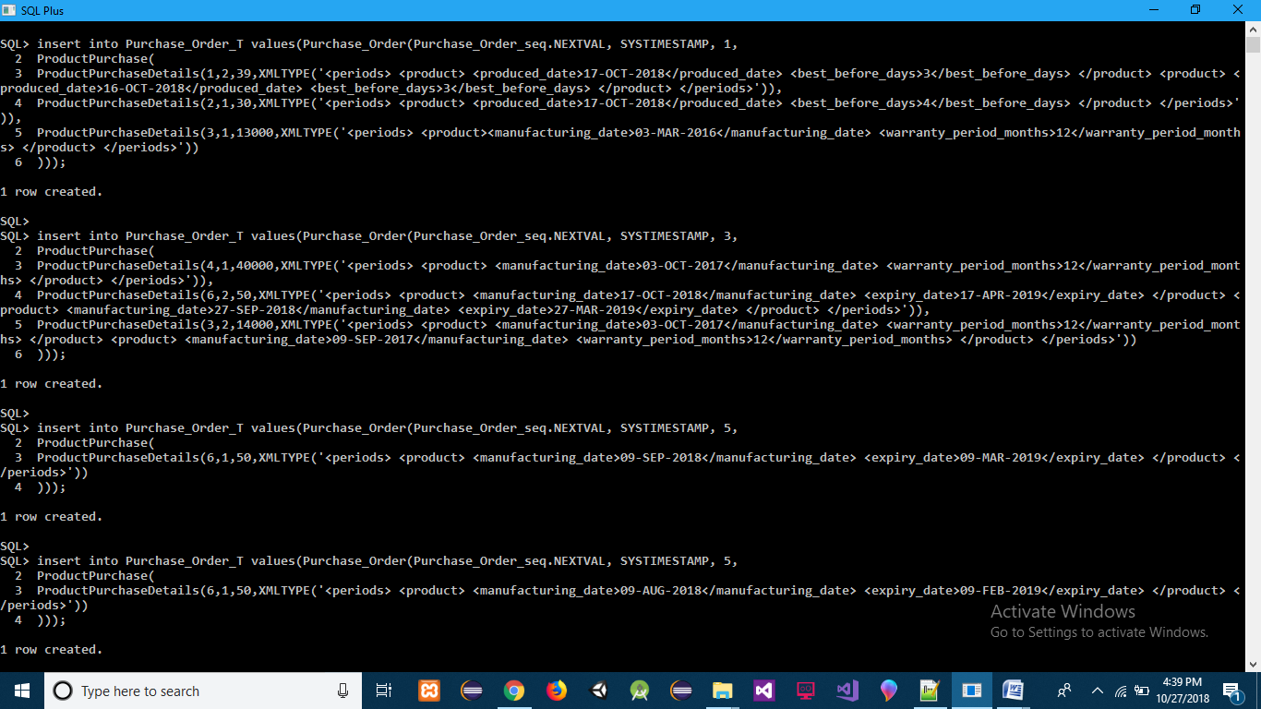

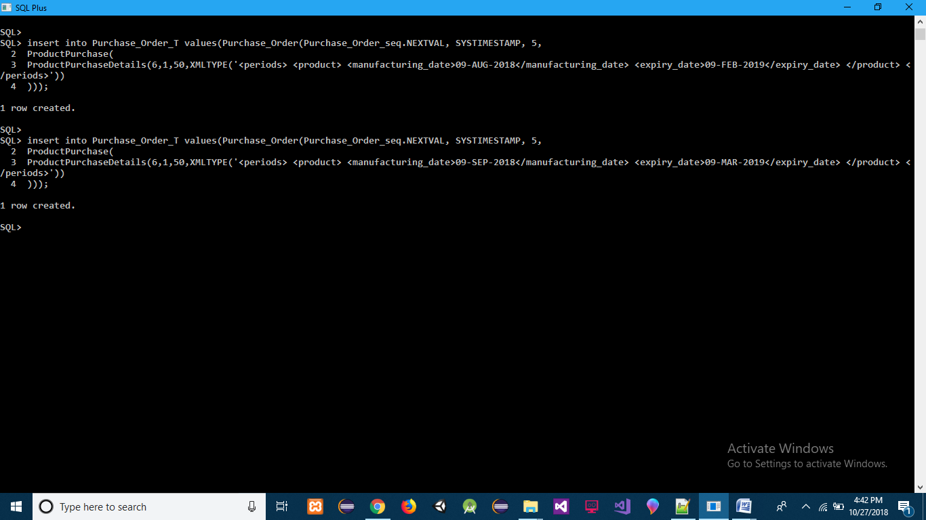

EXECUTE Product_Insert('Moto G4', XMLTYPE('<description> <area>5400</area> <price>14000</price> <is_delicate>0</is_delicate> <needs_temperature_control>no</needs_temperature_control> <features> <camera>15mp</camera> <ram>2gb</ram> </features> </description>'), 'p3.jpeg','Electronic');

insert into Purchase_Order_T values(Purchase_Order(Purchase_Order_seq.NEXTVAL, SYSTIMESTAMP, 5,

ProductPurchase(

ProductPurchaseDetails(7,2,14000,XMLTYPE('<periods> <product> <manufacturing_date>03-OCT-2017</manufacturing_date> <warranty_period_months>12</warranty_period_months> </product> <product> <manufacturing_date>09-SEP-2017</manufacturing_date> <warranty_period_months>12</warranty_period_months> </product> </periods>'))

)));

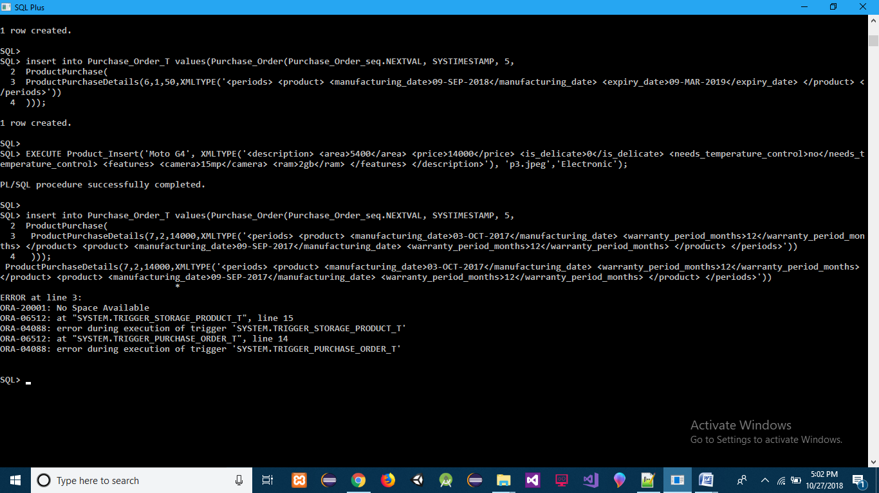

**ACTION :-**

select * from Storage_Products_T;

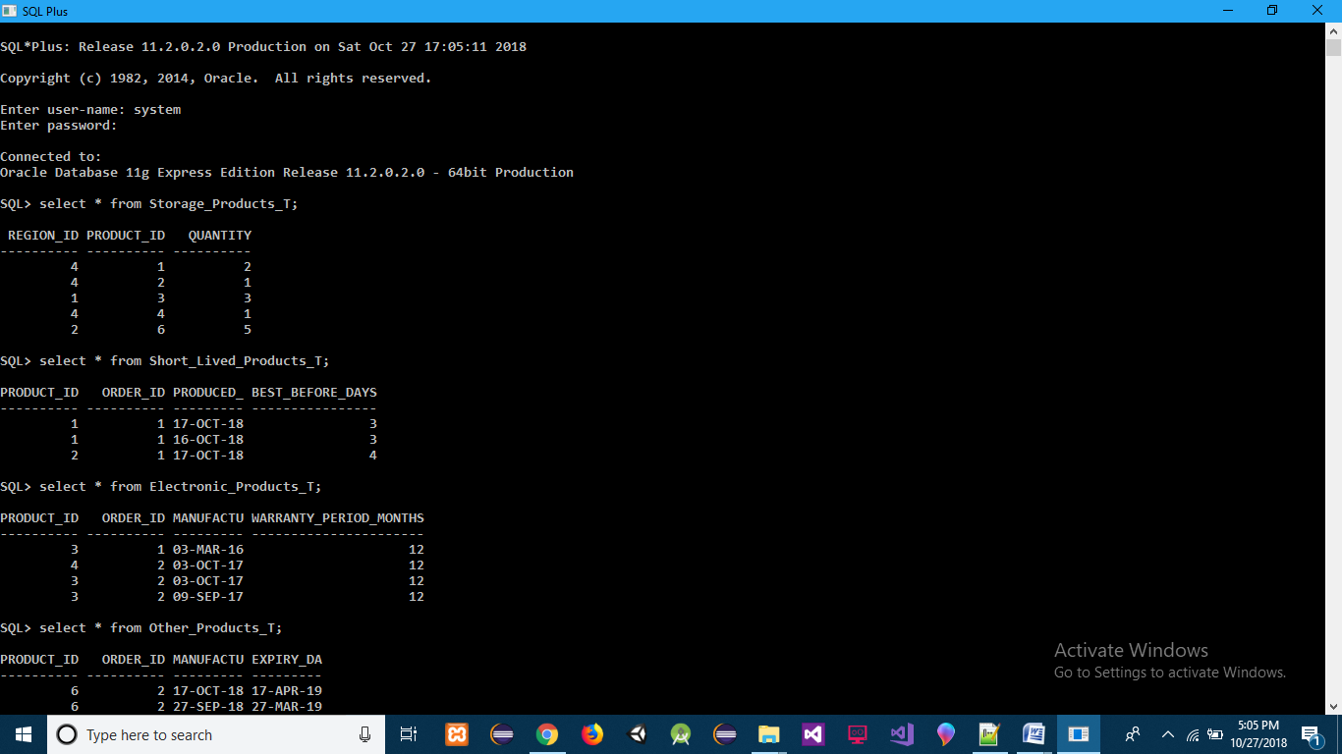

select * from Short_Lived_Products_T;

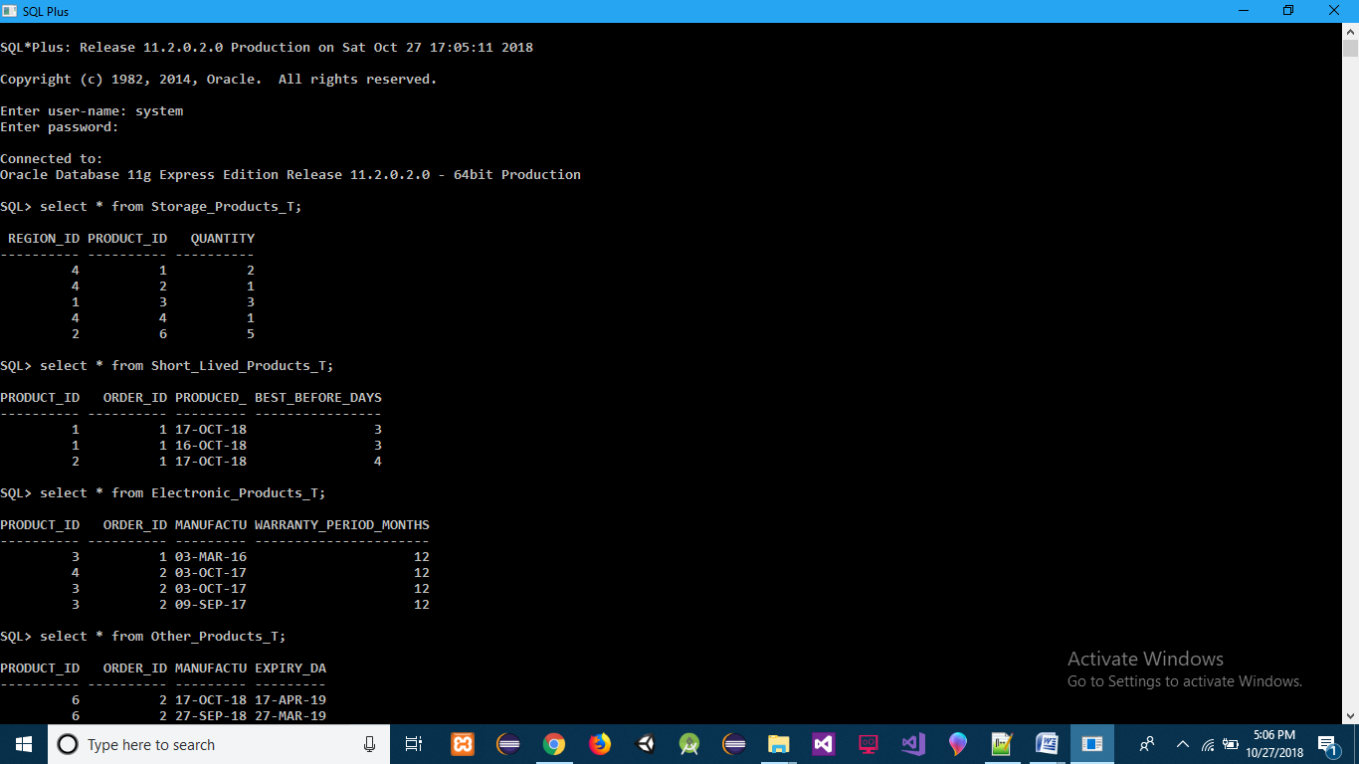

select * from Electronic_Products_T;



select * from Other_Products_T;

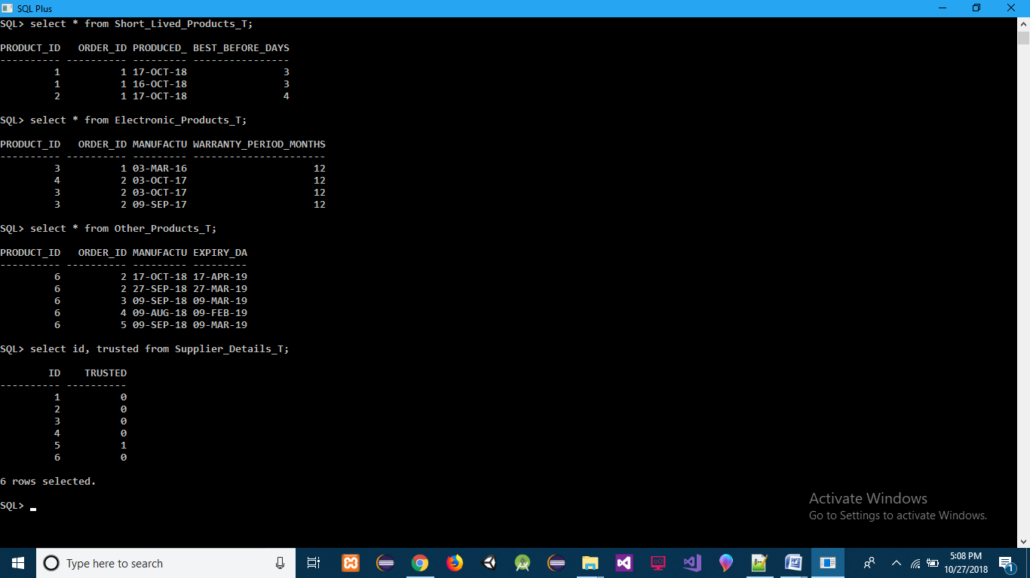

select id, trusted from Supplier_Details_T;



**TRIGGER 4(Area Of Distribution Warehouse is Filled or Not)**

**AND**

**TRIGGER 5[Sales Order Steps](Insert into Distribution_Products_T according to Sales Order, if space is available and remove from Storage_Products_T respective product and Decide Automatically Customer is regular according to it’s No of Orders till now)**

**AND**

**Function to maintain Atomicity in Purchase Order (Is Any Product Out Of Stock?):-**

create or replace trigger Trigger_Distribution_Product_T

before insert on Distribution_Products_T

for each row

declare

totalWarehouseArea number;

productArea number;

totalProductArea number;

pArea number;

BEGIN

totalProductArea := 0;

select SDO_GEOM.SDO_AREA(s.region_sd,0.005) into totalWarehouseArea from DistributionWarehouse_Region_T s where region_id = :new.region_id;

FOR pr IN(select s.product_id, s.quantity from Distribution_Products_T s where region_id = :new.region_id) LOOP

select (extractvalue(column_value,'/description/area') * pr.quantity) into productArea from Product_Details_T p, TABLE(XMLSEQUENCE(p.DETAILS)) q where p.id = pr.product_id;

totalProductArea := totalProductArea + productArea;

END LOOP;

select extractvalue(column_value,'/description/area') into pArea from Product_Details_T p, TABLE(XMLSEQUENCE(p.DETAILS)) q where p.id = :new.product_id;

IF (totalWarehouseArea - totalProductArea) < pArea THEN

RAISE_APPLICATION_ERROR(-20001,'No Space Available');

END IF;

END;

/

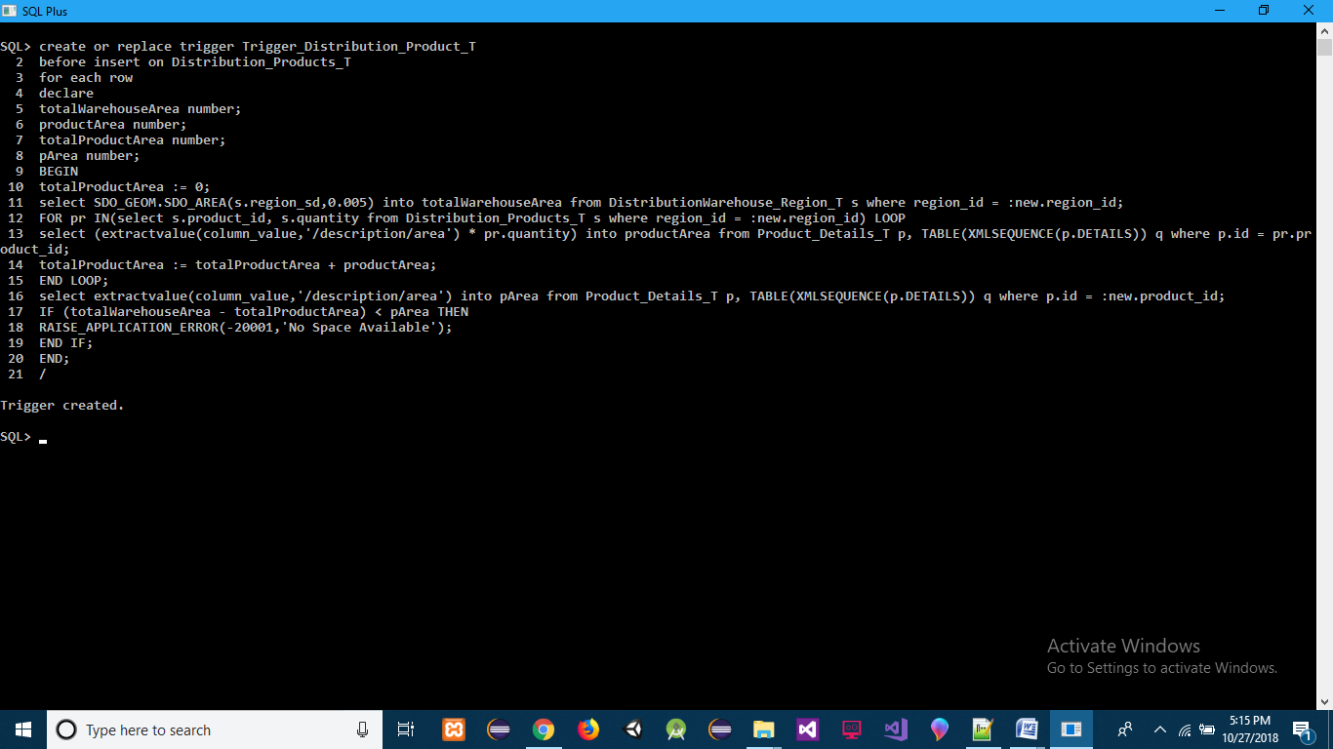

CREATE OR REPLACE FUNCTION isOutOfStock(products IN ProductSales) RETURN VARCHAR2

IS

cursor prod is select * from TABLE(products);

stockQty number;

outOfStock varchar2(500);

counter number;

countProduct number;

BEGIN

counter := 0;

FOR p in prod LOOP

stockQty := 0;

select count(*) into countProduct from Storage_Products_T where product_id = p.product_id;

IF countProduct > 0 THEN

select quantity into stockQty from Storage_Products_T where product_id = p.product_id;

END IF;

IF stockQty < p.quantity THEN

IF counter = 0 THEN

outOfStock := 'Products ordered more than in stock with ';

END IF;

outOfStock := outOfStock || ' id : '|| p.product_id;

END IF;

counter := counter + 1;

END LOOP;

RETURN outOfStock;

END;

/

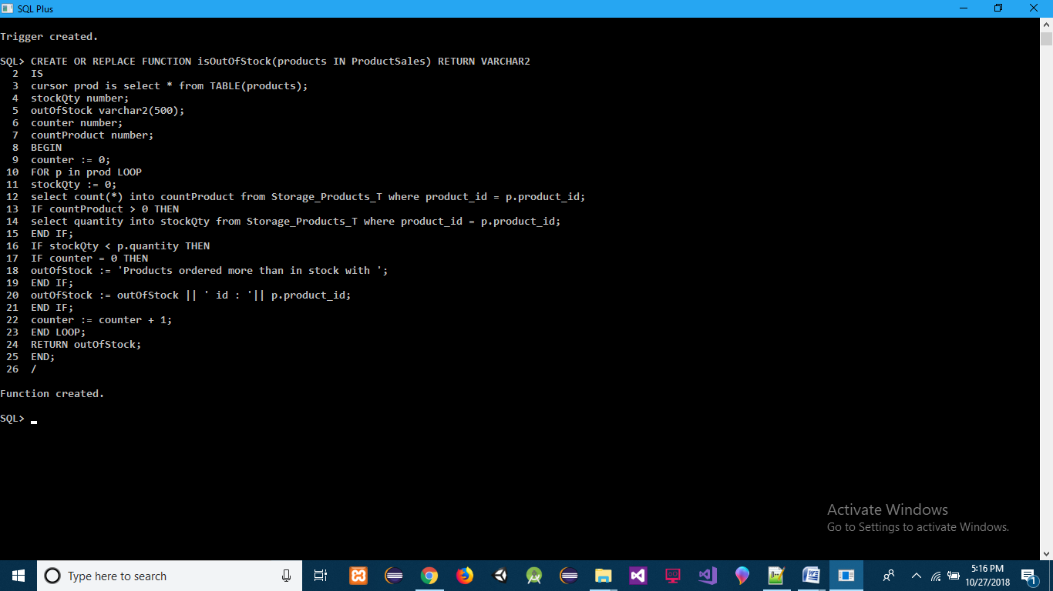

create or replace trigger trigger_Sales_Order_T

before insert on Sales_Order_T

for each row

declare

cursor prod is select * from TABLE(:new.products);

isExists number;

storageProdQty number;

outOfStock varchar2(500);

customerCount number;

begin

outOfStock := isOutOfStock(:new.products);

DBMS_OUTPUT.PUT_LINE(LENGTH(outOfStock));

IF LENGTH(outOfStock) > 0 THEN

raise_application_error(-20001, outOfStock);

ELSE

FOR p in prod LOOP

IF :new.isFaulty = 1 THEN

select count(*) into isExists from Distribution_Products_T where product_id = p.product_id and region_id = 1;

IF isExists > 0 THEN

update Distribution_Products_T set quantity = quantity + p.quantity where product_id = p.product_id and region_id = 1;

ELSE

insert into Distribution_Products_T values(1,p.product_id,p.quantity);

END IF;

ELSE

select count(*) into isExists from Distribution_Products_T where product_id = p.product_id and region_id = 2;

IF isExists > 0 THEN

update Distribution_Products_T set quantity = quantity + p.quantity where product_id = p.product_id and region_id = 2;

ELSE

insert into Distribution_Products_T values(2,p.product_id,p.quantity);

END IF;

END IF;

select quantity into storageProdQty from Storage_Products_T where product_id = p.product_id;

IF storageProdQty = p.quantity THEN

delete from Storage_Products_T where product_id = p.product_id;

DBMS_OUTPUT.PUT_LINE('It''s time to buy a product with product id : '|| p.product_id);

ELSIF storageProdQty > p.quantity THEN

update Storage_Products_T set quantity = quantity - p.quantity where product_id = p.product_id;

END IF;

END LOOP;

select (count(*) + 1) into customerCount from Sales_Order_T where customer_id = :new.customer_id;

IF customerCount = 3 THEN

update Customer_Details_T set regular = 1 where id = :new.customer_id;

END IF;

END IF;

END;

/

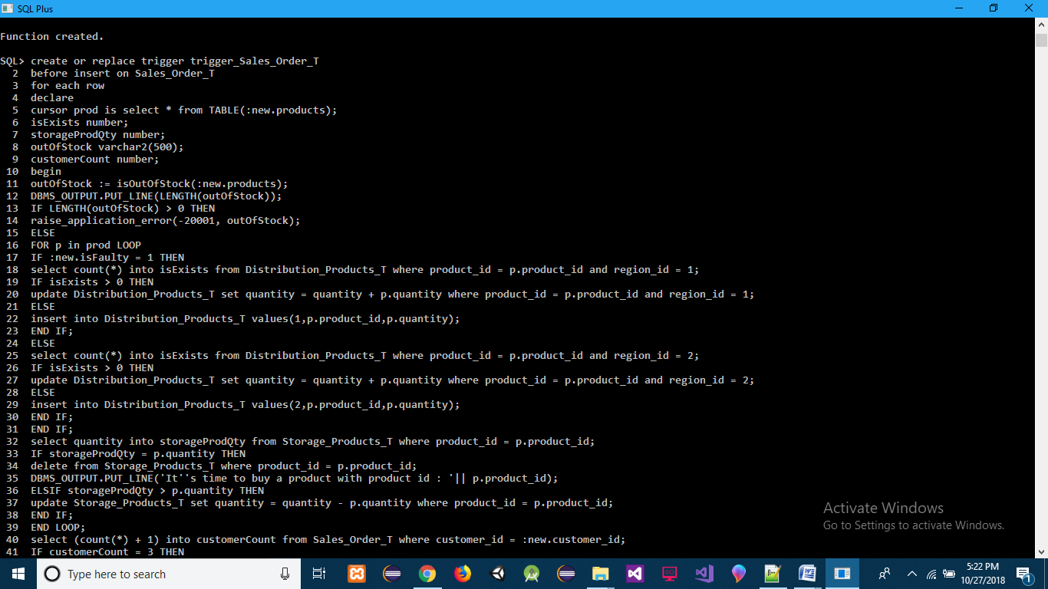

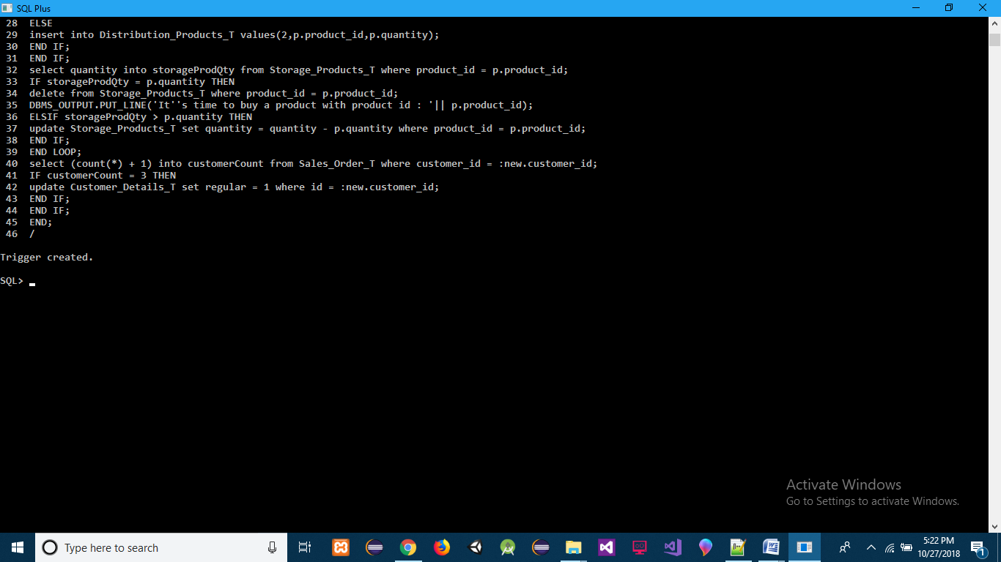

**INSERT :-**

insert into Sales_Order_T values(Sales_Order(Sales_Order_seq.NEXTVAL, SYSTIMESTAMP, 2, ProductSales(ProductSalesDetails(1,7,42),ProductSalesDetails(3,3,15000),ProductSalesDetails(6,3,53),ProductSalesDetails(5,2,1002)),1,0));

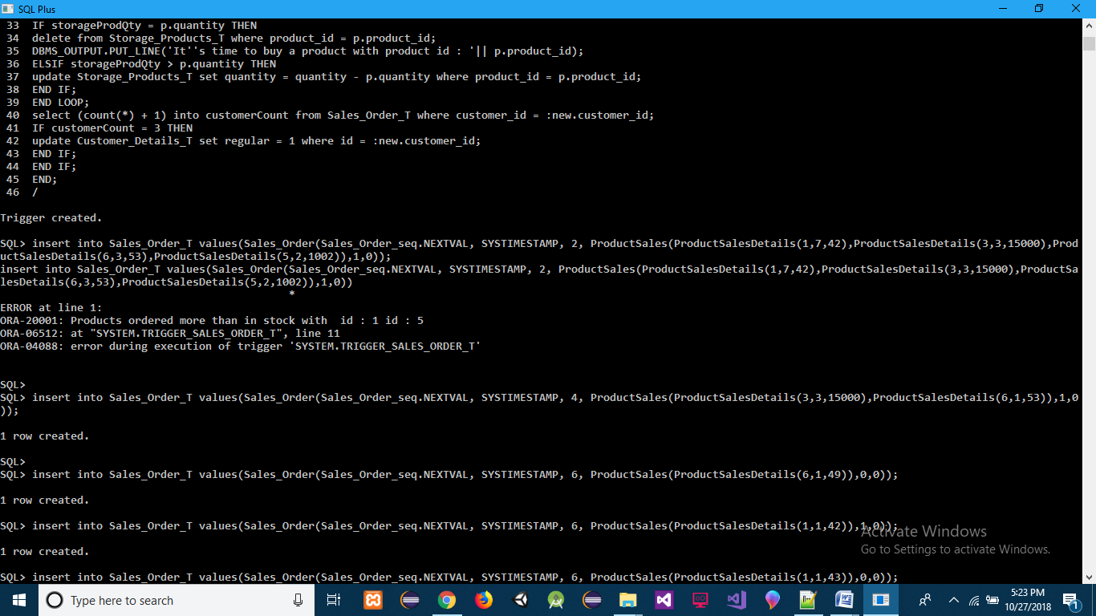

insert into Sales_Order_T values(Sales_Order(Sales_Order_seq.NEXTVAL, SYSTIMESTAMP, 4, ProductSales(ProductSalesDetails(3,3,15000),ProductSalesDetails(6,1,53)),1,0));

insert into Sales_Order_T values(Sales_Order(Sales_Order_seq.NEXTVAL, SYSTIMESTAMP, 6, ProductSales(ProductSalesDetails(6,1,49)),0,0));

insert into Sales_Order_T values(Sales_Order(Sales_Order_seq.NEXTVAL, SYSTIMESTAMP, 6, ProductSales(ProductSalesDetails(1,1,42)),1,0));

insert into Sales_Order_T values(Sales_Order(Sales_Order_seq.NEXTVAL, SYSTIMESTAMP, 6, ProductSales(ProductSalesDetails(1,1,43)),0,0));

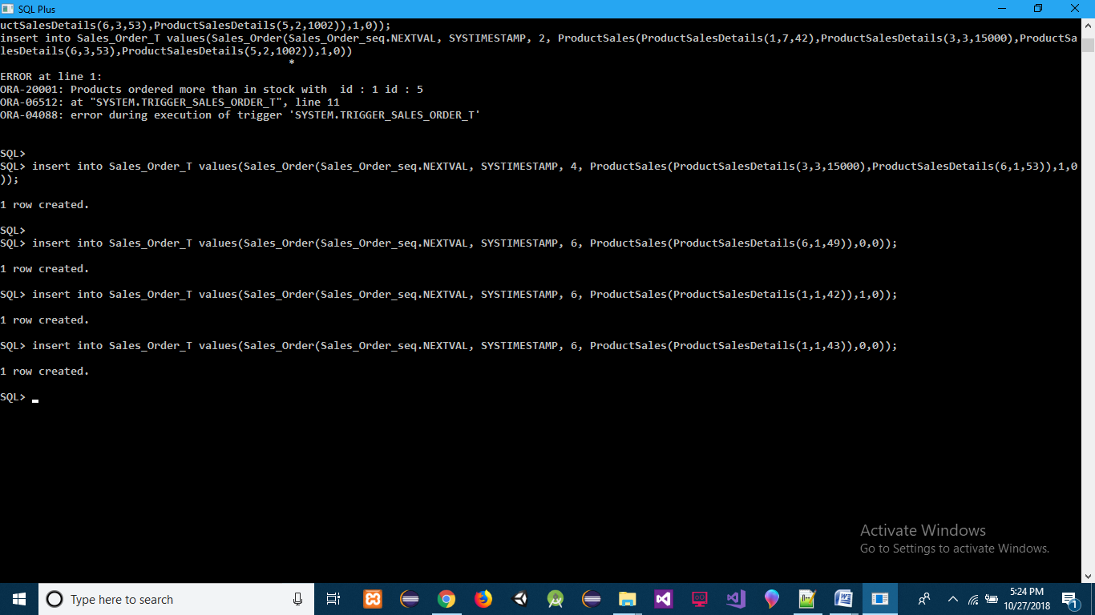

**ACTION :-**

select * from Storage_Products_T;

select * from Distribution_Products_T;

select id, regular from Customer_Details_T;

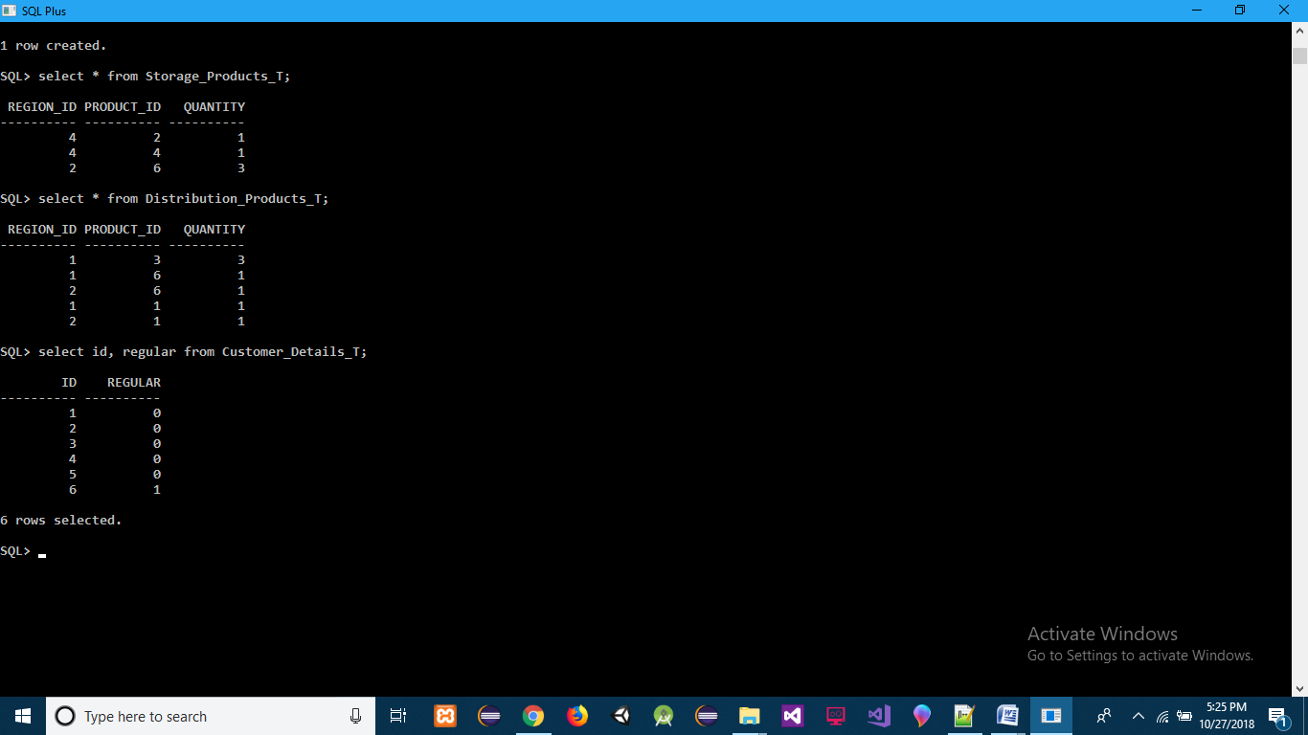

**TRIGGER 6[Transport Order Steps](Transport Order is inserted remove the Sales Order products from Distributed Warehouse) :-**

create or replace trigger trigger_Transport_Order_T

before insert on Transport_Order_T

for each row

declare

cursor orders is select * from TABLE(:new.products);

distProdQty number;

faulty number(1);

reg_id number;

begin

FOR o in orders LOOP

select isFaulty into faulty from Sales_Order_T where order_id = o.sales_order_id;

IF faulty = 1 THEN

reg_id := 1;

ELSE

reg_id := 2;

END IF;

FOR prod in (select p.product_id, p.quantity from Sales_Order_T s,TABLE(s.products) p where s.order_id = o.sales_order_id) LOOP

select quantity into distProdQty from Distribution_Products_T where product_id = prod.product_id and region_id = reg_id;

IF distProdQty > prod.quantity THEN

update Distribution_Products_T set quantity = quantity - prod.quantity where product_id = prod.product_id and region_id = reg_id;

ELSIF distProdQty = prod.quantity THEN

delete from Distribution_Products_T where product_id = prod.product_id and region_id = reg_id;

ELSE

RAISE_APPLICATION_ERROR(-20001,'Wrong Data');

END IF;

END LOOP;

UPDATE Sales_Order_T SET isTransported = 1 where order_id = o.sales_order_id;

END LOOP;

END;

/

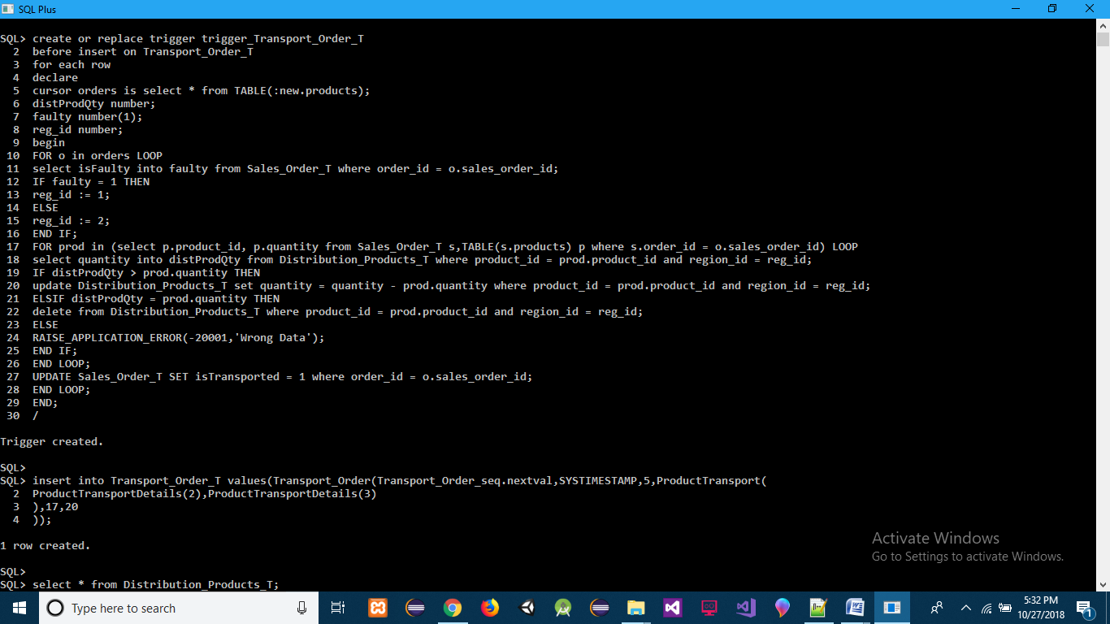

**INSERT :-**

insert into Transport_Order_T values(Transport_Order(Transport_Order_seq.nextval,SYSTIMESTAMP,5,ProductTransport(

ProductTransportDetails(2),ProductTransportDetails(3)

),17,20

));

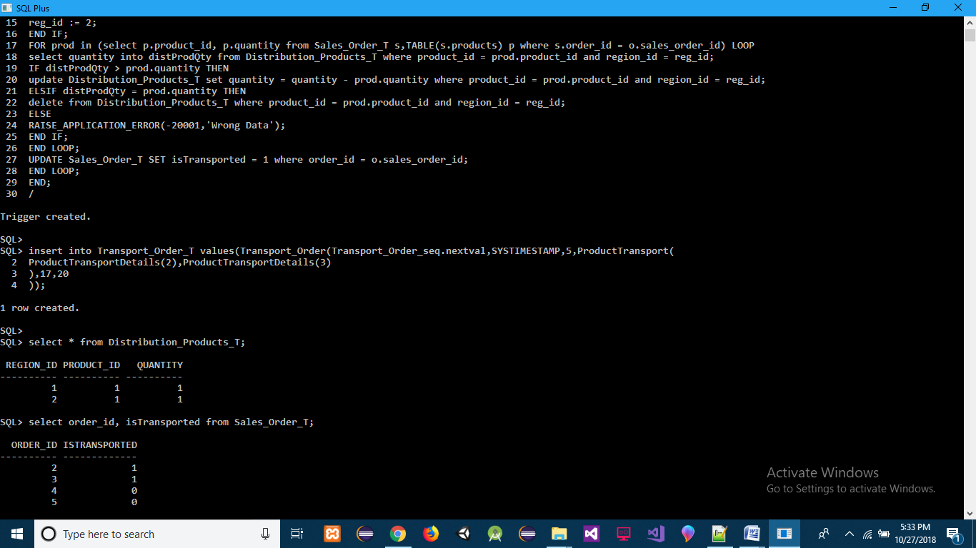

**ACTION :-**

select * from Distribution_Products_T;

select order_id, isTransported from Sales_Order_T;

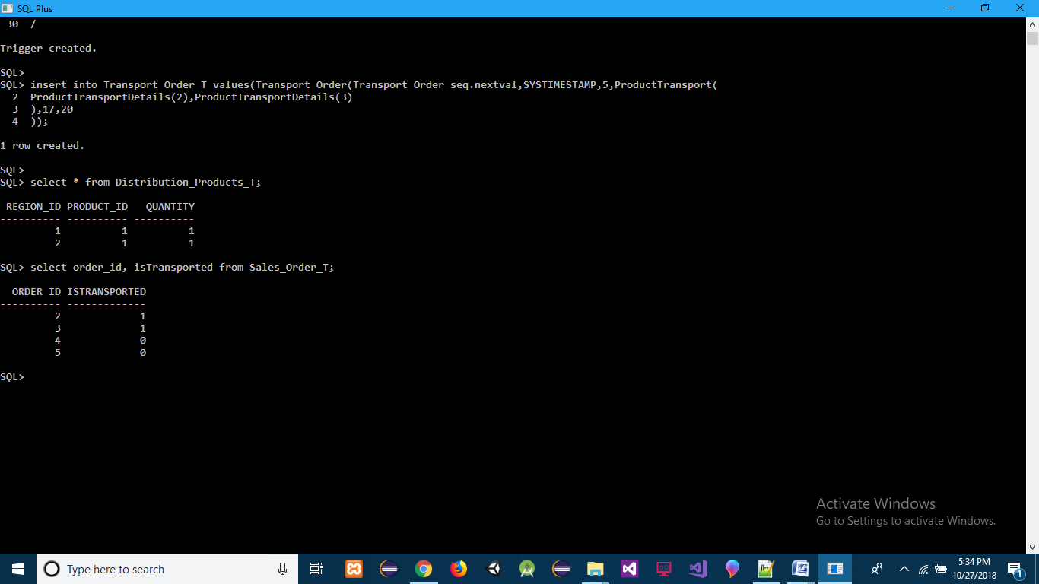

**TRIGGER 7(delete Classification if Product is deleted) :-**

create or replace trigger delTrigger_Product_T

after delete on Product_Details_T

for each row

BEGIN

delete from Short_Lived_Products_T where product_id = :old.id;

delete from Electronic_Products_T where product_id = :old.id;

delete from Other_Products_T where product_id = :old.id;

END;

/

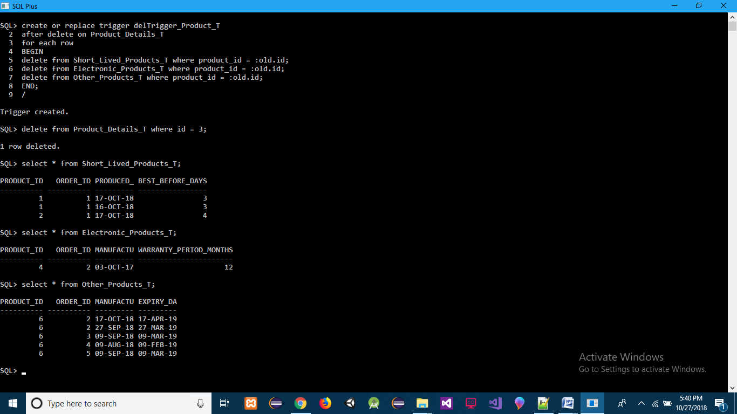

**DELETE :-**

delete from Product_Details_T where id = 3;



**ACTION :-**

select * from Short_Lived_Products_T;

select * from Electronic_Products_T;

select * from Other_Products_T;

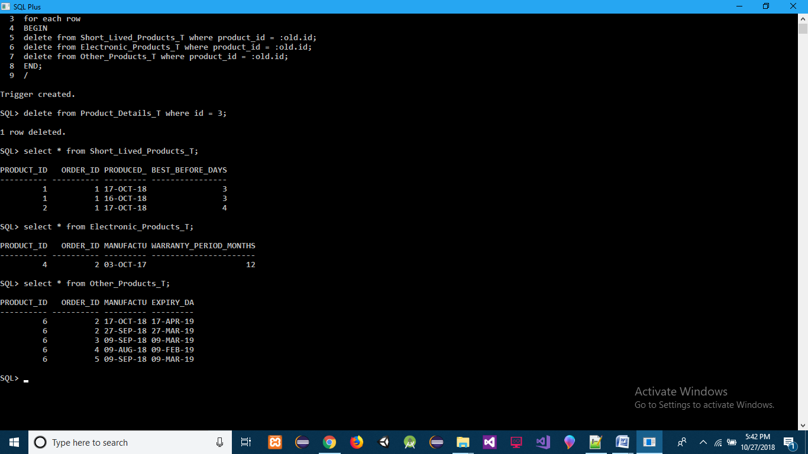

=============================================================

**QUERIES :-**

**Q] Making Object Table and Type Accessible from HR Database**

**ANS]**

create or replace type FullName1 oid '0C314EDC4A1243CFA00AE3871359D8D8' as object(

first_name varchar2(20),

last_name varchar2(20)

)

/

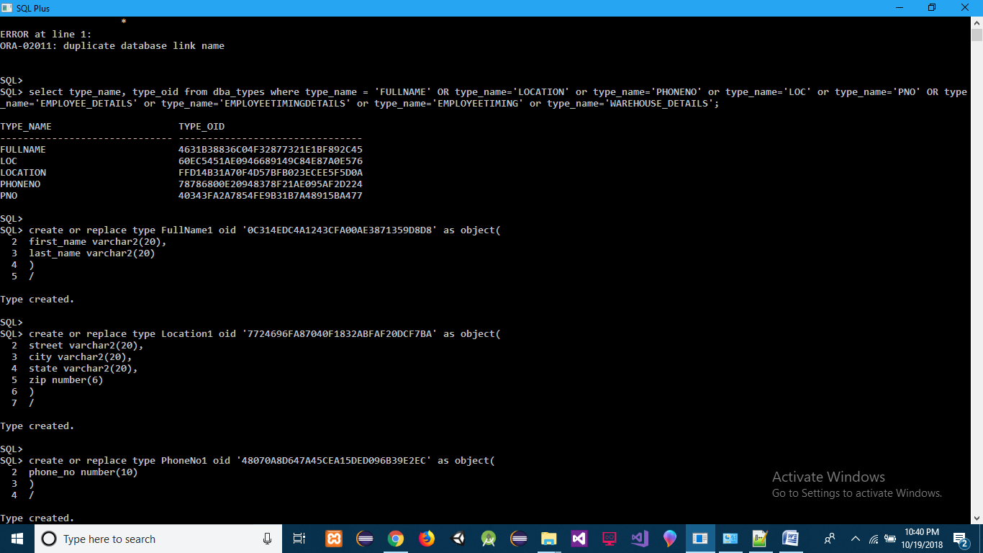

create or replace type Location1 oid '7724696FA87040F1832ABFAF20DCF7BA' as object(

street varchar2(20),

city varchar2(20),

state varchar2(20),

zip number(6)

)

/



create or replace type PhoneNo1 oid '48070A8D647A45CEA15DED096B39E2EC' as object(

phone_no number(10)

)

/

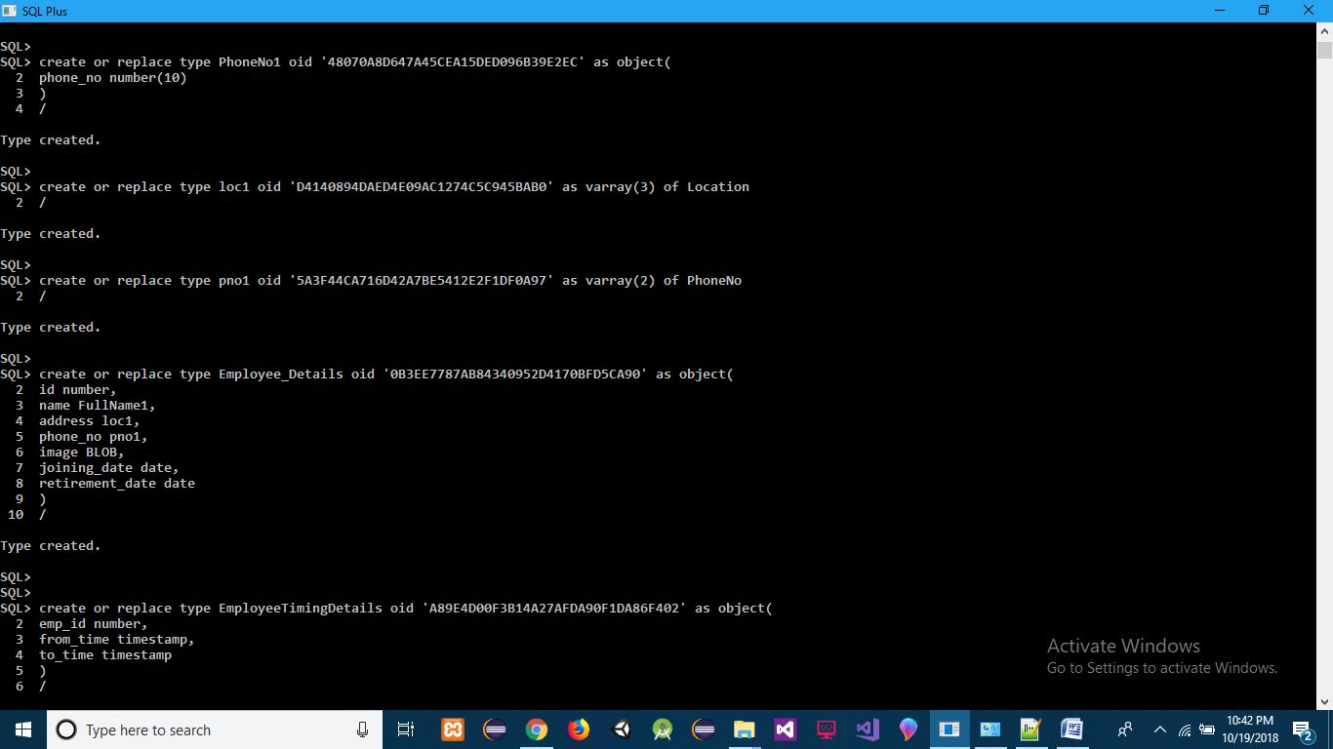

create or replace type loc1 oid 'D4140894DAED4E09AC1274C5C945BAB0' as varray(3) of Location

/



create or replace type pno1 oid '5A3F44CA716D42A7BE5412E2F1DF0A97' as varray(2) of PhoneNo

/



create or replace type Employee_Details oid '0B3EE7787AB84340952D4170BFD5CA90' as object(

id number,

name FullName1,

address loc1,

phone_no pno1,

image BLOB,

joining_date date,

retirement_date date

)

/



create or replace type EmployeeTimingDetails oid 'A89E4D00F3B14A27AFDA90F1DA86F402' as object(

emp_id number,

from_time timestamp,

to_time timestamp

)

/

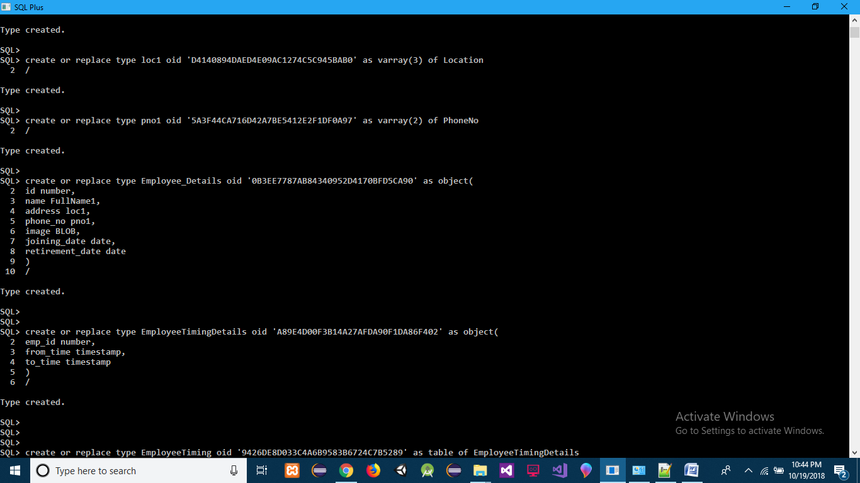

create or replace type EmployeeTiming oid '9426DE8D033C4A6B9583B6724C7B5289' as table of EmployeeTimingDetails

/

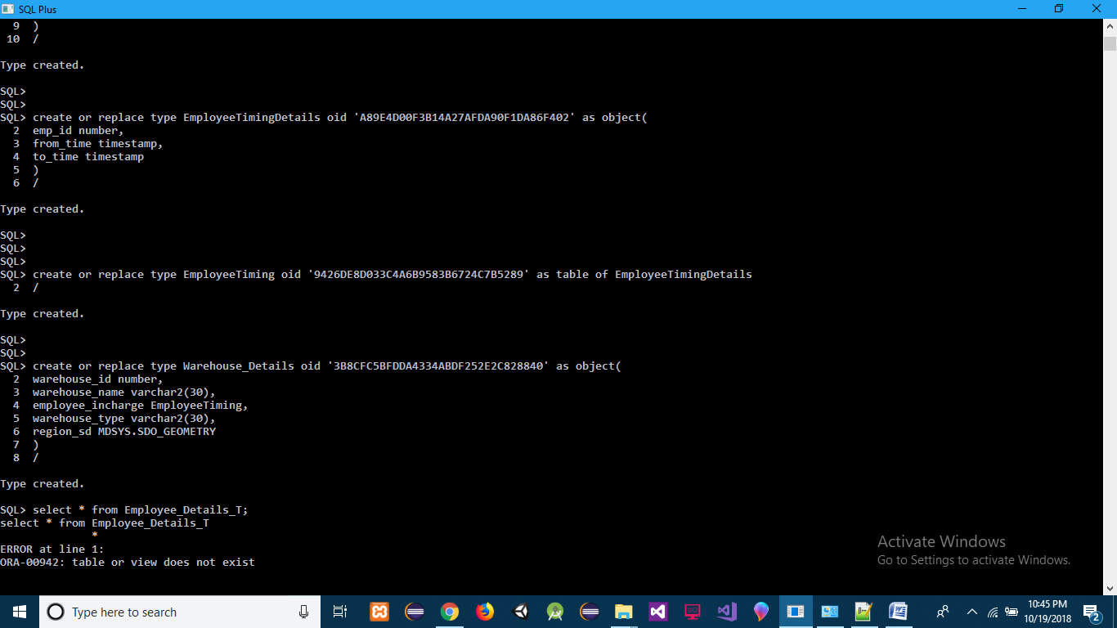

create or replace type Warehouse_Details oid '3B8CFC5BFDDA4334ABDF252E2C828840' as object(

warehouse_id number,

warehouse_name varchar2(30),

employee_incharge EmployeeTiming,

warehouse_type varchar2(30),

region_sd MDSYS.SDO_GEOMETRY

)

/

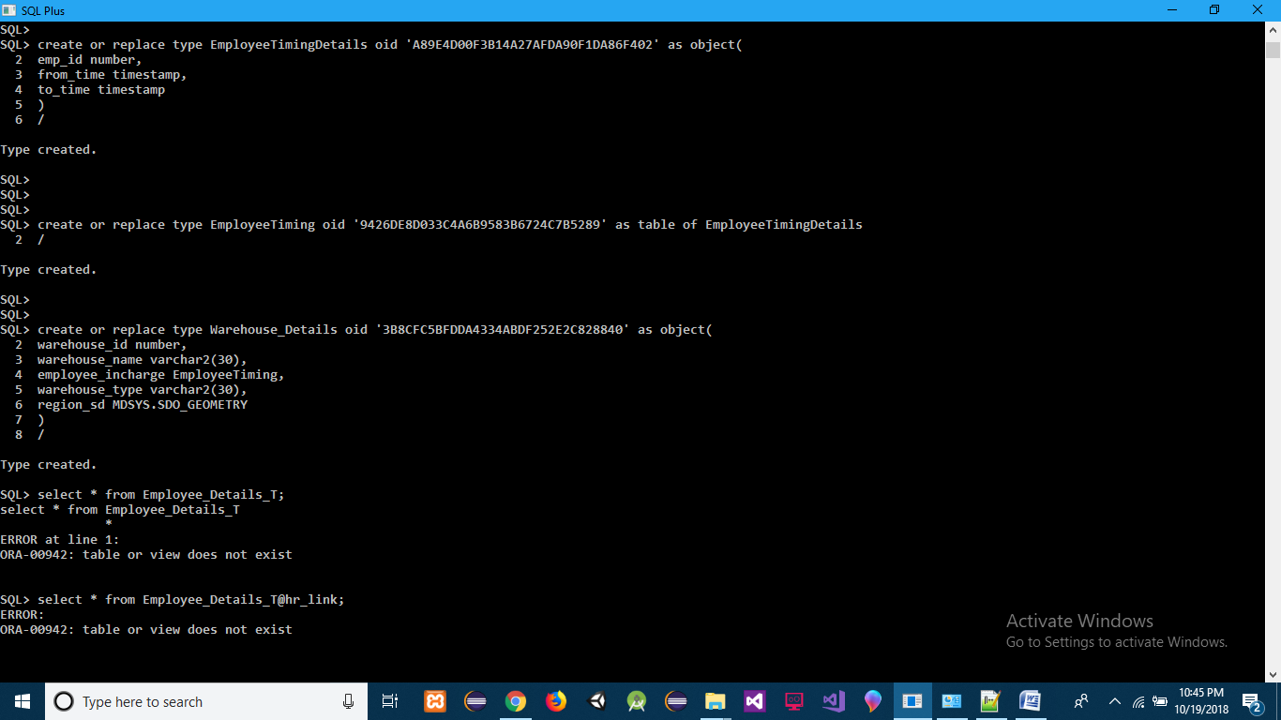

**Q] Create a Database Link to Connect HR Database**

**ANS]** create database link hr_link connect to system identified by "orcl" using 'other';

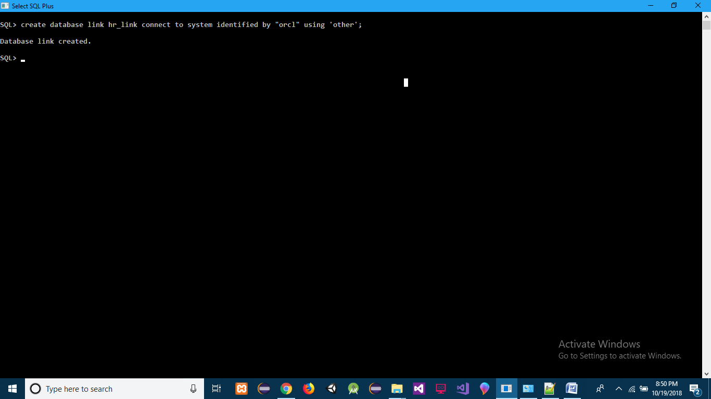

**Q] Get Employee Joining and Retiring details from HR Database**

**ANS]** select id,joining_date,retirement_date from Employee_Details_T@hr_link;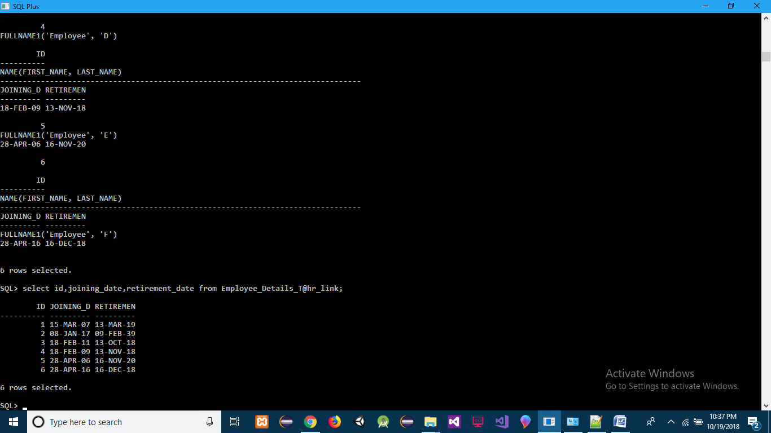

**Q] Get Warehouse details from HR Database**

**ANS]** select warehouse_id, warehouse_name, warehouse_type from Warehouse_Details_T@hr_link;

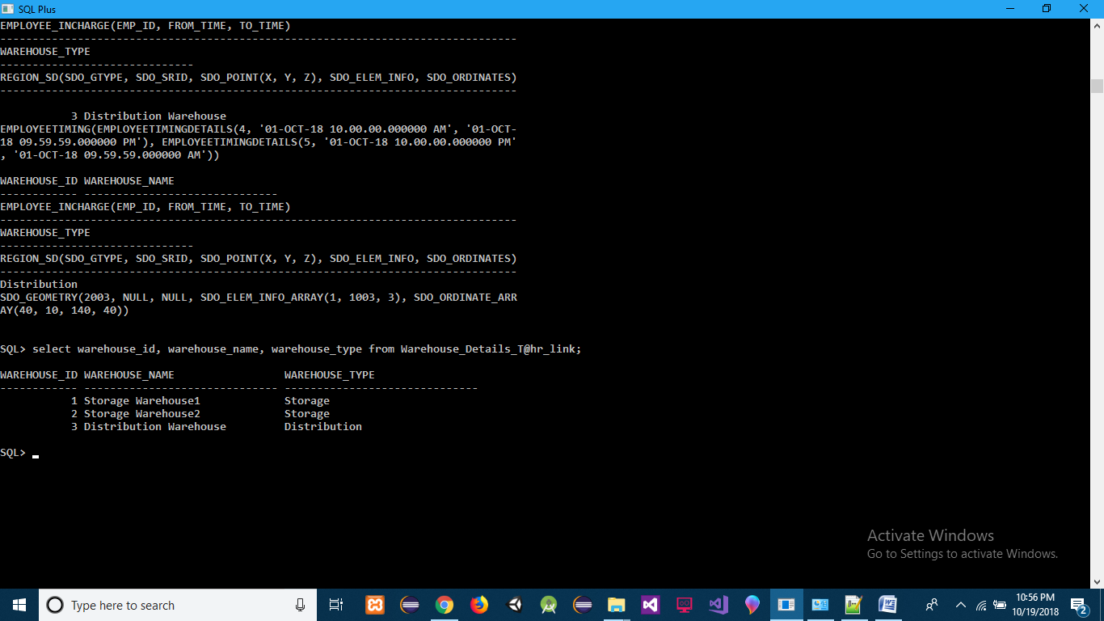

------------------------------------------------------------------------------------------------------------------------------------------

product purchase decision

best supplier for a product

purchase order

storage warehouse location and employee details

best customer for a product

distribution warehouse location and employee details

best transporter

**Q] Get the details of most purchased product**

**ANS]** select pd.id,pd.name,pd.productType from Product_Details_T pd where pd.id IN (select prod.product_id from Purchase_Order_T p, TABLE(p.products) prod group by prod.product_id having count(prod.product_id) >= ALL(select count(prod1.product_id) from Purchase_Order_T p, TABLE(p.products) prod1 group by prod1.product_id));

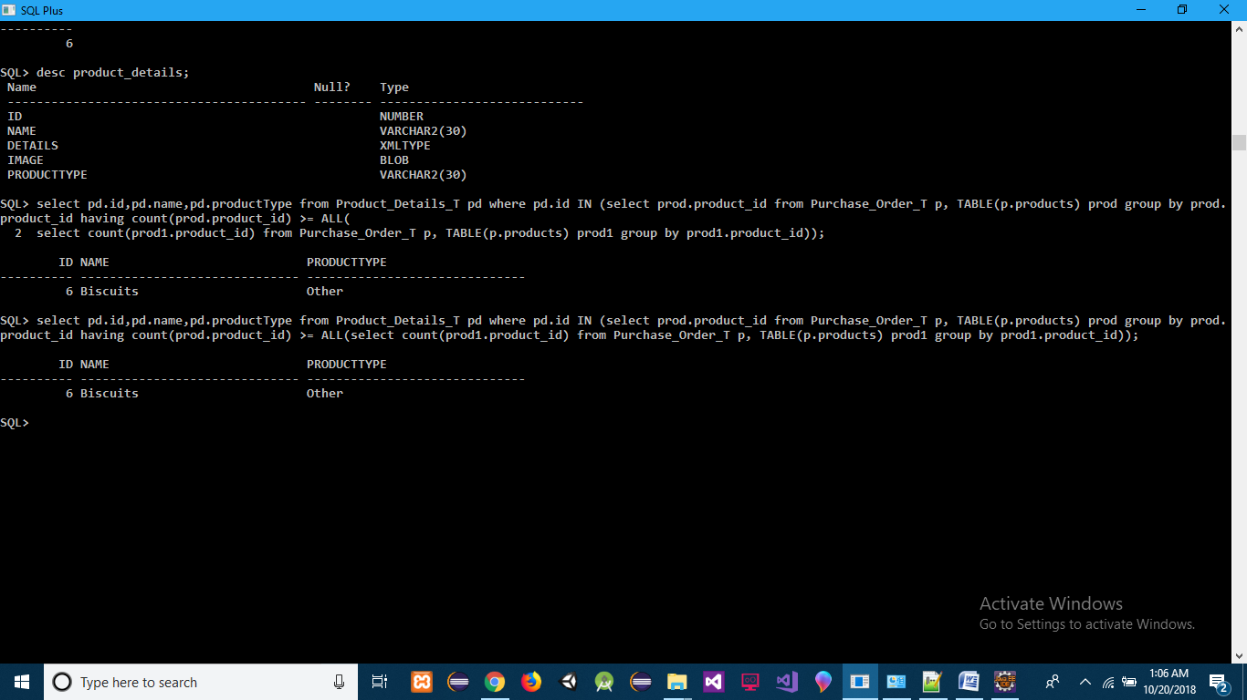

**Q] Get the details of most sold product**

**ANS]** select pd.id,pd.name,pd.productType from Product_Details_T pd where pd.id IN (select prod.product_id from Sales_Order_T s, TABLE(s.products) prod group by prod.product_id having count(prod.product_id) >= ALL(select count(prod1.product_id) from Sales_Order_T s1, TABLE(s1.products) prod1 group by prod1.product_id));

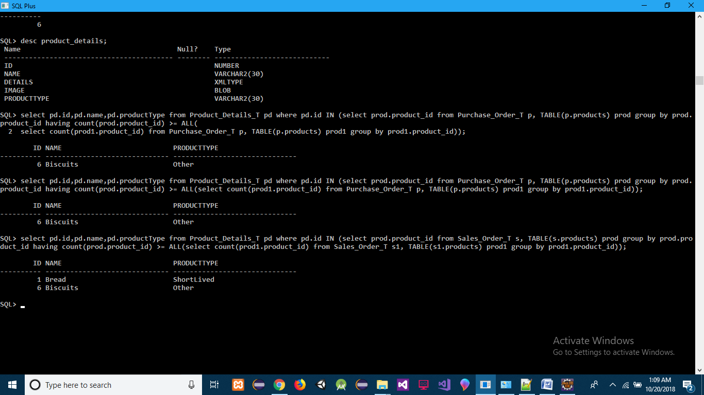

**Q] Get the Total Money Saved till Now while Purchasing of product**

**ANS]** select a.id, sum(a.diff) Total_Money_Saved from (select p1.id, p1.name, (p1.actualPrice - p.price) diff from(select prp.product_id, prp.price from Purchase_Order_T pr, TABLE(pr.products) prp) p INNER JOIN(select prod.id, prod.name, extractvalue(COLUMN_VALUE,'/description/price') actualPrice from Product_Details_T prod, TABLE(XMLSEQUENCE(prod.details)) pd)p1 ON p.product_id = p1.id) a group by a.id;

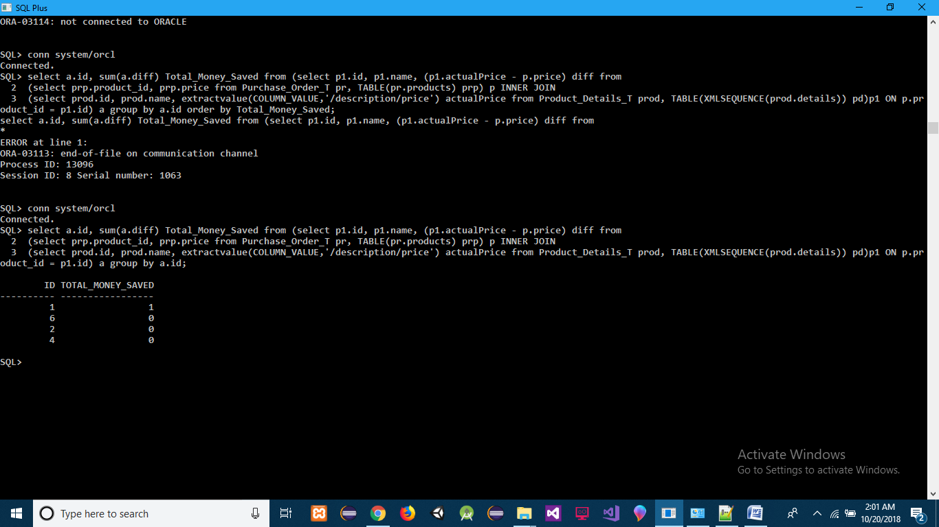

**Q] Get the Total Money Profited till Now while Selling the product**

**ANS]** select a.id, sum(a.diff) Total_Money_Profited from (select p1.id, p1.name, (p.price - p1.actualPrice) diff from(select prp.product_id, prp.price from Sales_Order_T pr, TABLE(pr.products) prp) p INNER JOIN(select prod.id, prod.name, extractvalue(COLUMN_VALUE,'/description/price') actualPrice from Product_Details_T prod, TABLE(XMLSEQUENCE(prod.details)) pd)p1 ON p.product_id = p1.id) a group by a.id;

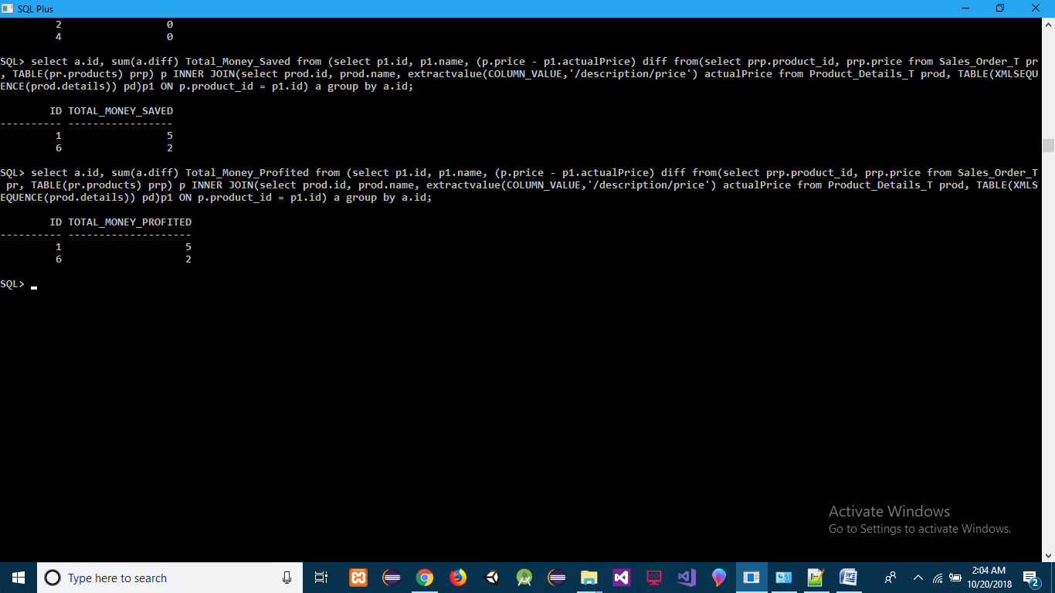

**Q] Out Of Stock Product**

**ANS]** select pd.id,pd.name,pd.productType from Product_Details_T pd where pd.id NOT IN (select sp.product_id from Storage_Products_T sp);

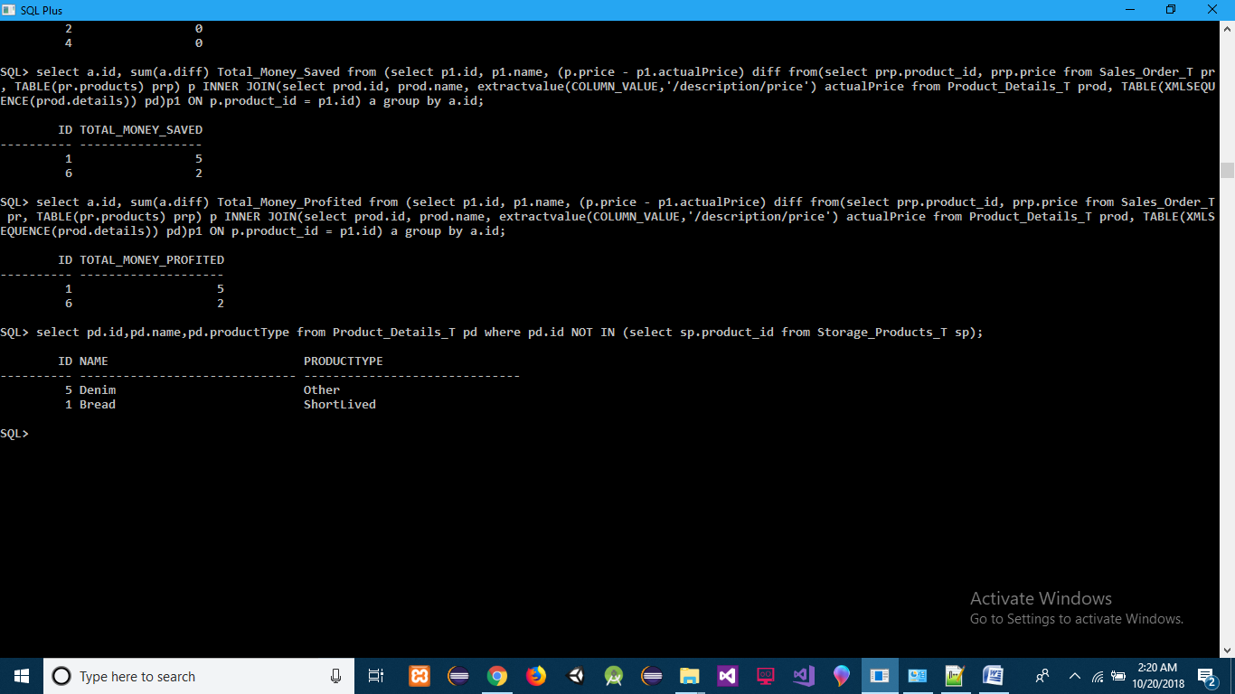

**Q] Related Products Produced in Market (Purchased Data)**

**ANS]**

db.Products.find().sort({"Qty":-1});

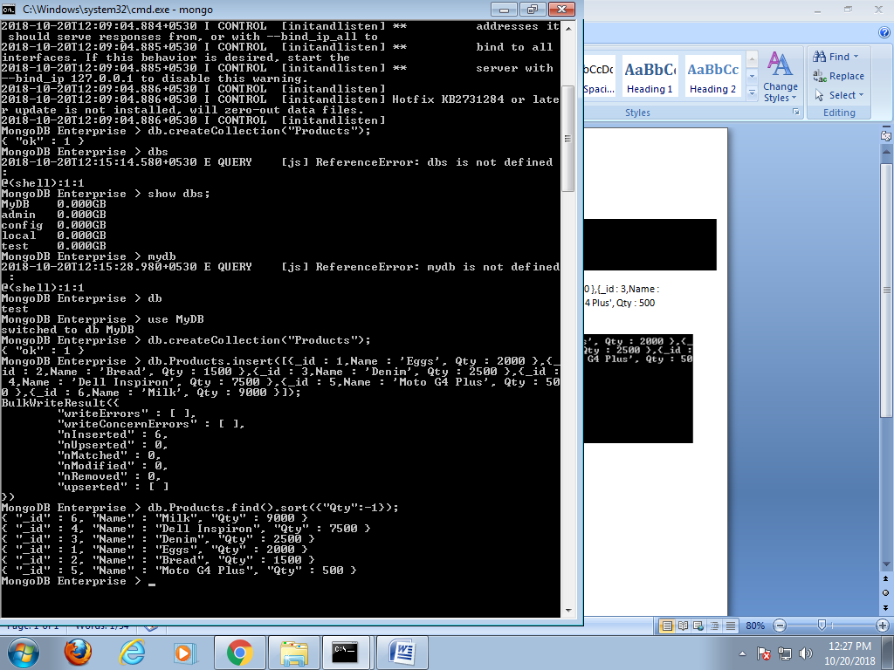

------------------------------------------------------------------------------------------------------------------------------------------

**Q] Get the Name and Contact of Most Active Supplier for particular product id**

**ANS]** select s.id, s.name.first_name FIRST_NAME, s.name.last_name LAST_NAME, p.phone_no from Supplier_Details_T s, TABLE(s.phone_no) p where id IN (select p.supplier_id from purchase_order_t p, TABLE(p.products) prod where prod.product_id = 6 group by p.supplier_id having count(p.order_id) >= ALL (select count(p1.order_id) from purchase_order_t p1, TABLE(p1.products) prod1 where prod1.product_id = 6 group by p1.supplier_id));

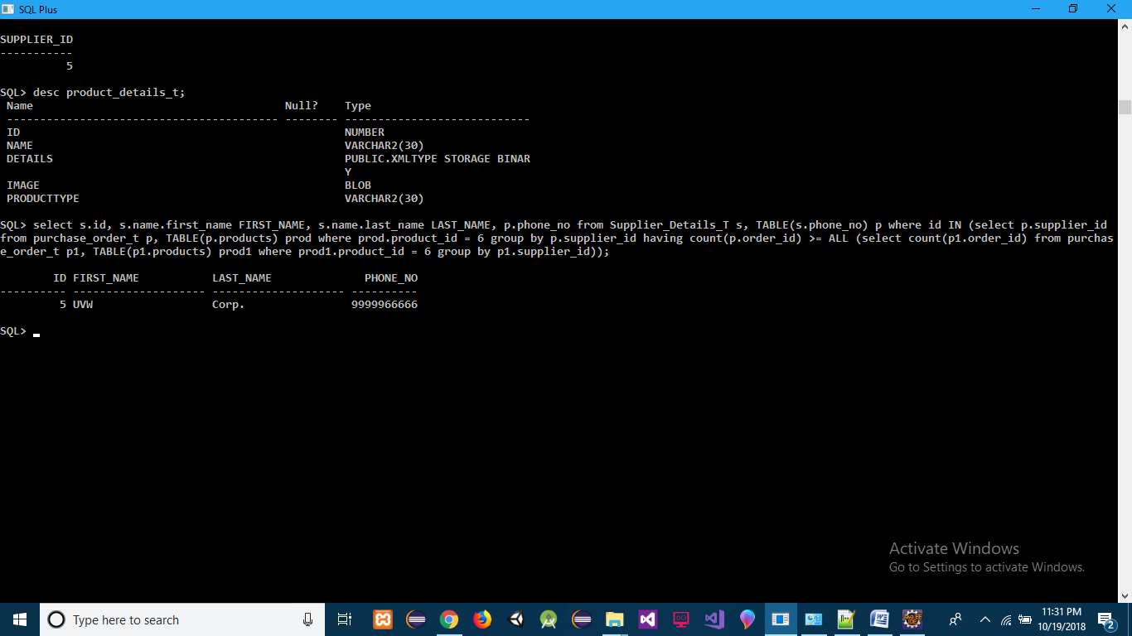

**Q] Get the Name and Contact of all Trusted Supplier for particular product id**

**ANS]** select s.id, s.name.first_name FIRST_NAME, s.name.last_name LAST_NAME, p.phone_no from Supplier_Details_T s, TABLE(s.phone_no) p where trusted = 1;

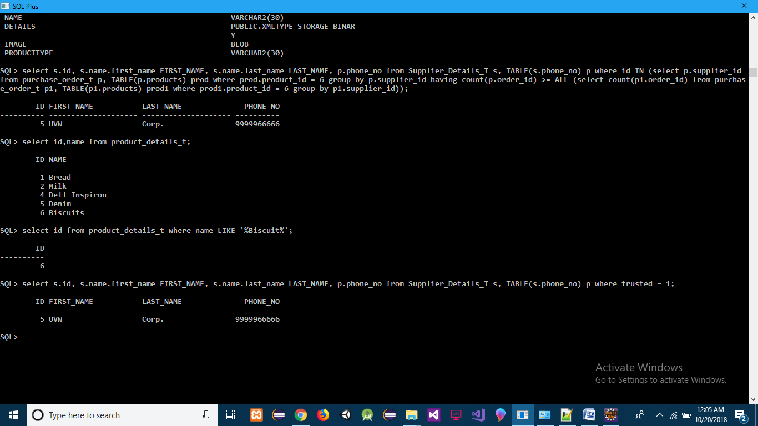

**Q] Get the Name and Contact of least cost Supplier for particular product id**

**ANS]** select a.id, a.FIRST_NAME, a.PHONE_NO, b.Min_Price_Offered from(select s.id, s.name.first_name FIRST_NAME, s.name.last_name LAST_NAME,p.phone_no PHONE_NO from Supplier_Details_T s, TABLE(s.phone_no) p) a INNER JOIN (select pur.supplier_id,min(prod.price) Min_Price_Offered from purchase_order_t pur, TABLE(pur.products) prod where prod.product_id = 6 group by pur.supplier_id order by Min_Price_Offered) b ON a.id = b.supplier_id;

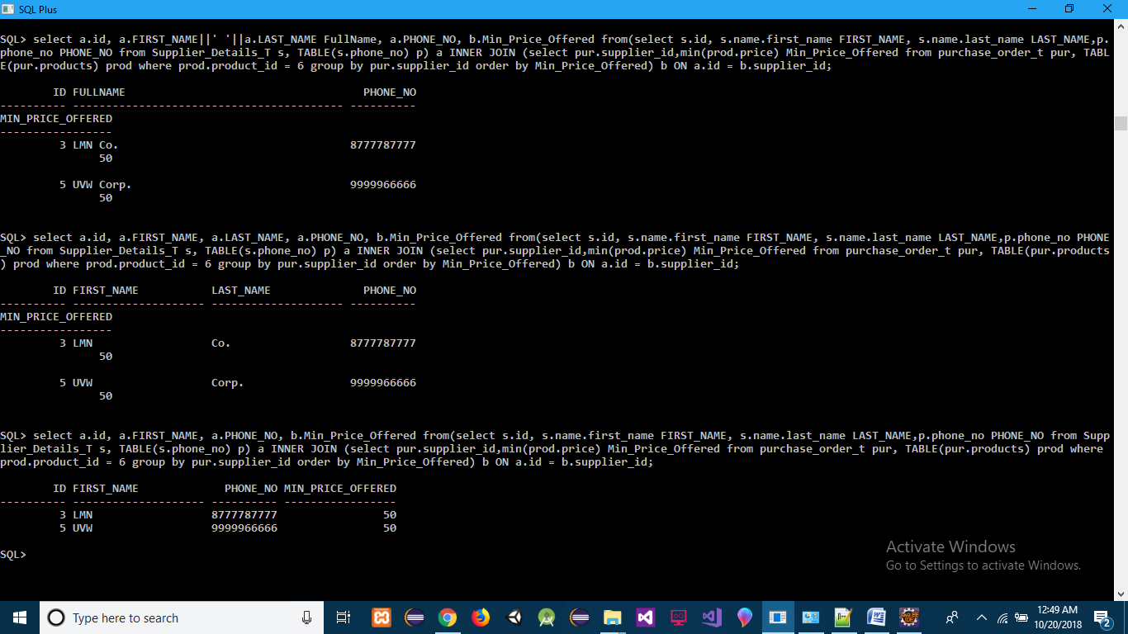

------------------------------------------------------------------------------------------------------------------------------------------

**Q] Detail about Warehouse Compartments where Purchased Product will be stored**

**ANS]** SELECT s.warehouse_id, s.storage_compartment_id, s.region_name from StorageWarehouse_Region_T s WHERE s.region_id = (select region_id from Allocation_Details_T where product_id = 6);

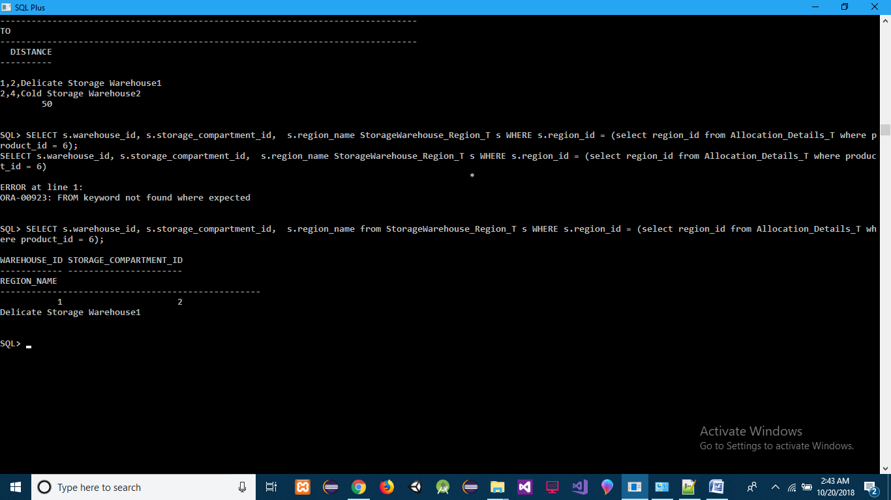

**Q] Distance of All the Storage Compartments to (Warehouse Compartment where Purchased Product will be stored)**

**ANS]** SELECT s.warehouse_id||','||s.storage_compartment_id||','|| s.region_name "FROM", s1.warehouse_id||','||s1.storage_compartment_id||','|| s1.region_name "TO", SDO_GEOM.SDO_DISTANCE(s.region_sd, s1.region_sd, 0.005) DISTANCE FROM StorageWarehouse_Region_T s, StorageWarehouse_Region_T s1 WHERE s.region_id = (select region_id from Allocation_Details_T where product_id = 6) and s1.region_id <> (select region_id from Allocation_Details_T where product_id = 6);

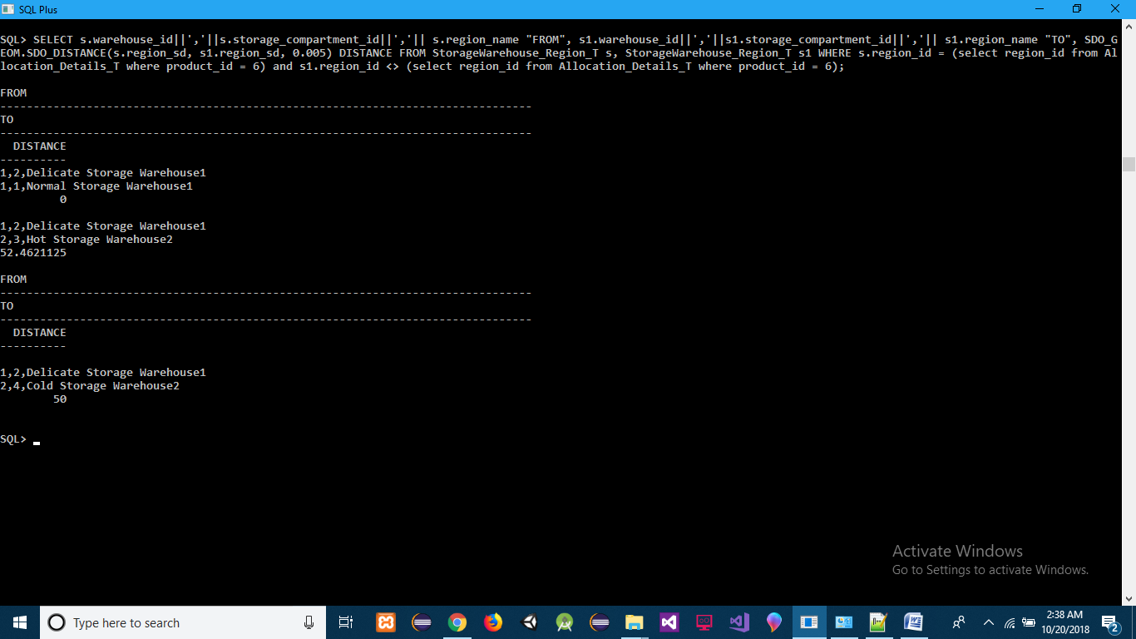

**Q] Employee Working in Warehouse where Purchased product will be stored**

**ANS]**

select e.emp_id, to_char(e.from_time, 'HH24:MI:SS') from_time,to_char(e.to_time, 'HH24:MI:SS') to_time from Warehouse_Details_T@hr_link w, TABLE(w.employee_incharge) e where warehouse_id IN (select warehouse_id FROM StorageWarehouse_Region_T WHERE region_id IN (select region_id from Allocation_Details_T where product_id = 6));

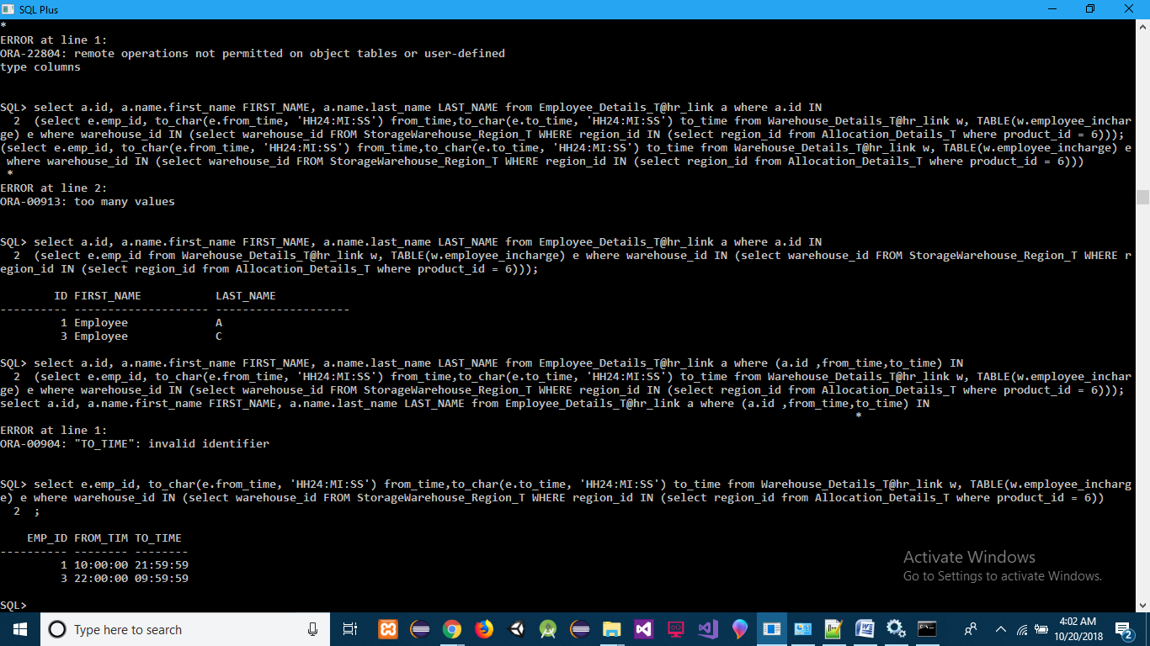

**Q] Employee Details Working in Warehouse where Purchased product will be stored**

**ANS]** select a.id, a.name.first_name FIRST_NAME, a.name.last_name LAST_NAME from Employee_Details_T@hr_link a where a.id IN(select e.emp_id from Warehouse_Details_T@hr_link w, TABLE(w.employee_incharge) e where warehouse_id IN (select warehouse_id FROM StorageWarehouse_Region_T WHERE region_id IN (select region_id from Allocation_Details_T where product_id = 6)));

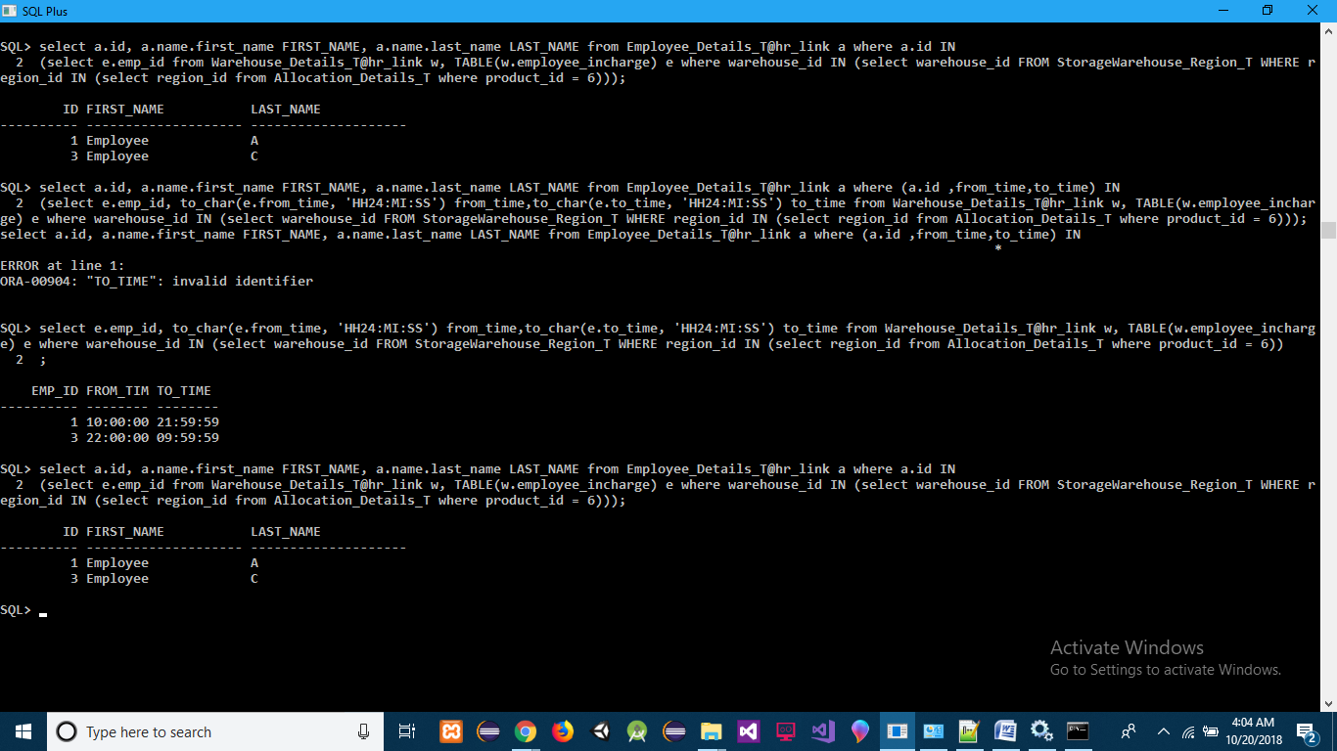

------------------------------------------------------------------------------------------------------------------------------------------

**Q] Get the Remaining Periods for Products**

**ANS]** (select s.product_id,s.getRemainingPeriods() "Remaining" from Short_Lived_Products_T s

UNION ALL

(select e.product_id,e.getRemainingPeriods() "Remaining" from Electronic_Products_T e

UNION ALL

select o.product_id,o.getRemainingPeriods() "Remaining" from Other_Products_T o))

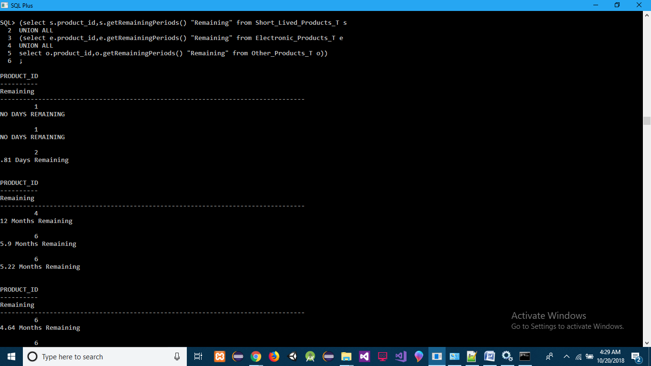

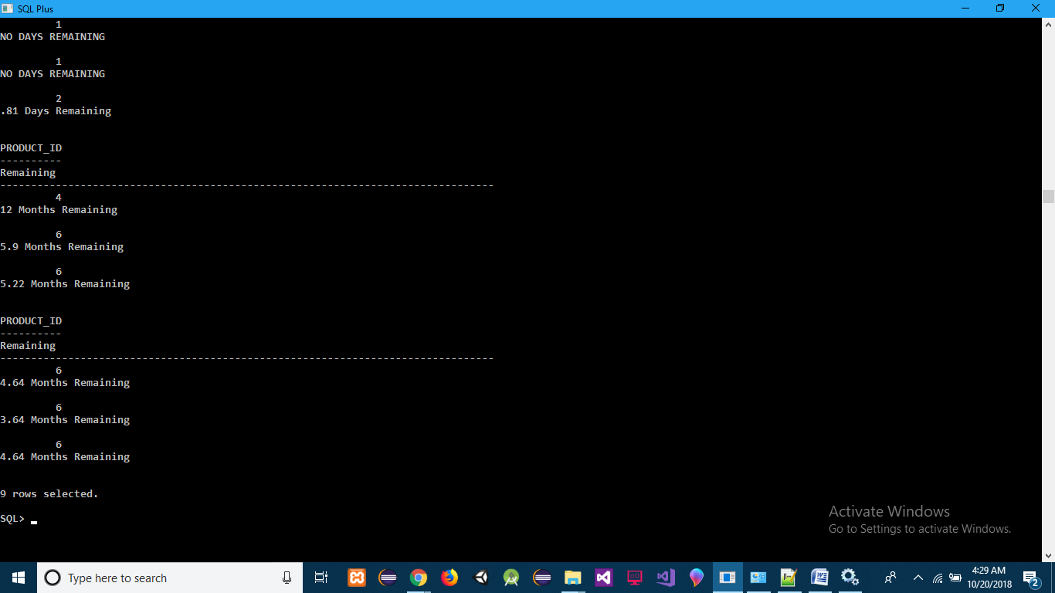

**Q] Get the Name and Contact of Most Active Customer for particular product id**

**ANS]** select s.id, s.name.first_name FIRST_NAME, s.name.last_name LAST_NAME, p.phone_no from Customer_Details_T s, TABLE(s.phone_no) p where id IN (select p.customer_id from sales_order_t p, TABLE(p.products) prod where prod.product_id = 6 group by p.customer_id having count(p.order_id) >= ALL (select count(p1.order_id) from sales_order_t p1, TABLE(p1.products) prod1 where prod1.product_id = 6 group by p1.customer_id));

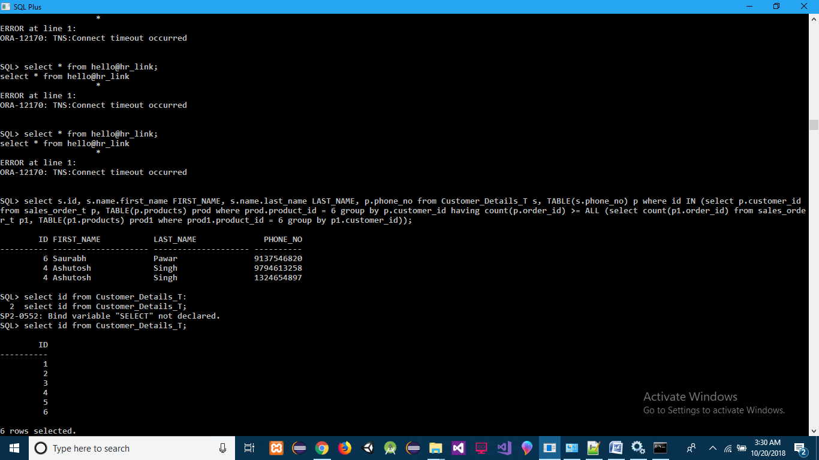

**Q] Get the Name and Contact of all Regular Customer for particular product id**

**ANS]** select s.id, s.name.first_name FIRST_NAME, s.name.last_name LAST_NAME, p.phone_no from Customer_Details_T s, TABLE(s.phone_no) p where regular = 1;

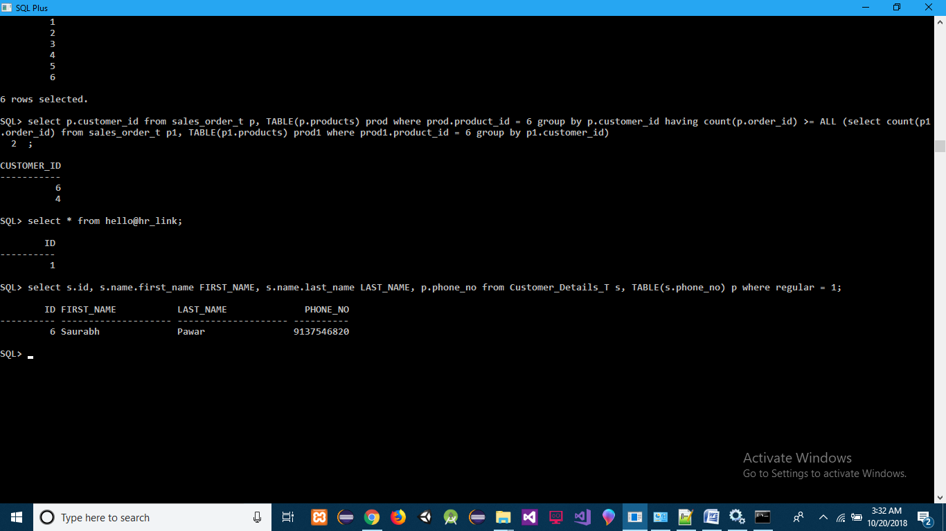

**Q] Get the Name and Contact of least bargaining Customer for particular product id**

**ANS]** select a.id, a.FIRST_NAME, a.PHONE_NO, b.Max_Price_Sold from(select s.id, s.name.first_name FIRST_NAME, s.name.last_name LAST_NAME,p.phone_no PHONE_NO from Customer_Details_T s, TABLE(s.phone_no) p) a INNER JOIN (select pur.customer_id,max(prod.price) Max_Price_Sold from sales_order_t pur, TABLE(pur.products) prod where prod.product_id = 6 group by pur.customer_id order by Max_Price_Sold) b ON a.id = b.customer_id;

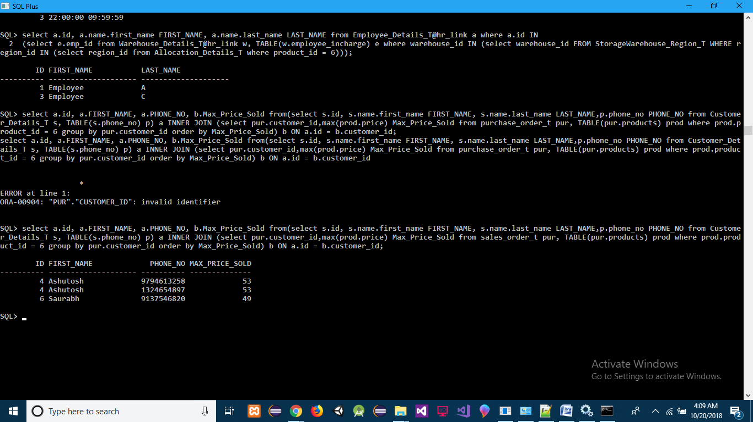

------------------------------------------------------------------------------------------------------------------------------------------

**Q] Distance from (Warehouse Compartment where Purchased Product is stored) to Distribution Warehouse**

**ANS]** SELECT s.warehouse_id||','||s.storage_compartment_id||','|| s.region_name "FROM", d.warehouse_name "TO", SDO_GEOM.SDO_DISTANCE(s.region_sd, d.region_sd, 0.005) DISTANCE FROM StorageWarehouse_Region_T s, Warehouse_Details_T@hr_link d WHERE s.region_id = (select region_id from Allocation_Details_T where product_id = 6) and d.warehouse_type = 'Distribution';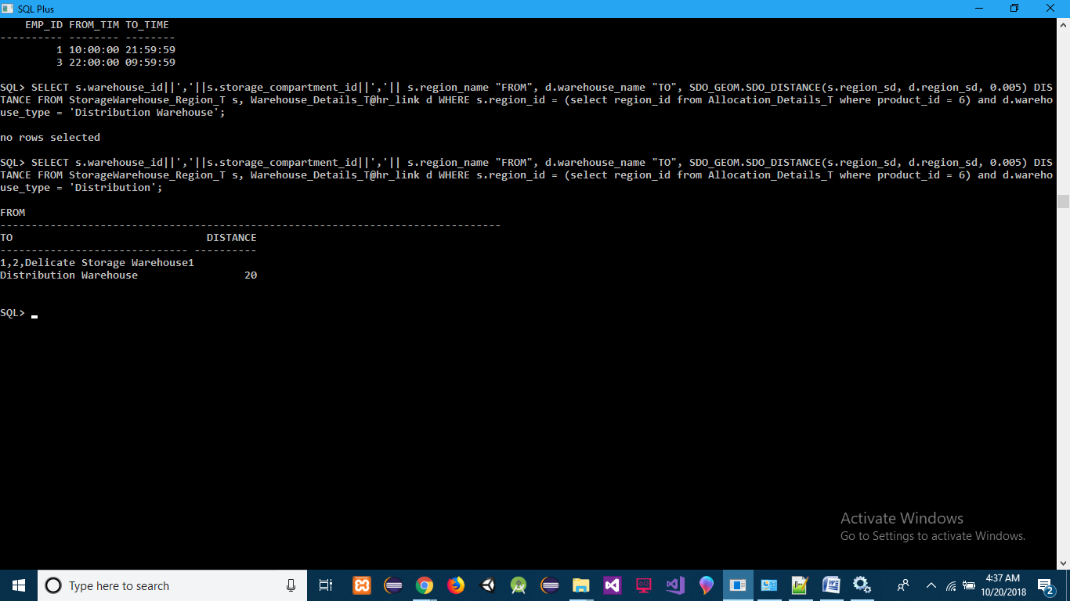

**Q] Employee Working in Warehouse where Sales product will be stored**

**ANS]**

select e.emp_id, to_char(e.from_time, 'HH24:MI:SS') from_time,to_char(e.to_time, 'HH24:MI:SS') to_time from Warehouse_Details_T@hr_link w, TABLE(w.employee_incharge) e where warehouse_type = 'Distribution';

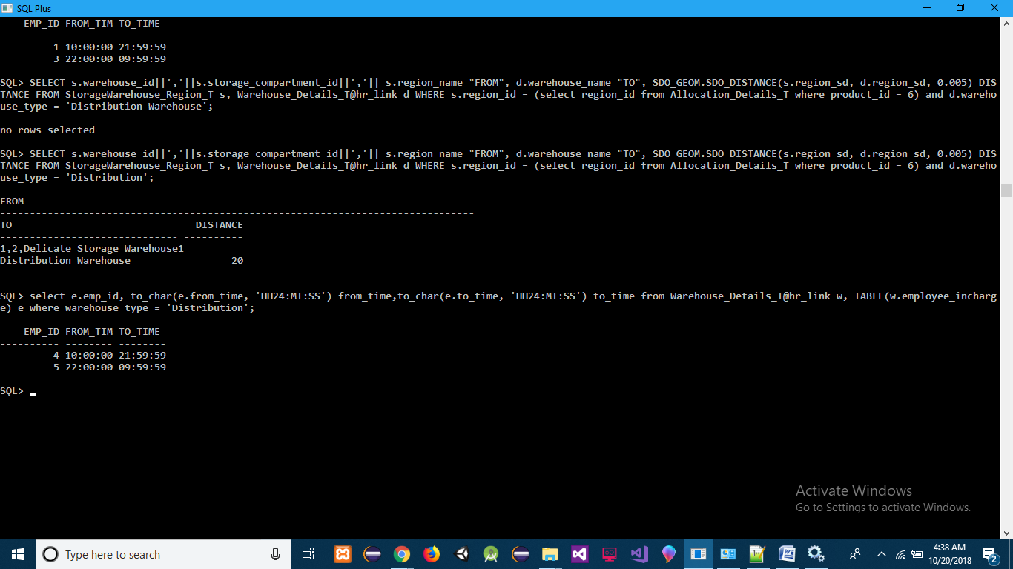

**Q] Employee Details Working in Warehouse where Sales product will be stored**

**ANS]**

select a.id, a.name.first_name FIRST_NAME, a.name.last_name LAST_NAME from Employee_Details_T@hr_link a where a.id IN(select e.emp_id from Warehouse_Details_T@hr_link w, TABLE(w.employee_incharge) e where warehouse_type = 'Distribution');

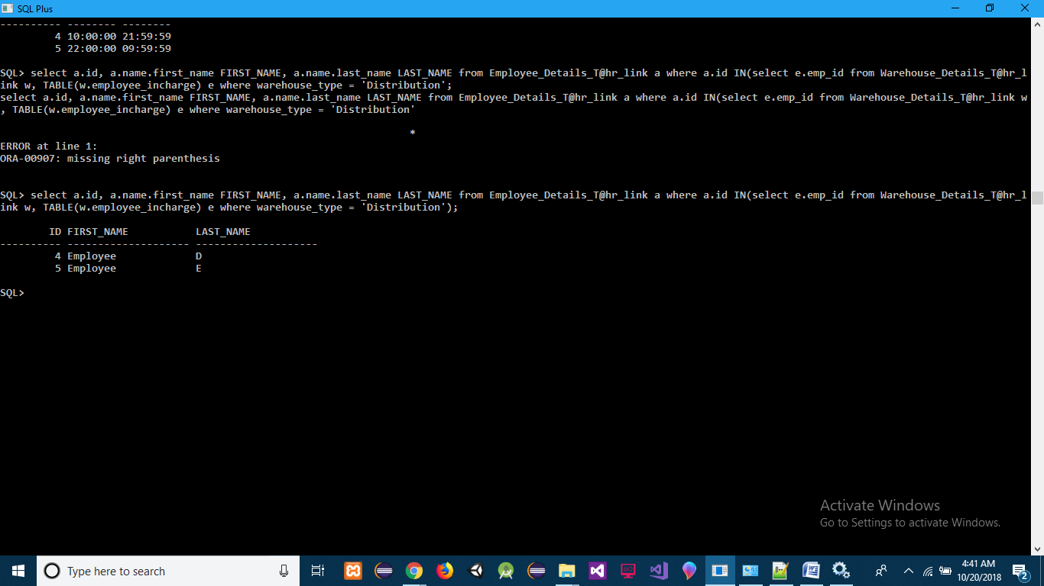

------------------------------------------------------------------------------------------------------------------------------------------

**Q] Most Active Transporter**

**ANS]** select s.id, s.name.first_name FIRST_NAME, s.name.last_name LAST_NAME, p.phone_no from Transporter_Details_T s, TABLE(s.phone_no) p where id IN (select p. transporter_id from Transport_order_t p group by p.transporter_id having count(p.order_id) >= ALL (select count(p1.order_id) from Transport_order_t p1 group by p1. transporter_id));

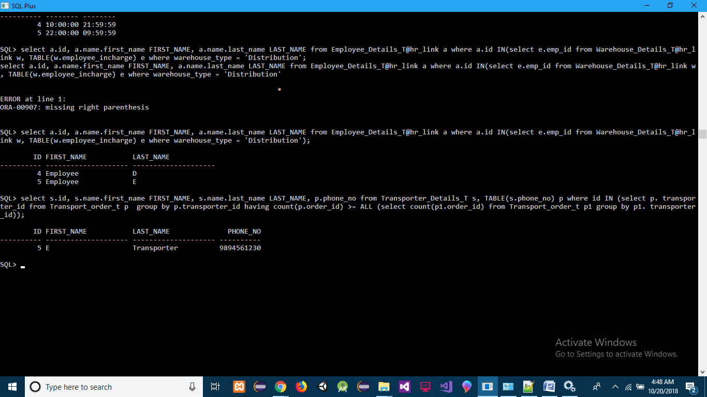

**Q] Most Cheap Transporter Facility**

**ANS]** select s.delicate_protection, s.temperature_control,min(cost_per_km) from Transporter_Details_T s group by s.delicate_protection, s.temperature_control;

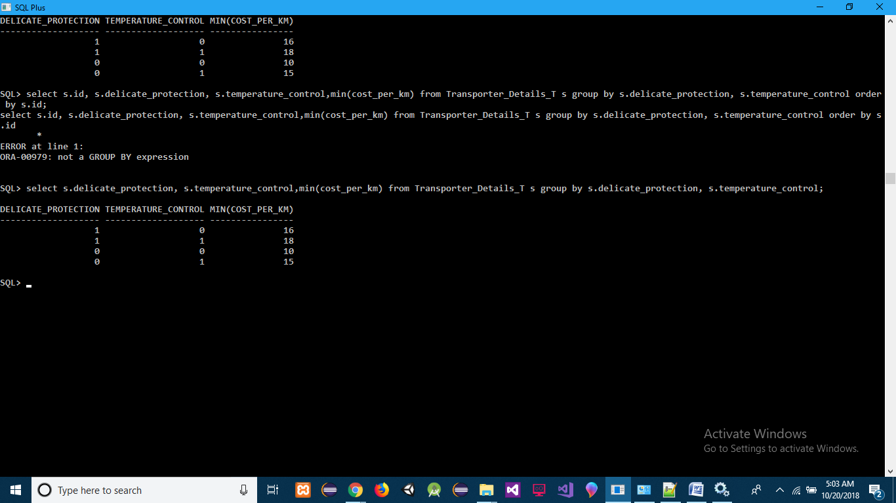

**JAVA CODE FOR PRODUCT IMAGE RETRIEVE:-**

**package** multimedia;

**import** java.awt.*;

**import** javax.swing.*;

**import** java.awt.event.*;

**import** java.sql.*;

**public** **class** retriveimage1 **extends** JFrame {

**static** JComboBox *imageid*;

JLabel label1, label2;

**static** String *Imagename* = "";

String filename = "";

ImageIcon image;

JLabel imagelabel;

Connection connection;

Statement statement;

**byte**[] imageBytes = **new** **byte**[2048];

**public** retriveimage1() {

**super**("Warehouse Products");

label1 = **new** JLabel("Select Product ID:");

label2 = **new** JLabel("Product is:");

*imageid* = **new** JComboBox();

*imageid*.setRequestFocusEnabled(**true**);

fillid();

imagelabel = **new** JLabel();

getContentPane().setLayout(**new** FlowLayout());

getContentPane().add(label1);

getContentPane().add(*imageid*);

getContentPane().add(label2);

getContentPane().add(imagelabel);

setSize(800, 600);

setVisible(**true**);

*imageid*.addActionListener(**new** ActionListener() {

**public** **void** actionPerformed(ActionEvent ae) {

**try** {

getImage();

} **catch** (Exception e) {

System.***out***.println("Error" + e.getMessage());

}

}

});

}

**public** **void** fillid() {

**try** {

DriverManager.*registerDriver*(**new** oracle.jdbc.driver.OracleDriver());

String url = "jdbc:oracle:thin:@(DESCRIPTION ="

+ "(ADDRESS = (PROTOCOL = TCP)(HOST = DESKTOP-RKPVUH7)(PORT = 1521))" + "(CONNECT_DATA ="

+ " (SERVER = DEDICATED)" + "(SERVICE_NAME = XE)" + ")" + "))";

String username = "system";

String password = "orcl";

connection = DriverManager.*getConnection*(url, username, password);

statement = connection.createStatement();

String SQL = "SELECT id FROM Product_Details_T ORDER BY id";

ResultSet resultset = statement.executeQuery(SQL);

**while** (resultset.next())

*imageid*.addItem(resultset.getString(1));

} **catch** (Exception e) {

System.***out***.println(e.getMessage());

}

}

**public** **void** getImage() {

*Imagename* = "";

**try** {

DriverManager.*registerDriver*(**new** oracle.jdbc.driver.OracleDriver());

String url = "jdbc:oracle:thin:@(DESCRIPTION ="

+ "(ADDRESS = (PROTOCOL = TCP)(HOST = DESKTOP-RKPVUH7)(PORT = 1521))" + "(CONNECT_DATA ="

+ " (SERVER = DEDICATED)" + "(SERVICE_NAME = XE)" + ")" + "))";

String username = "system";

String password = "orcl";

connection = DriverManager.*getConnection*(url, username, password);

statement = connection.createStatement();

String SQL = "SELECT * FROM Product_Details_T WHERE id=" + *imageid*.getSelectedItem();

ResultSet resultset = statement.executeQuery(SQL);

**while** (resultset.next()) {

*Imagename* = resultset.getString(2);

imageBytes = resultset.getBytes(4);

}

image = **new** ImageIcon(imageBytes);

imagelabel.setIcon(image);

label2.setText("Your selected Image name is : " + *Imagename*);

resultset.close();

statement.close();

connection.close();

}

**catch** (Exception e) {

System.***out***.println(e.getMessage());

}

}

**public** **static** **void** main(String args[]) {

**new** retriveimage1();

}

}

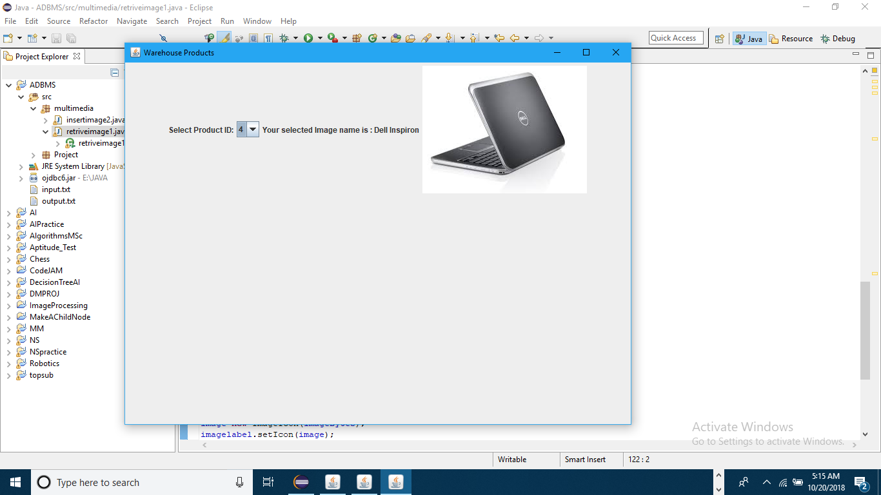

**--------------------------------------END------------------------------------------**